STUDENTS’ PERCEPTIONS OF USING GOOGLE TRANSLATE APPLICATION TOWARD THEIR ENGLISH VOCABULARY KNOWLEDGE

A Paper
Submitted to the English Language Education Study Program,
Faculty of Teacher Training and Educational Sciences Pakuan University
as a Partial Fulfillment of Requirements for the Sarjana Pendidikan Examination


By:

R. Muh Rizaldy
031118085
ENGLISH LANGUAGE EDUCATION STUDY PROGRAM
FACULTY OF TEACHER TRAINING AND
EDUCATION PAKUAN UNIVERSITY
2022

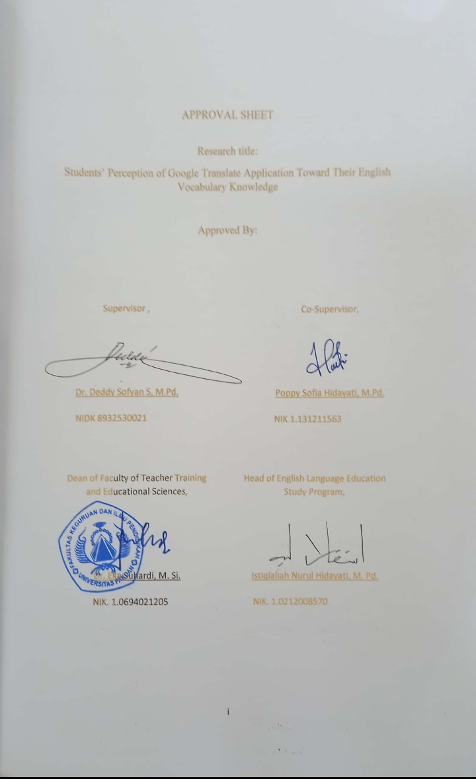

DECLARATION

I hereby declare that the paper entitled “Students’ Perception of Google Translate Application toward their English Vocabulary Knowledge” is completely my own work. I am fully aware that I have quoted some statements and ideas from many resources. All quotations are properly acknowledged in the text. Should there be a claim on the originality of this paper, I would be prepared to take any legal responsibility.

Bogor,November2022

Raden Muhamad Rizaldy

PREFACE

Alhamdulillah, praise is only to Allah SWT for all His abundant blessing, mercies, and guidance that the writer is able to complete this paper entitled, “Students’ Perception of Google Translate Application toward their English Vocabulary Knowledge”. This paper is submitted to fulfill one of the requirements for the Sarjana Pendidikan Examination in the English Education Study Program, Faculty of Teacher Training and Educational Sciences, Pakuan University. The writer realizes that this paper is still simple and far from being perfect. Therefore, he will appreciate all comments, corrections, and suggestions for further improvement of this paper. Finally, he hopes that this paper will be useful for the readers.

Bogor, November 2022

Raden Muhamad Rizaldy

ACKNOWLEDGEMENT

The writer would like to express the greatest gratitude to Allah SWT who has given His blessing. he also realizes that he could not write the paper properly without the involvement of those who have supported him in conducting the research.
The first writer would like to express his gratitude to Dr. Deddy Sofyan S, M.Pd. as the supervisor, and Poppy Sofia Hidayati, M.Pd. as the co-supervisor. also the head of the English Language Education Study Program They have given their criticism, time, advice, suggestion, and motivation in completing this paper.
His gratitude also goes to Poppy Sofia Hidayati, M.Pd. as his academic counselor off Class D, and all lecturers of the English Language Education Study Program, Faculty of Teacher Training and Educational Sciences, Pakuan University who have given motivation and knowledge to the writer in conducting this paper. The writer also thanks KH. Muhammad Husni Thamrin who has allowed the writer to conduct the research in Insan Kamil Bogor.This paper is dedicated to his beloved family. he would like to thank his parents R.Sutiarna and Nyai Nurnilasari Sarbini, and he also would like to thank his two sisters R.A. Desty Andika Sarnia and R.A. Siti Fatimah Azzahra, and his brother R.Muh.Alief Firdaus for their advice, motivation, pray, and financial support. Last, but not least, he also like to thank his uncle Ferry Fazri that give positive energy and accompany him in working on this paper through his jokes.

ABSTRACT

The writer chose Google translate because Google translate is a popular machine translation, so the paper entitled “Students’ Perception about Google translate application toward their English vocabulary Knowledge” has the purpose to know students' perceptions of using Google translate toward their English vocabulary knowledge. In this research the writer uses descriptive qualitative is applied in this research. This research is conducted at Insan Kamil Bogor to 2nd grade of senior high school in August 2022. The instruments that used in this research were Questionnaires, Interviews, and documentation. Based on the result of this research, it is found that students’ perception about Google Translate toward their English vocabulary knowledge, in the questionnaire, most of the students for about 75% of students agree that Google translate makes students easier to understand English vocabulary, and also the result from the interview the perception from students about Google translate application toward their English vocabulary knowledge have a better respond. The last for the documentation shows that for about 50% of students who use Google translate to have a better score than those who do not use Google Translate for their assignments, it means that the data from the documentation has good response from students about using Google translate for their English vocabulary knowledge. The conclusion of this research is that students have a good perception about the use of Google translate toward their English vocabulary knowledge.
Keywords: English Vocabulary, Google Translate, Students’ Perception.

TABLE OF CONTENTS

APPROVAL i
DECLARATION ii
PREFACE iii
ACKNOWLEDGED iv
ABSTRACT v
TABLE OF CONTENT vi
LIST OF TABLE x
LIST OF FIGURE xi
CHAPTER 1 INTRODUCTION 1
- Backgroundof Study 1
- Reason for Choosing the Topic 2
- Aim of the Research 3
- Research Question 3
- Research Focus 3
- Operational Definition 4
- Research Significance 5
CHAPTER II THEORETICAL FOUNDATION 7
- Vocabulary 7
  - The definition 7
  - Kinds of vocabulary 8
  - The importance of vocabulary enrichment in learning English 9
- Google translate 10
  - Definition of Google translate 10
  - The benefit of Google translate 10
  - The kind of ways to use Google translate 11
- Perception 12
1. The definition of perception 12
2. The process of perception 13
- Related Research 14
CHAPTER III RESEARCH METHOD 16
- Research Method and Design 16
- Research Site and Participants 16
- Research Instrument 17
1. Questionnaire 18
Table 3.1 19
2. Interview 23
Tables 3.2 24
3.Documentation 27
- Research Procedure 27
Figure 3.1 28
- Data Analysis 29
1. Questionnaire 29
2. Interview 29
3. Documentation 29
CHAPTER IV 31
A. Data Description 31
A. 1. Data from Questionnaire 31
A. 2. Data from Student’ Interview 42
A. 3. Data from Documentation 51
B. Data Analysis 52
CHAPTER V 56
A. Conclusion 56
A. 1. Understanding information 56
A. 2. Awareness 57
A. 3. Senses 57
B. Suggestion 58
BILBIOGRAPHY 60
LIST OF APENDICES 64
Appendix 1 : Research Instrument 65
Appendix 2 : Instrument of Questionnaire 74
Appendix 3 : Instrument of Interview 75
Appendix 4 : Instrument of Documentation 76
Appendix 5 : Surat Keterangan Bimbingan Skripsi 77
Appendix 6 : Fotokopi Buku Bimbingan Skripi 79
Appendix 7 : Surat Izin Penelitian 82
Appendix 8 : Surat Bukti Penelitian 84

LIST OF TABLE
Table 3.1 19
Table 3.2 24
Table 4.1 32
Table 4.2 36
Table 4.3 39

LIST OF FIGURE

Figure 3.1 28

CHAPTER I
INTRODUCTION

- Background of the Study
Being able to understand other languages is what we need right now. People can understand other languages by translating them in various ways. In today's era, people can learn many things easily using a smartphone. The existence of smartphones helps people to get information more easily. Currently one of the technological advances in Machine Translation, the application of this useful technology is good to be applied in any field, one of which is in the field of education. Machine Translation will help in the field of education, especially for students who translate other languages ​​into the language they are learning. Students will find it easier to gain new knowledge by using a foreign language, especially English. Rahayu (2021), mention that English is one of the international languages that are very important to learn, especially in Indonesia. In Indonesia, English has become the foreign language of communication and it is taught as a foreign language, English is learned in school as an international language. Learning English can be assisted through machine translation which will make it easier for students in translating the new English vocabulary that students will get.
The media here also has many functions, namely in the field of education, generating motivation and stimulating learning activities, as well as influencing student psychology, and the popular media for translating
commonly used is Google translate, according to Yanti(2019) one of the popular Machine Translates commonly used is Google Translate.
According to Maulida(2017), Google translate is a free multilingual machine translation service developed by Google to translate and learn English vocabulary from text, speech, images, websites, or videos in real-time from one language to another. Google translate has many benefits in education. The benefits of Google translate that can be felt by students are in translating the original language into English. Students are greatly helped by the google translate application. Google Translate is also very easy to use by students.
Lacking English vocabulary knowledge makes students access information through Google Translate. New vocabulary can be easily accessed by students using this Google translate. However, the lack of knowledge of students in using this google translate Therefore, this research subject is in the second grade of senior high school. The writer also wants to know students' perception on Google translate in improving English vocabulary.

- Reason for Choosing the Topic
The writer chooses this topic because the school that will be researched, has students in the second grade of high school who are allowed to use translation media, namely Google translate and, Google translate is used when doing English assignments. Therefore the researcher wants to know students' perceptions Google translate application toward their English vocabulary knowledge. The writer chose google translate as research material because of the google translate is the popular machine translation based on Yanti( 2019) and easy to be accessed by students. The writer states that google translate is recommended for students because according to Maulida (2017) Google translate is a means of learning foreign language pronunciation for students who want to learn foreign languages, for example for those who want to learn to pronounce words, and Google translate also has an offline mode, so the application it can make students more efficient and also know other languages because it is free.
- Aim of the Research
This research aims to know students' perceptions on using Google translate application toward their English vocabulary knowledge.
- Research Question
Based on the aim of the research, therefore the research question is “How are the students' perceptions of Google Translate application toward their English vocabulary knowledge?”
- Research Focus
This research is focused on knowing the students’ English vocabulary knowledge by their perception of using Google translate .
- Operational Definition:
To support this research, the writer would like to explain terms related to the topic, there are:
  - Google Translate is a free multilingual machine translation service developed by Google to translate text, speech, images, websites, or real-time videos from one language to another. Another explanation is that it helps to translate foreign languages into a language that is understood according to the person who uses Google translate Maulida( 2017).
  - According to Sipayung(2018) vocabulary is one of the language aspects that has to be learned when people are learning a foreign language, and also that Vocabulary is central to English language teaching. Without sufficient vocabulary, students cannot understand others or express their ideas. Other functions of vocabulary, which are usually developed with age, serve as a useful and fundamental tool for communication and acquiring knowledge. Acquiring an extensive vocabulary is one of the largest challenges in learning a second language.for the vocabulary knowledge according to according to Viera (2017) Vocabulary knowledge is often viewed as a critical tool for second language learners because a limited vocabulary in a second language impedes successful communication. When they can't improve their vocabulary, they slowly lose interest in learning.

  - Perception is a person's response to something with his awareness and becomes information for himself or others. According to the statement Qiong (2017), Perception is the natural ability to understand or notice things quickly.

- Research Significance
- Theoretical Aspect
This research is expected to be useful for developing theories from previous theories. In addition, the theory developed can enrich the insights of scientific thinking, so that it can be used to strengthen the theory used in further scientific research studies. This insight into thinking is very important to know and continue to explore so that the writer can find new things that still need to be processed and developed. In addition, through the theory used, the authors hope the theories in this study can provide information about the results of students' perception about their English vocabulary knowledge.Thus, the theories used in this study can be used as a reference for comparison with other institutions, both internal and external, so that strengths, weaknesses, opportunities and challenges can be identified that may affect the use of Google Translate. In the world of education.
- Practical Aspect
- To develop students’ ability toward their English vocabulary knowledge.
- Using the easy and more attractive application translating by accessing Google translate.
- Institutional Aspect
- To develop learning methods so that students are more motivated and increase their knowledge in using Google translate in a more positive direction.
- To maximize the use of features in Google Translate so that students are more interested and have a variety of ways to translate English vocabulary in the Google Translate application.
- For the school to provide the facility for the students to access google translate such as providing the good internet for the students to access Google translate.

CHAPTER II
THEORETICAL FOUNDATION

  - Vocabulary
- Definition
In learning a foreign language, vocabulary is important as basic knowledge, according to Arsyad (2018) Vocabulary is one of the important language elements that students must master. Vocabulary includes a collection of words. The words are known only as individual words, but also as a group of words that have meaning. Vocabulary is a fundamental component of the second language or foreign language proficiency, one of the primary goals of language learning is to know the meanings of the words. A large vocabulary cannot guarantee the learner’s competence in learning English but the inadequacy of vocabulary will obstruct their chances to make success in learning English.
According to (Sipayung 2018)Vocabulary is one of the language aspects that has to be learned when people are learning a foreign language. By learning new vocabulary, learners can improve their listening, speaking, reading, and writing skills. Vocabulary is very important in language acquisition. Vocabulary is one of the components, Urbayati (2017) states: "Vocabulary is a core component of language proficiency and provides many of the foundations of how learners speak, listen, read and write." This means that vocabulary is an important
component. Affects four English skills: listening, speaking, reading, and writing. Therefore, students need to have a large vocabulary to support their skills.
The vocabulary is the total number or list of words that have meaning and are essential for expressing our thoughts based on Arsyad (2018). A good understanding of vocabulary will also help students pass the English test. Learning vocabulary is very important because students with limited vocabulary cannot express their thoughts accurately or answer questions on the test I you don't know how to increase your vocabulary, you may lose interest in learning English.

- Kinds of vocabulary
The are kinds of vocabulary according to Anjarwati and Chotimah (2019) mention that Vocabulary has many criteria and types in it, for example, there is active vocabulary and passive vocabulary. Active vocabulary denotes the words that students can use and call it in oral communication. While passive vocabulary is a word that is known by students’ recognition, they cannot call and produce it in writing. There are four different kinds of vocabulary, according to Montgomery (2007). One is speaking vocabulary, the words we use in an everyday talk at home and work. Another is writing vocabulary, the words we use in notes, letters, reports, or any other kind of writing. It is somewhat larger because you have time to stop and find the right word. Listening vocabulary is still larger. About kinds of vocabulary, Wiji Lestari (2013) states that there are four kinds of vocabulary in the text:
a. The first is function words. These words, although some of them may also have full-words meaning contents. Amount of these groups are auxiliaries, preposition, conjunction, depending on where they are placed.
b. The second is substitute words. Those words do not represent as individual things or specific actions, but function as substitutes for whole for classes of words. Its means that is a link among words.
c. The third types of vocabulary items are those that are distributed in use according to such grammatical matters as the absence or presence of a negative. For example, Rena speaks English well and Anton does too. Too means that Anton also can speak English well although the sentences does not show immediately that Anton can speak English well.
d. The large body of “content words” constitutes the fourth group of vocabulary items and chief materials are usually considered when the vocabulary items and chief materials are usually considered when the vocabulary of language is discussed.

- The Importance of Vocabulary Enrichment in Learning English
According to Utami (2015) that vocabulary has an important role in learning English. It is one element that links the four skills of speaking, listening, reading, and writing together. Without sufficient vocabulary, a person cannot communicate effectively or express all his ideas both orally and in writing. Having a limited vocabulary is also an obstacle for students in learning foreign languages and also according to Viera (2017) Vocabulary knowledge is often viewed as a critical tool for second language learners because a limited vocabulary in a second language impedes successful communication. When they can't improve their vocabulary, they slowly lose interest in learning.

  - Google translate
  - Definition
According to Maulida (2017), Google translate is a free multilingual media translation service developed by translating text, speech, images, websites, and rational-timeline videos from one language to another. Yanti ( 2019) said from her research that Google Translate was a useful media in translation class, but the effectiveness and Google Translate meaning were still inaccurate enough for students. The effectiveness of Google Translate was 17%. It showed that students still could not translate effectively by using Google Translate.

  - The benefit of google translate:
  - One of the main advantages of Google Translate is that it is very fast. According to Yanti (2019), Google Translate is easy and fast to use. A human translator cannot compete with the speed nor, as a result, the number of translations that Google Translate can perform.
  - Google translate is free ,Maulida (2017) mentioned that googles translate will be useful for those who want to learn English for free, especially how to pronounce words, Google translate can be used.

  - The kind of ways to use google translate:
There are many ways of using google translate such as using google translate to know how to pronounce some words in other languages, according to Maulida (2017) googles translate will be useful for those who want to learn English for free, especially how to pronounce words, Google translate can be used, and another way according to De Vries, Schoonvelde, and Schumacher (2018) mention that using google translate is for the specific machine-translation service to evaluate the performance of machine-translated texts in bag-of-words analyses.

  - Perception
  - Definition
Perception is a person's point of perspective in facing a particular situation. by perspective, somebody considers things based on certain ways. According to Miller (2005) perspective is a way or method for seeing various situations or phenomena. Therefore, Miller also mentions that the choice of perspective taken by a person has implications for the theory and methodology that used and mastered. Qiong, (2017) said that the definition of perception: In philosophy, psychology, and cognitive science, perception is the process to reach awareness or understanding of sensory information. Dulamea & Dulamea, (2011) mention that The word “perception” comes from the Latin words percep, perception, and means “receiving, collecting, the action of taking possession, and apprehension with the mind or senses, according to Qiong, ( 2017) perception is the way that you notice things with your senses of sight, hearing, etc. Karadoğan Doruk et al( 2021) said that perception is the way we notice or recognize things using our senses of sight, smell, hearing, and touch According to a more elaborate definition, perception is the “awareness of the elements of the environment through physical sensation” which indicates “a mental process, such as seeing, hearing, or smelling, resulting from the immediate external stimulation of a sense organ”.
The conclusion that the writer gets from the sentence above that perception is a process to achieve an understanding of information obtained through sensory information and how to receive information which is done with sensory awareness, and also a way of thinking, working, and acting on a person's self which is formed by the five senses and is influenced by one's experiences.

  - Process of Perception
Perception is a process by which someone selects, organizes, and interprets sensory stimulation into meaningful information about his or her work environment based on Faradilah (2020). There are some stages of perception according to Qiong, (2017) there are three stages in the process of perception. The first step is selection, which is a perception-forming process in which we transform environmental stimuli into meaningful experiences. The second stage in the perception process in s organization, Qiong, (2017) says that after selecting information from the outside world, we need to organize it by finding certain meaningful patterns. This organizing stage is done by placing objects or people into categories, therefore it is also called categorization by some researchers. At this stage of perception, social and physical events or objects that we encounter will immediately have a shape, color, texture, size, etc. based on the journal, the third stage in perception is interpretation, which refers to the process of attaching meaning to the selected stimulus. Once the selected stimuli have been categorized into structured and stable patterns, understand these patterns by assigning meaning to them.
The conclusion that the writer gets from the statement above is perception can be formed if various kinds of external stimuli, then stimuli enter and are re-categorized into a category so that they are more focused on interpreting each of the existing categories. Then processed into a perception that can be information for the public.

  - Related research
The writer found related research to support the similar variables to be sources for conducting the current research. The first was written by Maulida, (2017) entitled “Student Perceptions On The Use Of Google Translate As A Media Translation Of English Materials” this research was made with the same background as the writer because it contains students' perceptions of the use of google translate. The difference is the focus on using google translate to do English tasks which are translated into Indonesian to make it faster, the student focuses on learning English vocabulary through google translate. This research used the qualitative method.
the second is written by Yanti & Meka, ( 2019) entitled “The students’ perception in using Google Translate as a media in translation class” This research generally has the same title as the writer, which is about students' perception of Google Translate, but the focus of this study is students' views on the effects of advantages and disadvantages of using Google Translate on students.
Meanwhile, the writer wants to do research about students' perceptions of Google Translate as a tool to improve English vocabulary mastery, that distinguishes it from the related research above is that this research focuses on improving vocabulary, not in developing complete sentences like the related research above which is translated with the google translate application, This study uses a qualitative method. This study has a similar title to the writer which is to find out the students' perception of google translate but has a different background in each.

CHAPTER III
RESEARCH METHODOLOGY

- Research method and design
To identify the perception of students of google translate as a tool to improve English vocabulary mastery, a qualitative approach is applied in this research. As stated by Personal & Archive, (2018) Qualitative research is a form of social action that stresses the way people interpret and make sense of their experiences to understand the social reality of individuals. Qualitative methods provide results that are usually rich and detailed, offering ideas and concepts to inform your research.
The case was used as a method of study by the writer, because the research is focused on one phenomenon that was selected and wanted to be understood in depth, ignoring other phenomena. One such phenomenon can be a school leader or education leader, a group of students, a program, a process, a policy implementation, or a concept. The writer focused on students’ perception of Google translate application toward their English vocabulary knowledge.
- Research site and participant
The writer conducted the research at Insan Kamil High School because the students there are already literate with technological developments in this
modern era, and the English teacher allowed the students to improve their English vocabulary mastery by using google translate, also the location is in the city, precisely on Jalan Aria Suryalaga, West Bogor so that internet access is very fast, making it easier for students to access google translate. In line with the school program holding online classes and having several English language programs using Google Translate as a translation tool, this was done by high school students. The writer used a purposive method for students retrieval because this technique is used to collect data from several students in the class so that it does not have to involve all students in the class, therefore the writer will select fifteen students in second grades high school who use Google Translate in learning, and based on students who have good grades in English assignment.

- Research instrument
The research instrument were tools or facilities that were used by the writer to collect data. To collect data the writer determines the method and the instrument first. Arikunto (2012) stated the method was the way that was used by the researcher in collecting data for his research. And the instrument was the means or the facility that was used by the researcher in collecting data for his work would be easy and the result is better, accurate, complete, and systematic, so it would be easy to be processed. The research is a qualitative research study, the research used the non-test instrument, which are questionnaires, student interviews, and documentation.
- Questionnaire
The first step is a questionnaire. The purpose of the questionnaire is to get the data about students’ perceptions on google translate to improve their English vocabulary mastery. Sugiyono (2008) explained that the questionnaire is a technique of collecting data that is done by giving some questions or statements to respondents. This questionnaire was used to support and get the validity of interviews to relate to learning English vocabulary mastery by using google translate. The writer used a closed-ended question because according to Lestari (2019)close-ended question is a question that requires a more specific answer, and The responses were in the form of statements related to supportive ideas or opinions as reflected in five categories of responses, they are Strongly Agree (SA), Agree (A), Neutral (N), Disagree (D), and Strongly Disagree (SD).
According to Beglar & Nemoto, (2014) said that Likert-scale questionnaires are data that can be gathered relatively quickly from large numbers of respondents, they could provide highly reliable person ability estimates, and the validity of the interpretations made from the data they provide can be established through a variety of means, and the data they provide can be profitably compared, contrasted, and combined with qualitative data. The guidance of the poll is to put a tick (v) to the level of understanding in light of the understudy's perspectives. The writer chooses the questions in the questionnaire based on self-development obtained from the perception theory taken from the article Qiong, (2017) from that point forward, the information is deciphered by the writer. The poll design is drawn as follows:
Table 3.1
Questionnaire form

Indicator | No | Statement | SA | A | N | D | SD
UNDERSTANDING VOCABULARY | 1. | Menggunakan Google translate membuat saya lebih mudah memahami kosakata bahasa Inggris.
 | 2. | Google translate memudahkan saya dalam menerjemahkan setiap kosa kata baru ke bahasa Inggris menggunakan aplikasi.
 | 3. | Saya merasa bahwa memahami aplikasi terjemahan menggunakan google translate lebih baik dari pada aplikasi lain.
 | 4. | Saya merasa meningkatkan kemampuan saya dalam berbahasa Inggris meningkat, setelah menggunakan Google translate.
 | 5 . | Dengan menggunakan Google translate, pengetahuan kosa kata Bahasa Inggris saya dapat meningkat.
 | 6. | Google translate mempermudah saya dalam mencari kosa kata Bahasa Inggris yang sulit dicari .
 | 7. | Saya dipermudah dalam mengerjakan tugas bahasa Inggris saat menggunakan Google translate.
 | 8. | Google translate sangat membantu saya dalam memahami makna dari kosa kata Bahasa Inggris yang saya cari.
SENSE | 9. | Dengan menggunakan google translate saya dapat mengetahui penulisan kosa kata yang ada di Bahasa Inggris .
 | 10. | Saya bisa meningkatkan kemampuan mendengar dalam Bahasa Inggris dengan menggunakan Google translate.
 | 11. | Saya dapat memeriksa penguasaan kosakata bahasa Inggris saya di Google translate.
 | 12. | Saya dapat meningkatkan kemampuan membaca saya dalam Bahasa Inggris, dengan menggunakan Google translate.
 | 13. | Google translate membantu saya bagaimana cara untuk mengucapkan beberapa kosa kata Bahasa Inggirs.
AWARENES | 14. | Saya menjadi paham bagaimana cara menyebutkan sebuah kosa kata Bahasa inggris dengan benar setelah mendengarkan sebuah kata di Google translate.
 | 15. | Dengan Menggunakan Google translate, saya menjadi memahami bagaimana mengeja kata dalam kosakata bahasa Inggris dengan mudah.
 | 16. | Kemampuan Bahasa Inggris saya menjadi berkembang dengan menggunakan Google translate, karena banyak kosakata baru yang saya temukan.
 | 17. | Dengan menggunkan Google translate komunikasi saya dengan bahasa Inggris lebih hebat dari sebelumnya.
 | 18. | Google translate membuat saya tertarik untuk menambah kosakata bahasa Inggris saya sebanyak mungkin.

- Interview
The second step is Interview and it was conducted with students using several question forms to obtain information about perceptions of the use of google translate as a tool to improve English vocabulary mastery. The writer used open-ended question because according to Sari(2017)open-ending questions allowed the respondent to express an opinion without being influenced by the researcher. This interview was used to validate the data collected from the questionnaire that had been answered by the students. The recorder turned on to record the information obtained from the student. The writer chooses the questions in the questionnaire based on self-development obtained from the perception theory taken from the article Qiong, (2017) from that point forward, the information was deciphered by the writer. The poll design is drawn as follows:
Table 3.2
Question form for students

Indicators | No | Question | Explanation
UNDERSTANDING VOCABULARY | 1. | Apakah penggunaan Google translate membuat anda lebih memahami bagaimana menggunakan kosa kata bahasa Inggris dengan baik dan benar ? Jelaskan.
 | 2. | Bagaimana Google translate membantu anda dalam memahami kosa kata Bahasa Inggris ?
 | 3. | Apa yang anda lakukan dalam menambah kosa kata Bahasa Inggris anda, dengan menggunakan Google translate ?
 | 4. | Apa yang anda lakukan dalam mempermudah pengerjaan tugas Bahasa Inggris anda, menggunakan Google translate ?
AWARENESS | 5. | Apakah dengan Google translate dapat lebih meningkatkan kemampuan anda dalam berbahasa Inggris ?
 | 6. | Apakah dengan Google translate anda lebih teliti dalam pengejaan kosa kata Bahasa Inggris ?
SENSES | 7. | Bagaimana anda meningkatkan kemampuan berbicara Bahasa Inggris anda dengan menggunakan Google translate?
 | 8. | Apa yang membuat anda menggunakan Google translate untuk meninggkat kan kemampuan Bahasa Inggris anda ?
 | 9. | Mengapa anda memilih Google translate sebagai alat untuk meningkatkan kemampuan Bahasa Inggris anda ?
 | 10. | Bagaiman anda meningkatkan kemampuan Bahasa Inggris ketika mengerjakan tugas Bahasa inggris dengan menggunakan Google translate?

- Documentation
For the final step the writer validated the data instrument between questionnaire and interview that have been done before by comparing with the results of daily assignment scores regarding their practice about translating local language into English language using Google translate , the results of the data were analyzed between both of them then were used as supporting data by the writer in this research in order to get research results regarding students' perception on google translate as a tool to improve English vocabulary mastery.

- Research procedure
The writer communicated to the English teacher regarding the schedule to carry out research in the classroom, and ask for help to prepare 15 students in the class, who have good to very good English lessons after that, the writer distributed questionnaires to 15 students to fill in the questionnaire, and the next stage was conducting interviews. In, terms of the results of the answers from the questionnaire, 5 samples of students who use Google translate most often and also understand the use of Google translate will be interviewed by the writer. The writer analyzed the document of students’ assignments to compare with the results of the questionnaire and student interviews, to be analyzed and conduct research in order to obtain research results and will be concluded using a qualitative description.

Figure 3.1
Research instrument process

Questionnaire
The first step in collecting data validation , the writer will conduct a questionnaire, the purpose of selecting the questionnaire in the step is used to support and obtain the validity of interviews related to learning English vocabulary mastery by using google translate.

Interview
The second step in collecting data validation, the writer will conduct an interview after the data is obtained using a questionnaire, then the author conducts interviews with students who use Google translate to improve English vocabulary mastery based on data from the previous questionnaire.

Documentation
The final step in collecting data validation, the writer will conduct a documentation, by using the results of daily assignment scores regarding student’s practice about translating local language into English language using Google translate, the will be compared with validate the data instrument between questionnaire and interview that have been done before the results of the data will be analyzed between both of them then will be used as supporting data by the writer in this research in order to get research results regarding students' perception on google translate as a tool to improve English vocabulary mastery.

- Data Analyses
- Questionnaire
The data collected from the questionnaire is analyzed and described in a form of paragraph. In analyzing the questionnaire, the reliability of questionnaire is counted as follows:
- Counting every answer of the questionnaire to determine the frequency.
- Describing the data from the questionnaire
- Counting the percentage by using ∑ x / n. 100%
Note:
∑ x = total of the respondents who have a similar degree
∑n = total of the participants

- Interview
The information gathered from the interview was broken down by transcribing and coding. Also, the writer rechecked to make sure information from the interviews for the students.

- Documentation
The writer analyzed the data obtained through the documentation instrument, by comparing the data with the results from student statements obtained through questionnaires and interviews and then match with the student assignment scores obtained from the teacher regarding the assignment of local language translation into English using Google translate then it can be seen in the conclusions in students' perceptions of google translate as a tool to improve English vocabulary mastery.

CHAPTER IV
DATA DESCRIPTION AND ANALYSIS

- Data Description
This research was conducted in SMA INSAN KAMIL BOGOR at the 20th of August and 27th of August 2022. There were twenty students, all of them are the second grade of senior high school. The researcher used three instruments in order to obtain the data related to students ‘perceptions on Google translate application as a tool to improve English vocabulary mastery. The instruments are : questionnaire, interview, and documentation. The purpose of research was to investigate or describe research question of the research.

A. 1. Data from Questionnaire
Questionnaire was the first instrument of this research to find the data. The questionnaire was distributed to the twenty students on 20th August 2022. The questionnaire was used to figure the students’ perspective toward Google translate application to learn English vocabulary knowledge and also classified the students' responses into five categories by using Likert's 5 scale which are Strongly Agree (SA), Agree (A), Neutral (N), Disagree (DA), and Strongly Disagree (SD). The questionnaire was constructed based on 3 indicators that related to the theories. There are 18 questions that should be answered by the students from the second grade of senior high school in Insan Kamil School and the data from the questions will be descripted based on the indicator.
Table 4.1
no | Statement | Scale and number of students
no | Statement | SA | A | N | D | SD
1 | Menggunakan Google translate membuat saya lebih mudah memahami kosakata bahasa Inggris | 7 | 7 | 5 | 1 | -
2 | .Google translate memudahkan saya dalam menerjemahkan setiap kosa kata baru ke bahasa Inggris. | 9 | 10 | 1 | - | -
3 | Saya merasa bahwa memahami aplikasi terjemahan menggunakan google translate lebih baik dari pada aplikasi lain. | 2 | 5 | 11 | 2 | -
4 | Saya merasa meningkatkan kemampuan nya dalam berbahasa Inggris, setelah menggunakan Google translate. | 2 | 8 | 7 | 2 | 1
5 | Dengan menggunakan google translate, kosa kata Bahasa Inggris saya dapat meningkat. | - | 7 | 10 | - | 3
6 | Google translate mempermudah saya dalam mencari kosa kata Bahasa inggris yang sulit dicari . | 3 | 12 | 3 | 2 | -
7 | Saya dipermudah dalam mengerjakan tugas bahasa Inggris saat menggunakan Google translate. | 10 | 6 | 4 | - | -
8 | Google translate sangat membantu saya dalam memahami makna dari kosa kata Bahasa Inggris yang saya cari. | 10 | 5 | 5 | - | -

- Understanding vocabulary
The first indicator is about understanding vocabulary and there are 8 questions from this indicator, that will show the students' perception of understanding English vocabulary knowledge by using Google translate.
The first statement asked the students about “Using Google translate makes the students get the point about what the meaning from every English vocabulary”. Based on the data among 20 students there were 5% chose disagree, 25% chose neutral, and also there were 35% chose agree, after that, there were 35% chose strongly agree to the statement that Using Google translate makes them get the point about what the meaning from every English vocabulary.
The second statement asked the students about “Google translate makes students understand how to translate language into the English language by using the application”. Based on the data from the questionnaire, among 20 students there were student 5% chose neutral, and there were 50% chose agree, also there were 45% chose strongly agree to the statement that Google translate makes students understand how to translate local language into the English language by using the application.
The thirth statement asked the students about “the students feel that understanding the translation application using Google Translate is better than other applications”. Based on the data among from the questionnaire, among 20 students there were 55% chose neutral and there were 10% chose disagree, 10% chose strongly agree, and also 25% chose agree to the statement that they feel about understanding the translation application using Google Translate is better than other applications.
The fourth statement asked the students about “I feel that my English skills have improved, after using Google translate”. Based on the data from the questionnaire, among 20 students there were 40% chose agree, 10% chose strongly agree, 35% chose neutral, and also 10% chose disagree, and the last 5% chose strongly disagree to the statement that they feel their English skills have improved, after using Google translate.
The fifth statement asked the students about “Using google translate, my English vocabulary knowledge can increase”. Based on the data from the questionnaire that, among 20 students there were 50% chose neutral for this statement, and 15% chose strongly disagree, after that there were 35% chose agree to the statement that Using Google translate, their English vocabulary knowledge can increase.
The sixth statement asked the students about “google translate makes it easier for me to find vocabulary that is hard to find”. Based on the data from the questionnaire that among 20 students there were 15% chose strongly agree, and there were 60% chose agree, for choosing neutral there were 15% , and there were 10% chose disagree to the statement that Google translate makes it easier for the students to find vocabulary that is hard to find.
The seventh statement asked the students about “I could be easy to do English assignments when I use Google translate”. Based on the data from the questionnaire that among 20 students there were 50% chose strongly agree, and there were 30% chose agree, and also there were 20% chose neutral to the statement that they could be easy to do English assignments when they use Google translate.
The eighth statement asked the students about “Google translate really helps me in understanding the meaning from English vocabulary that I search”. Based on the data from the questionnaire that among 20 students there were 25% chose strongly agree, and there were 50% chose agree, and also there were 25% chose neutral to the statement that Google translate really helps them in understanding the meaning of English vocabulary that they search.
From the first indicator, it can be concluded that most of the students agree more with the statement given by the writer regarding the students' perception of their understanding in using Google translate as a learning tool for English vocabulary mastery. Based on the data in (Table 4.1), it shows the number of students who agree and strongly agree with the students' views on their understanding of using Google translate as a learning tool for English vocabulary mastery compared to those who disagree or are neutral.

Table 4.2
no | Statement | Scale and number of students
no | Statement | SA | A | N | D | SD
1 | Dengan menggunakan google translate saya dapat mengetahui penulisan kosa kata yang ada di Bahasa inggris . | 5 | 10 | 5 | - | -
2 | Saya bisa meningkatkan kemampuan mendengar dalam Bahasa inggris dengan menggunakan Google translate. | 2 | 9 | 6 | 2 | 1
3 | Saya dapat memeriksa penguasaan kosakata bahasa Inggris saya di google translate. | 2 | 10 | 4 | 4 | -
4 | Saya dapat meningkatkan kemampuan membaca dalam Bahasa inggris dengan menggunakan Google translate. | 5 | 5 | 8 | 2 | -
5 | Google translate membantu saya cara untuk mengucapkan beberapa kosa kata Bahasa inggirs. | 6 | 8 | 6 | - | -

- Awareness
The second indicator is about awareness and there are 5 questions from this indicator that will show the students' perception of awareness about using Google Translate as an English vocabulary mastery learning tool.
The first asked the students about “By using Google translate I could know how to write the vocabulary in English language”. Based on the data from the questionnaire that among 20 students there were 25% chose strongly agree, and there were 50% chose agree, and also there were 25% chose neutral to the statement that by using Google translate the students could know how to write the vocabulary in the English language.
The second statement asked the students about “I could increase my listening skill in English language by using Google translate”. Based on the data from the questionnaire that among 20 students ,there were 10% chose strongly agree, and there were 45% chose agree, and also there were 30% chose neutral, disagree there were 10% and there were 5% chose strongly disagree to the statement that the students could increase their listening skill in English language by using Google translate.
The third statement asked the students about “I could check my English vocabulary mastery in Google translate”. Based on the data from the questionnaire that among 20 students there were 10% chose strongly agree, and there were 10 students 50% chose agree, and also there were 4 students 20% chose neutral, and there were 10% chose disagree to the statement that they could check their English vocabulary mastery in Google translate.
The fourth statement asked the students about “I could increase my reading skill in English language by using Google translate”. Based on the data from the questionnaire that among 20 students there were 25% chose strongly agree, and there were 25% chose agree, and also there were 40% chose neutral, and there were 10% chose strongly disagree to the statement that they could increase their reading skill in English language by using Google translate.
The fifth statement asked the students about “Google translate helps me how to speak some vocabulary”. Based on the data from the questionnaire that among 20 students there were 30% chose strongly agree, and there were 40% chose agree, and also there were 30% chose neutral to the statement that Google translate helps them how to speak some vocabulary.
The conclusion obtained from this second indicator shows that almost all students agree with the writer's statement regarding their awareness of the use of Google translate as an English vocabulary mastery learning tool. According to the data in (Table 4.2), the number of students who agree with each statement in each number is more than those who disagree or are neutral.
Table 4.3
no | Statement | Scale and number of students
no | Statement | SA | A | N | D | SD
1 | Saya menjadi paham bagaimana cara menyebutkan sebuah kosa kata Bahasa inggris dengan benar setelah mendengarkan sebuah kata di google translate. | 6 | 12 | 1 | 1 | -
2 | Dengan Menggunakan Google translate, saya menjadi memahami bagaimana mengeja kata dalam kosakata bahasa Inggris dengan mudah. | 4 | 9 | 6 | 1 | -
3 | Kemampuan Bahasa inggris saya menjadi berkembang dengan menggunakan google translate, karena banyak kosakata baru yang saya temukan. | 6 | 5 | 7 | 2 | -
4 | Dengan menggunkan google translate komunikasi saya dengan bahasa Inggris lebih hebat dari sebelumnya. | 2 | 6 | 6 | 5 | 1
5 | Google translate membuat saya tertarik untuk menambah kosakata bahasa Inggris saya sebanyak mungkin. | 7 | 4 | 5 | 2 | 1

- Senses
The third indicator is about sense and there are 5 questions from this indicator that will show the students' perception of sense about using Google Translate as an English vocabulary mastery learning tool.
The First statement asked the students about “I could understand how to spell an English vocabulary in the right way after listening in Google translate”. Based on the data from the questionnaire that among 20 students there were 30% chose strongly agree, and there were 60% chose agree, and also there were 5% chose neutral, and also there were 5% chose disagree to the statement that they could understand how to spell an English vocabulary in the right way after listening in Google translate.
The second asked the students about “By using Google translate, I could understand how to spell words in English vocabulary easily”. Based on the data from the questionnaire that among 20 students there were 20% chose strongly agree, and there were 45% chose agree, and also there were 30% chose neutral, and also there were 5% chose disagree to the statement that By using Google translate, the students could understand how to spell word in English vocabulary easily.
The third asked the students about “My English skill could be developed by using Google translate, because there are a lot of new vocabulary that I found”. Based on the data from the questionnaire that among 20 students there were 30% chose strongly agree, and there were 25% chose agree, and also there were 35% chose neutral, and also there were 10% chose disagree to the statement that their English skill could be developed by using Google translate, because there are a lot of new vocabularies that they found.
The fourth asked the students about “by using Google translate my communication skill in English language is better than before”. Based on the data from the questionnaire that among 20 students there were 10% chose strongly agree, and there were 30% chose agree, and also there were 30% chose neutral, and also there were 25% chose disagree after that there were 5% chose strongly disagree to the statement that by using Google translate their communication skill in English language are better than before.
The fifth asked the students about “Google translate makes me interested to increase my English vocabulary as much as possible”. Based on the data from the questionnaire that among 20 students there were 35% chose strongly agree, and there were 20% chose agree, and also there were 25% chose neutral, and also there were 10% chose disagree after that there were 5% chose strongly disagree to the statement that Google translate makes me interested to increase my English vocabulary as much as possible.
The final conclusion in this third indicator is the student's agreement are more agree than disagree based on the data in (Table 4.3) with the statement in the use of Google translate in improving their ability by using their senses that can be applied when they search for vocabulary in Google translate.

A. 2. Data from Student’ Interview
Interviews were done as the second step in data collection in order to collect more detailed information than was provided by the questionnaire. Twenty students from the XI IPS 2 class were chosen as participants, and after get data from questionnaire the students were selected by the writer become 10 students who were really agree with the statements that were given by the writer, so 10 of them were given ten questions to be answered. According to the students' responses to the questionnaire, all of the questions that are provided and related to the indications that they were given and chosen by students. This interview was also aimed to finish the data needed for this research.
On August 20th, 2022, at 10.30 AM, the interview was held. To facilitate the writer in transcribing the data, the entire interview process was documented. Regarding their opinions on Google Translate as a tool to learn English vocabulary mastery, nearly all of the data were in agreement. It expresses their interest in using Google Translate as a tool to improve their English vocabulary mastery and all of the questions are based on the indicators and there are 3 indicators: understanding vocabulary, awareness, and sense.

- Understanding vocabulary
The first indicator is understanding information and there are 2 questions for this indicator about deepening their understanding of Google translate information as an English vocabulary mastery learning tool.
The first interview focused on how Google Translate is used by students to comprehend how to use English vocabulary correctly. The students who participated in the interview stated that Google Translate makes learning English vocabulary easier for them

Excerpt 1
Ya, karena dengan Google translate saya bisa memahami beberapa kosakata bahasa inggris yang saya belum paham sebelumnya.”
“Yes, because with Google translate I can understand some English vocabulary that I have not understood before.“
Excerpt 2
Penggunaan Google translate dapat membuat saya lebih memahami penggunaan kosa kata dalam bahasa Inggris, karena didalam Google translate terdapat fitur translate Instan yang dapat menerjemahkan kata maupun kalimat dalam hitungan detik.”
["Using Google translate can make me better understand the use of vocabulary in English, because in Google translate there is an Instant translate feature that can translate words and sentences in seconds."]
The second question was asked about how does google translate help students in understanding English vocabulary, most of the students who were interviewed by the researcher conveyed that they could translate not only to other language but also they could get the meaning of vocabulary.
Excerpt 3
“Dengan mengartikan kosa kata Bahasa Inggris yang belum saya tahu maknanya, dan diberi tau contoh penggunaan kosa kata tersebut.”
[By interpreting English vocabulary that I don't know the meaning of, and being given examples of how to use the vocabulary."]
Excerpt 4
“Dari setiap kosa kata Google translate bisa membantu saya memahami makna tersebut lebih dalam (makna yang saya cari).”
[“From each vocabulary Google translate can help me understand the meaning more deeply (the meaning that I'm looking for).”]

The third question was asked about what do you do to add your vocabulary by using Google translate. Among 10 students most of them who were interviewed by the researcher that the students conveyed they translate the word that they do not know before or things around the students.
Excerpt 5
“Dengan mencari beberapa kosakata yang saya belum tau artinya di Google translate.”
[“By finding some vocabularies that I don’t know the meaning in Google translate.”]
Excerpt 6
“Menerjemahkan kosa kata Bahasa Inggris yang saya tidak ketahui dan melakukannya setiap hari.”
[“Translating English vocabulary that I do not know before and do it everyday”]

The fourth questions was asked about what do you do to make your English assignment easier, using Google translate. Most of them who were interviewed by the researcher that the students conveyed they using it for completing they task by feature in Google translate.
Excerpt 7
“Google translate sangat membantu saya khususnya dimateri “Paraphrase” ,meaning, part of speech, dll yang membuntuhkan terjemahaan karena dengan menggunakan Google translate saya sangat merasa terbantu.”
[“Google translate is very helpful for me, especially in the matter of "Paraphrase", meaning, part of speech, etc. which need translation because using Google translate I feel very helpful."]

Excerpt 8
“saya langsung foto tugas saya menggunakan fitur Google lens/translate disitu langsung keluar terjemahan dari tugas Bahasa Inggris yang sudah di foto dari tugas saya.”
["I immediately took a photo of my assignment using the Google lens/translate feature, there immediately came out a translation of the English assignment that had been photographed from my assignment."]

The conclusion from the questions based on indicators and several theories included by the writer that the perceptions of students in the second grade of Insan Kamil senior high School Bogor, from class 11 IPS 2 on google translate, stated that students were greatly helped in understanding English vocabulary by using google translate.

- Awareness
Awareness is the second indicator and based on it, there were 2 questions and the questions are about their awareness in using Google translate towards their English vocabulary knowledge.
The fifth question was asked about whether using Google translate can further improve you in speaking English. some students responded to this question and it was very helpful for them because after knowing the vocabulary they were looking for, they could be heard through the speaker button on Google translate, so they could practice by listening to the pronunciation of the vocabulary.
Excerpt 9
“Betul, Google translate akan sangat membantu saya, karena saat saya mengetik satu kata, saya bisa menekan tombol speaker untuk mengetahui cara membacanya.”
[“Yes, Google translate will really help me, because when I type a word, I can press the speaker button to find out how to read it.”]
Excerpt 10
“Sangat setuju, karena banyak sekali fitur yang terdapat di aplikasi Google translate yang sangat bisa membantu saya.”
["Strongly agree, because there are so many features in the Google translate application that can really help me."]

The sixth question was asked about whether with Google translate you were more careful in spelling English vocabulary. Most of the students who were interviewed by the writer that they conveyed agree with that question, they could be more thorough in spelling English vocabulary they.

Excerpt 11
“Tentu, dengan fitur yang disediakan oleh google translate saya jadi lebih berhati hati dalam mengeja kosa kata Bahasa inggris.”
[“Of course, with the features provided by Google Translate, I am more careful in spelling English words."]

Excerpt 12
“ya lebih teliti, karena saya akan sanget memperhatikan setiap kata bahkan setiap huruf yang saya tulis , supaya sesuai dengan terjemahan yang dihasilkan.”
["Yes, be more careful, because I will pay close attention to every word and even every letter that I write, to match the resulting translation."]

The conclusion obtained from the interview results through the questions based on the awareness indicator, states the perception that students are aware that with Google translate they can translate or search for some vocabulary that they did not know before using Google translate.

- Seneses
The last indicator is senses and it focuses on students' perception about Google translate as a tool to learn English vocabulary mastery with students senses.
The seventh question was asked about, how do you improve your English speaking skills by using Google translate. Most of the students who were asked by the writer said that they used the repeated pronunciation method after knowing the pronunciation of google translate.
Excerpt 13
“Dengan mengucap ulang apa yang di ucapkan oleh Google tanslate.”
["By repeating what Google translate said."]

Excerpt 14
“Dengan cara mencoba mengetik kalimat tersebut, lalu saya mendengarkan cara google translate mengeluarkan suara penyebutan yang benar dan saya bisa mempelajari cara penyebutannya perkata agar lebih fasih.”
["By trying to type the sentence, then I listen to how Google Translate makes the correct pronunciation sound and I can learn how to pronounce the word to make it more fluent."]

The eighth question was asked about, what makes students use google translate to improve your English skills. Most of the students who were asked by the researcher said that they are interested in using Google translate because it is easy to access and also has many translation features and is free.

Excerpt 15
“Karena lebih mudah digunakan dan sangat praktis, google translate juga lebih cepat sehingga akan memudahkan cara pemakaiannya.”
["Because it is easier to use and very practical, google translate is also faster so that it will make it easier to use."]

Excerpt 16
“Karena fitur didalam google translate sangat banyak, jangkauannya dari berbagai negara /Bahasa sangat lengkap, dan terlepas dari itu google translate itu gratis.”
[“Because there are so many features in Google Translate, its reach from various countries / languages are very complete, and apart from that, Google Translate is free.”]

The ninth question was asked about, Google translate as a tool to improve your English skills. And almost all of the students who were asked by the researcher stated that it was the ease of accessing google translate that made students choose Google translate.

Excerpt 17
“Karena alat terjemahan yang paling mudah dijangkau untuk saat ini adalah Google translate.”
[“Because the most accessible translation tool for now is Google translate.”]
Excerpt 18
“Saya memilih google translate karena selain Google translate ada yang sulit dicari atau harus mendownload terlebih dahulu hasil terjemahannya, saya lebib memilih google translate karena praktis menggunakannya.”
[“I chose google translate because apart from Google translate there are some that are difficult to find or have to download the translation results first, I prefer google translate because it is practical to use it.”]

The tenth question was asked about improving English skills when doing English assignments using Google translate. Most of the students who were asked by the researcher conveyed they memories every sound that google translate speaks.
Excerpt 19
“Dengan mengingat apa yang sudah diterjemahkan oleh google translate.”
["By remembering what google translate has translated."]
Excerpt 20
“Dengan menerjemahkan nya terlebih dahulu kosa katanya di google translate lalu didengarkan suara dari google translate secara langsung.”
[“By translating the vocabulary first in google translate and then listening to the voice from google translate directly."]

The conclusion obtained from the last indicator and data obtained from data interviews conducted by the author, that students use Google translate as a learning tool for mastering English vocabulary by using their senses as well and it turns out that according to the data, it is very helpful for students in learning their English.

A. 3. Data from Documentation
The last step of this research is documentation, the researcher wants to get more information about students' perception about google translate as a tool to learn English vocabulary mastery. In this step, the documentation data is taken from student assignments. The task taken for documentation is about the task of recount text material so that the teacher asks the students to retell the story and understand the story, and most of them who were asked in the interview by the researcher use google translate, when they don't understand some vocabulary. The results obtained are for students who have been selected with the criteria often and understand and also agree about the use of Google translate as a tool for learning English vocabulary mastery, by having errors in spelling or grammar that are rare, even perfect, there are no errors in spelling and also grammar.
The conclusion obtained in this documentation is that the results of student assignments that have been selected in the interview instrument regarding students who are more agree and interested in using google translate as learning to learn vocabulary mastery have better assignment scores than children who do not agree with google translate.

B. Data Analysis
This study discusses the perception of students in using google translate as a improving tool for mastering English vocabulary. This study involved one of the classes at the Insan Kamil Bogor school in the second grade of senior high school exactly in 11 social class 2. This class uses Google Translate in one of the materials that they study. To get more accurate research results and data analysis, research was conducted based on 3 instruments: questionnaires, interviews, and documentation there were 3 indicators that were provided in the instruments.
- Understanding vocabulary
The first indicator of understanding information based on Qiong (2017) says perception is a process to achieve an understanding of sensory information, and got the conclusion from research that has been done, based on the conclusions of data for the first from the questionnaire, most of the percentages and the number of students answered statements that agreed with statements regarding their understanding of Google as an English vocabulary mastery translates learning tool, have more percentages than the number who choose to disagree or neutral. The conclusions obtained in this indicator through instrument interviews also show good student interest based on the answers that are responded to for each question. the last conclusion from the documentation shows that the tendency of students to understand English vocabulary using Google translate is very helpful, and, looking at the results from the assignments ten students who were selected as students who agree with the questionnaire statement using Google translate also have a better score.
- Awareness
The second indicator is awareness and based Karadoğan Doruk et al( 2021) said that perception is the “awareness of the elements of the environment through physical sensation” which indicates “a mental process, such as seeing, hearing, or smelling, resulting from the immediate external stimulation of a sense organ” based on the data that was analyzed from the instruments start from questionnaire data has conclusions that the students were aware about the way spell or speak about English vocabulary, and the percentages students who agreed were more than students who didn’t agree or neutral. The conclusions from interview for second indicator that the students’ perceptions were aware with Google translate that they can translate or search for some vocabulary which they did not know, before using Google translate. The students stated that Google translate greatly helped in understanding their English vocabulary. The next is documentation data and it also shows students who were chosen by their interest in Google translate have better score than students who were not interest in Google translate.
- Senses
The third indicator is about sense, according to Dulamea & Dulamea, (2011) mention that the word “perception” comes from the Latin words percep, perception, and means “receiving, collecting, the action of taking possession, and apprehension with the mind or senses. Statements based on the conclusion from every instruments in this indicator, the first is questionnaire that most of the students agreed with the statements and it could be seen from the percentages in table. The conclusions that the students' answers in the interviews were in line with this indicator that students use Google translate as a learning tool for mastering English vocabulary by using their senses as well and it turns out that according to the data, it is very helpful for students in learning their English. By using senses, students can get the information about what they need through Google translate. Documentation is the next instrument data and it also shows students who were chosen by their interest in Google translate have better score than students who were not interest in Google translate.

CHAPTER V
CONCLUSION AND SUGGESTION

- Conclusion
This research was conducted at Insan Kamil Senior High School Bogor, exactly in the second grade of social major 2. The research was done by doing Questionnaires, Interviews, Documentation, and all of them are based on the indicators. There are three indicators that become a reference for each instrument when it is given to students. In this data there are 3 conclusions based on the indicators used in this research.

- Understanding vocabulary
The first is from Understanding vocabulary which is one of the indicator, so the conclusion of data for the first from the questionnaire, most of the percentages and the number of students answered statements that agreed with statements regarding their understanding of Google as an English vocabulary mastery translates learning tool, have more percentages than the number who choose to disagree or neutral. The conclusions obtained in this indicator through instrument interviews also show good student interest based on the answers that are responded to for each question. the last conclusion from the documentation shows that the tendency of students to understand English vocabulary using google translate is very helpful, and, looking at the results from the assignments
ten students who were selected as students who agree with the questionnaire statement using Google translate also have a better score.

- Awareness
The second conclusion from awareness’ indicator, based on the data that was analyzed from the instruments start from questionnaire data has conclusions that the students were aware about the way spell or speak about English vocabulary, and the percentages students who agreed were more than students who didn’t agree or neutral. The conclusions from interview for second indicator that the students’ perceptions were aware with Google translate that they can translate or search for some vocabulary which they did not know, before using Google translate. The students stated that Google translate greatly helped in understanding their English vocabulary. The next is documentation data and it also shows students who were chosen by their interest in Google translate have better score than students who were not interest in Google translate.

- Senses
The last conclusion is from Senses that was concluded based on 3 instruments, the first is questionnaire that most of the students agreed with the statements and it could be seen from the percentages in table. Also the conclusions that the students' answers in the interviews were in line with this indicator that students use Google translate as a learning tool for mastering English vocabulary by using their senses as well and it turns out that according to the data, it is very helpful for students in learning their English. By using senses, students can get the information about what they need through Google translate. Documentation is the next instrument of data and it also shows students who were chosen by their interest in Google translate have a better score than students who were not interested in Google translate.

- Suggestion
Based on the conclusion, there are some suggestions to the students, teacher and the institution, and hopefully it would be useful for other future researcher.
The first Suggestion is given to all students who use Google translate application, as they use the application. They are suggested to use Google translate when they want to translate vocabulary, do not translate full of the sentences because the result from Google translate mostly translate has different meaning as the user want and it is suggested for students to practice English vocabulary mastery by using Google translate not only use for doing homework or other assignments.
The second suggestion is given for the English teacher, teacher can pay more attention to students who use offline dictionaries only to practice their English vocabulary because students cannot practice how to pronounce the vocabulary that students want to know and also train other senses that can be trained for English vocabulary mastery when do not using Google translate.
The third suggestion is for institutions to facilitate students when learning the English language by using a computer with a good internet connection, as well as a computer equipped with a good headset so that students can hear the pronounced voice more clearly when they access the Google translate translation application.
The last Suggestion is for another researcher who will do the same research as the writer, to take some data from other instruments so the data will be more complete than this research. And also to add more citations to make strong arguments that other researcher wants to do the same research as the writer.

BIBLIOGRAPHY

Anjarwati & chotimah , Tatik Muflihah , Nailul Authar(2019), Implication of English Vocabulary Instruction through Pictures for Elementary Students.

Arikunto, Suharsimi. Prosedur Penelitian. Jakarta: Rineka Cipta. 2012.

Arsyad, (2018) The Teaching And Learning Of Vocabulary Through Pictures At The Seventh Grade Of Mtsn 2 Pelaihari Tanah Laut School Year 2016/2017social, Humaniora, Science And Technology InDisruption Era Banjarmasin, 14 Juli 2018.

Beglar, D., & Nemoto, T. (2014). Developing Likert-scale questionnaires. JALT2013 Conference Proceedings, 1–8.

Chusnul Urbayati (2017) The Effect of Word Wall Media on Students ’ Vocabulary Journal Bahasa inggris Universitas Nusantara PGRI Kediri
Simki pedagogia vol.01 No.02 Tahun 2017.

De Vries, E., Schoonvelde, M., & Schumacher, G. (2018). No Longer Lost in Translation: Evidence that Google Translate Works for Comparative Bag-of- Words Text Applications. Political Analysis, 26(4), 417–430. https://doi.org/10.1017/.

Dulamea, A., & Dulamea, M. (2011). Conception and creativity-a cognitive neuropsychology approach. Romanian Journal of Neurology/ Revista Romana de Neurologie.

Faradilah. (2020). Student’s Perception Toward The Application of Blended Learning in Curriculum and Materials Development Subject. Pakuan University Bogor.

Katherin Miller. (2005). Communication Theories: Perspective, Processes, and Contexts.

Karadoğan Doruk, S., Mengü, S., & Ulusoy, E. (2021). Digital Siege. Faculty of Communication, Istanbul, Turkeyhttps://doi.org /10.26650/b /ss07. 2021.002.

Lestari (2019) Kahoot! and Quizizz: a comparative study on the implementation of e-learning application toward student's motivation, Stkip Pgri Tulungagung.

Maulida, H. (2017). Student's Perception Of Using Google Translate As A Media Translate English Materials. In Jurnal Saintekom (Vol. 7, Issue 1).

Montgomery, Judy K. (2007). The Bridge of Vocabulary: Evidence-Based Activities for Academic Success. USA: NCS Pearson Inc.

Personal, M., & Archive, R. (2018). Munich Personal RePEc Archive Qualitative Research Methodology in Social Sciences and Related Subjects Qualitative Research Methodology in Social Sciences and Related Subjects. Journal of Economic Development, Environment and People, 7(85654).

Qiong (2017), A Brief Introduction to Perception.Canada.

Rahayu(2021) Students' Perceptions Of Google Translate As A Media For Translating English Material,MAKASAR.

Sari(2017) Analysis of the covariance structure of health – related indicators in the elderly at home with a focus on subjective health. Universitas katolik soegijapranata.

Sipayung, R. W. (2018). The Effect of Word Wall Strategy on Students.

Vocabulary Achievement at SMP Negeri 5 Pematangsiantar in the Academic Year 2018/2019. Budapest International Research and Critics Institute (BIRCI-Journal) : Humanities and Social Sciences, 1(3), 251–263. https://doi.org/10.33258/birci.v1i3.48.

Sugiyono, (2008). Metode Penelitian Kuantitatif Kualitatif dan R&D. Bandung Alfabeta.

Utami, N. A. (2015). The Effectiveness of hot seat game for teaching vocabulary.
Http://Repository.Ump.Ac.Id/928/3/Aprilia Nurul Chapter Ii.Pdf.

Viera, R. T. (2017). Vocabulary Knowledge in the Production of Written Texts : A Case Study on EFL Language Learners. Revista Tecnológica ESPOL, 30(3), 89–105.
https://www.researchgate.net/publication/316148312_The_importance_of_v ocabulary_knowledge_in_the_production_of_written_texts_a_case_study_on_EFL_language_learners.

Wiji Lestari, (2013), Improving Students’ Vocabulary Mastery Through Word Clap Game, Salatiga: English Department of Education State Institute for Islamic Studies (STAIN) of Salatiga.

Yanti, M., & Meka, L. M. C. (2019). The students’ perception in using Google Translate as a media in translation class. …Teaching,
4432(November).
http://e-proceedings.iain-palangkaraya.ac.id/index.php/INACELT/article/view.

LIST OF APPENDICE

APPENDIX 1
RESEARCH INSTRUMENT

A. Questionnaire
KUESIONER PENELITIAN
STUDENTS’ PERCEPTIONS OF GOOGLE TRANSLATE APPLICATION TOWARD THEIR ENGLISH VOCABULARY KNOWLEDGE.

Instrumen Penelitian

Kepada, Adik-adik Siswa Kelas XI SMA INSAN KAMIL BOGOR . Sehubungan dengan penyusunan tugas akhir skripsi saya, perkenankanlah saya meminta kesediaan adik-adik untuk mengisi angket penelitian saya dalam rangka menyelesaikan tugas akhir skripsi saya yang berjudul:

STUDENTS‘ PERCEPTIONS ABOUT GOOGLE TRANSLATE APPALICATION TOWARD .THEIR ENGLISH VOCABULARY KNOWLEDGE

Saya mengharapakan agar adik-adik memberikan jawaban yang sejujurjujurnya sesuai dengan keadaan adik-adik yang sebenarnya. Jawaban yang adik-adik berikan tidak akan berpengaruh terhadap nilai adik-adik di sekolah. Atas bantuan dan partisipasi adik-adik semua, saya ucapkan terimakasih.

BOGOR, Agustus 2022

Peneliti, R.Muh.Rizaldy

Petunjuk Pengisian Kuesioner:
1. Isilah data diri anda pada tempat yang telah disediakan.
2. Bacalah dengan cermat setiap butir pertanyaan, kemudian jawablah sesuai keadaan anda yang sebenarnya pilih salah satu jawaban dengan cara memberi tanda cek (√) pada kotak jawaban yang sesuai.
3. Angket ini tidak mempengaruhi nilai dalam pembelajaran.
4. Kategori yang digunakan untuk menjawab soal adalah Strongly Agree (SA), Agree (A), Neutral (N), Disagree (D), and Strongly Disagree (SD).
5. Selamat mengerjakan dan terima kasih atas kesediaannya mengisi angket
ini.

Nama :
Nama sekolah :
Kelas :
Waktu : 15 menit
Questionnaire form
No | Statement | SA | A | N | D | SD
1. | Menggunakan Google translate membuat saya lebih mudah memahami kosakata bahasa Inggris.
2. | Google translate memudahkan saya dalam menerjemahkan setiap kosa kata baru ke bahasa Inggris menggunakan aplikasi.
3. | Saya merasa bahwa memahami aplikasi terjemahan menggunakan google translate lebih baik dari pada aplikasi lain.
4. | Saya merasa meningkatkan kemampuan saya dalam berbahasa Inggris, setelah menggunakan Google translate.
5 . | Dengan menggunakan google translate,pengetahuan kosa kata Bahasa Inggris saya dapat meningkat.
6. | Google translate mempermudah  saya dalam mencari kosa kata Bahasa Inggris yang sulit dicari .
7. | Saya dipermudah dalam  mengerjakan tugas bahasa Inggris saat menggunakan Google translate.
8. | Google translate sangat membantu saya dalam memahami makna dari kosa kata Bahasa Inggris yang saya cari.
9. | Dengan menggunakan google translate saya dapat mengetahui penulisan kosa kata yang ada di Bahasa Inggris .
10. | Saya bisa meningkatkan kemampuan mendengar dalam Bahasa Inggris dengan menggunakan Google translate.
11. | Saya dapat memeriksa penguasaan kosakata bahasa Inggris saya di Google translate.
12. | Saya dapat meningkatkan kemampuan membaca dalam  Bahasa Inggris dengan  menggunakan Google translate.
13. | Google translate membantu saya cara untuk mengucapkan beberapa kosa kata Bahasa Inggirs.
14. | Saya menjadi paham bagaimana cara menyebutkan sebuah kosa kata Bahasa Inggris dengan benar setelah mendengarkan sebuah kata di  google translate.
15. | Dengan Menggunakan Google translate, saya menjadi memahami bagaimana mengeja kata dalam kosakata Bahasa Inggris dengan mudah.
16 | Kemampuan Bahasa Inggris saya menjadi berkembang dengan menggunakan Google translate, karena banyak kosakata baru yang saya temukan.
17. | Dengan menggunkan Google translate komunikasi saya dengan Bahasa Inggris lebih hebat dari sebelumnya.
18. | Google translate membuat saya tertarik untuk menambah kosakata bahasa Inggris saya sebanyak mungkin.

Terima kasih

B. Interview
Interview tentang STUDENTS ‘PERCEPTIONS ON GOOGLE TRANSLATE APPLICATION TOWARD THEIR ENGLISH VOCABULARY KNOWLEDGE.

Petunjuk pengisian kuesioner :

1. mohon isi kolom identitas responden dengan identitas asli
2. silahkan tulis jawaban dengan jujur dan objektif pada setiap butir pertanyaan
3. jawab pertanyaan dengan cara mengisi bagian yang kosong pada kolom yang sudah tersedia
4. identitas responden akan dirahasiakan

Nama :
Nama sekolah :
Kelas :
No telepon :

No | Pertanyaan | Jawaban
1. | Apakah penggunaan google translate membuat anda lebih memahami bagaimana menggunakan kosa kata bahasa Inggris dengan baik dan benar ? Jelaskan.
2. | Bagaimana Google translate membantu anda dalam memahami kosa kata Bahasa Inggris ?
3. | Apa yang anda lakukan dalam menambah kosa kata Bahasa Inggris anda, menggunakan Google translate ?
4. | Apa yang anda lakukan dalam mempermudah pengerjaan tugas Bahasa Inggris anda, menggunakan Google translate ?
5. | Apakah dengan google translate dapat lebih meningkatkan kemampuan anda dalam berbahasa Inggris ?
6. | Apakah dengan google translate anda lebih teliti dalam pengejaan kosa kata Bahasa Inggris ?
7. | Bagaimana anda meningkatkan kemampuan berbicara Bahasa Inggris anda dengan menggunakan google translate?
8. | Apa yang membuat anda menggunakan Google translate untuk meninggkat kan kemampuan Bahasa Inggris anda ?
9. | Mengapa anda memilih Google translate sebagai alat untuk meningkatkan kemampuan Bahasa Inggris anda ?
10. | Bagaiman anda meningkatkan kemampuan Bahasa Inggris ketika mengerjakan tugas Bahasa Inggris dengan menggunakan Google translate ?

Terimakasih

APPENDIX 2
INSTRUMENT OF QUESTIONNAIRE

APPENDIX 3
INSTRUMENT OF INTERVIEW

APPENDIX 4
INSTRUMENT OF DOCUMENTATION

APPENDIX 5
SURAT KETERANGAN BIMBINGAN SKRIPSI

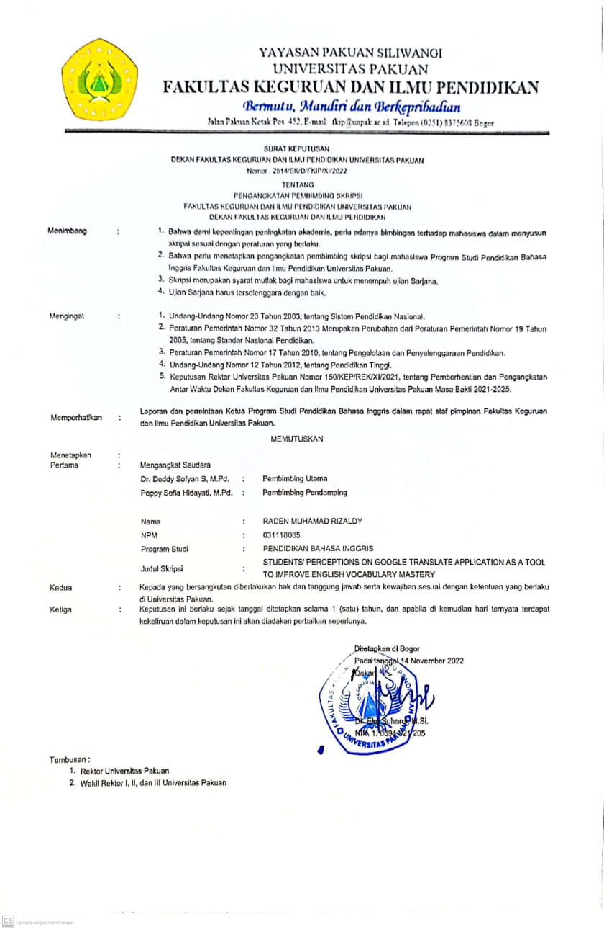

APPENDIX 6
FOTO KOPI BUKTI BIMBINGAN SKRIPSI

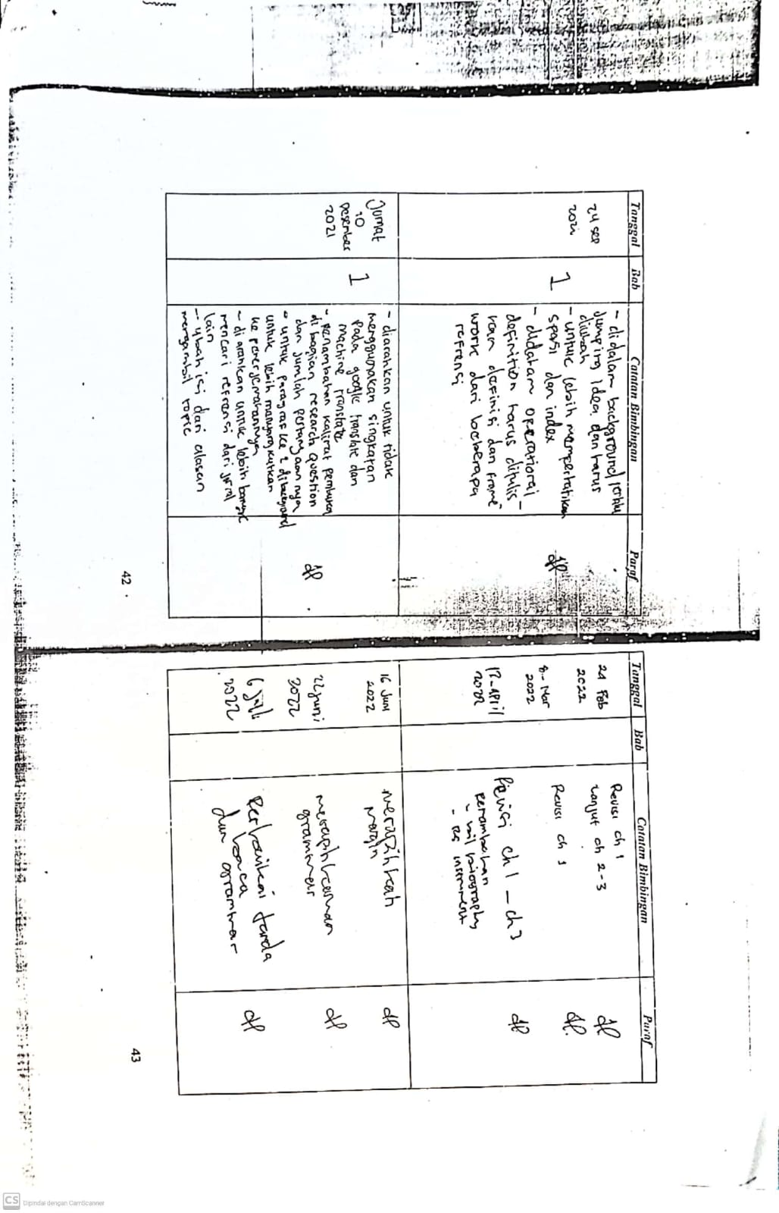

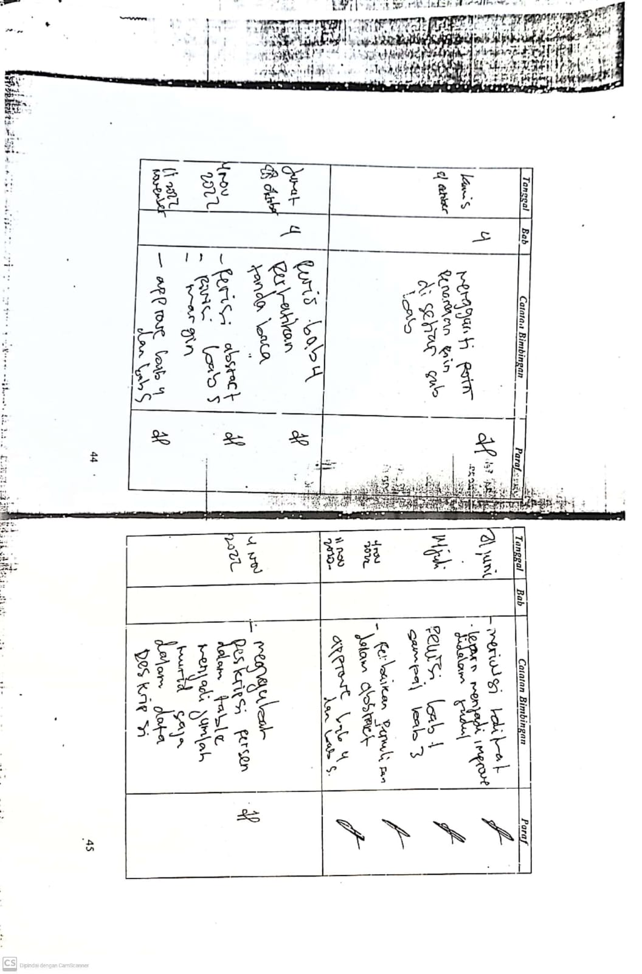

APPENDIX 7
SURAT IZIN PENELITIAN

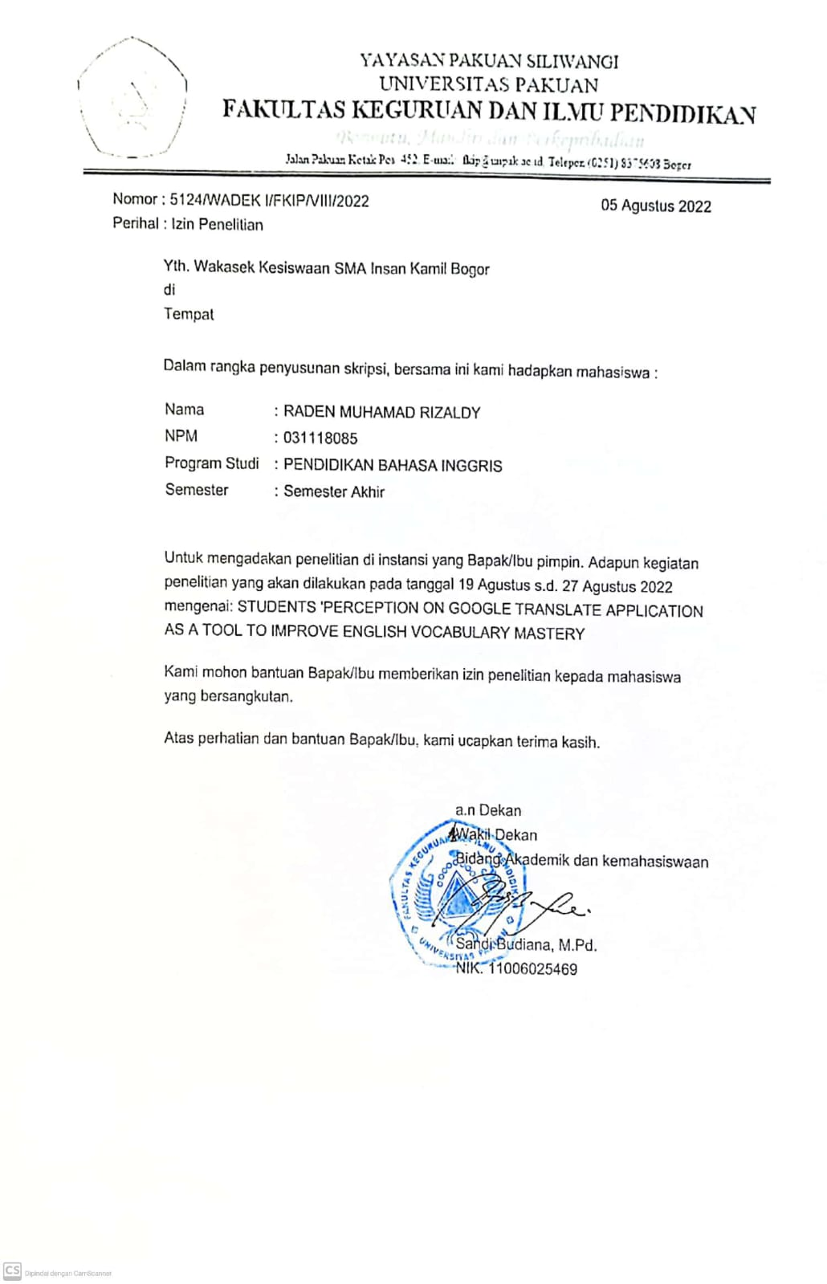

APPENDIX 8
SURAT BUKTI PENELITIAN

