STUDENTS' PERCEPTION TOWARD THE USE OF CAMBRIDGE ADVANCED LEARNER'S DICTIONARY IN PRONUNCIATION CLASS

A Paper
Submitted to the English Language Education Study Program,
Faculty of Teacher Training and Educational Sciences Pakuan University as a
Partial Fulfillment of the Requirement for the Sarjana Pendidikan Examination

By
Icha Ramadhani M
031118025


ENGLISH LANGUAGE EDUCATION STUDY PROGRAM
FACULTY OF TEACHER TRAINING AND EDUCATIONAL SCIENCES
PAKUAN UNIVERSITY
2022

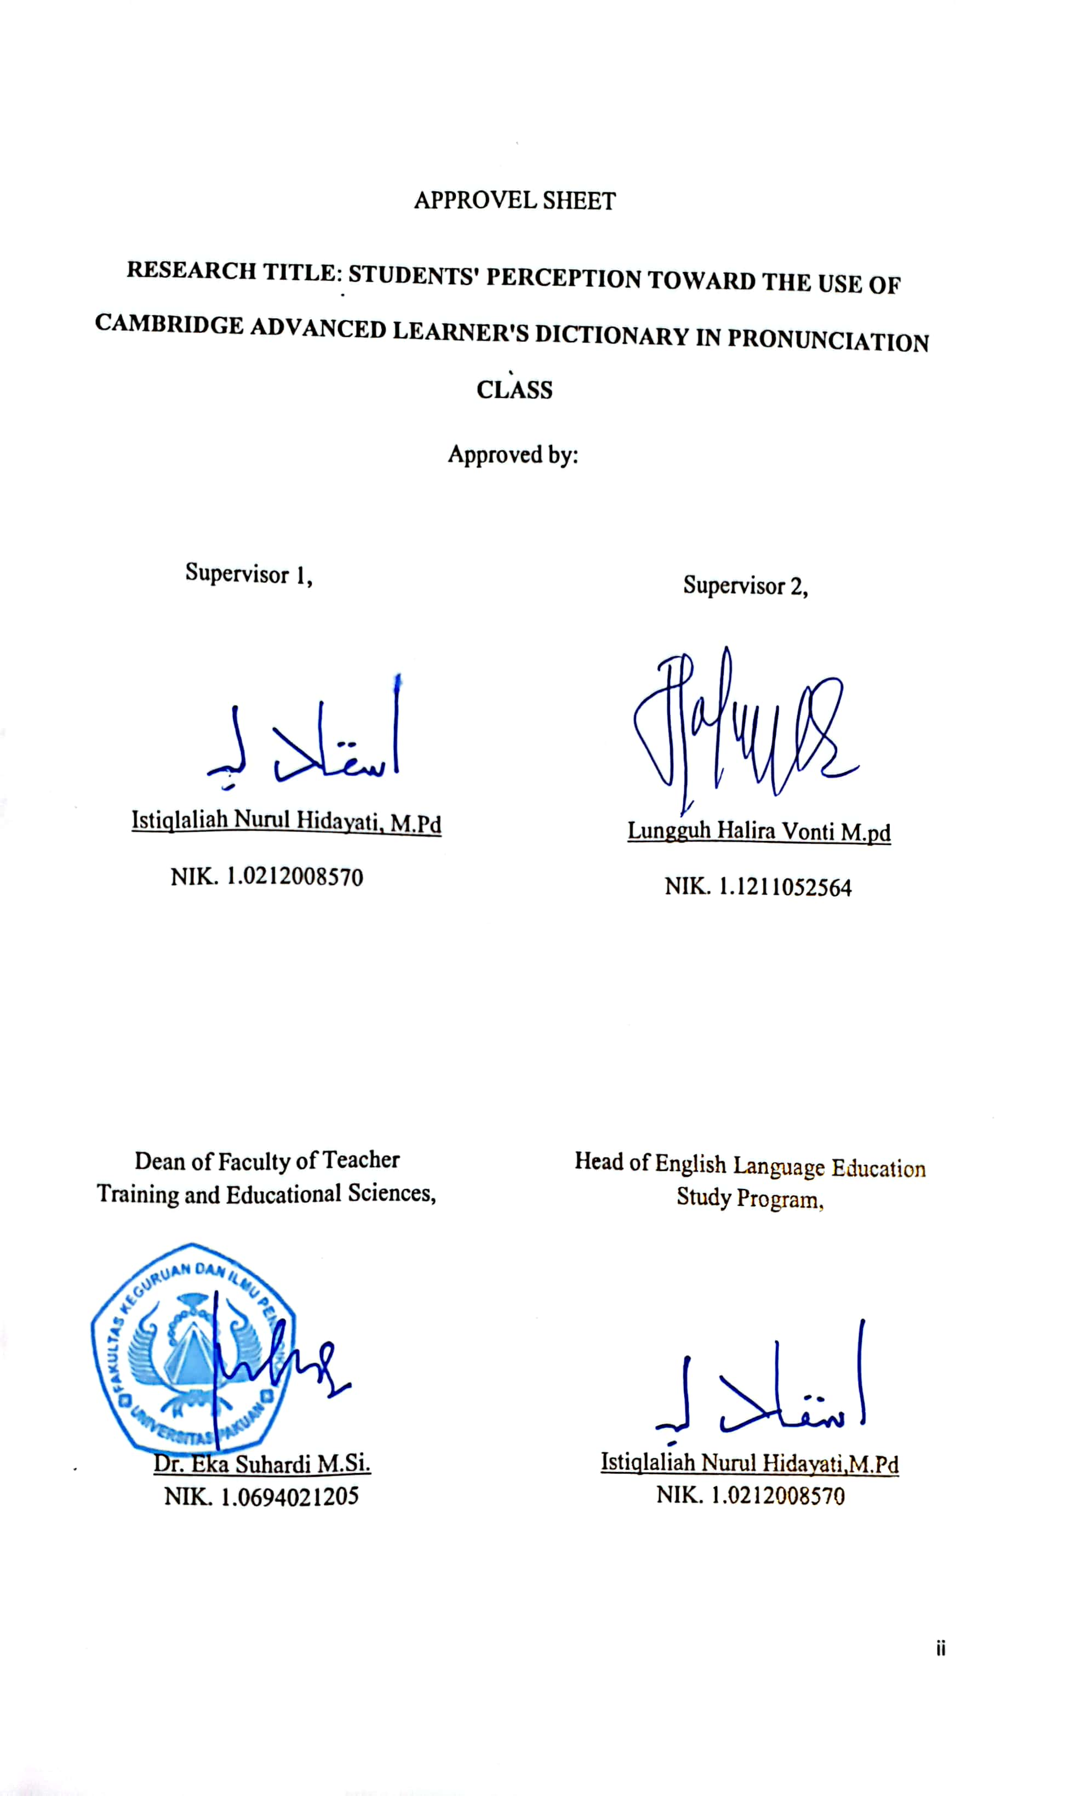
APPROVEL SHEET
RESEARCH TITLE: STUDENTS' PERCEPTION TOWARD THE USE OF CAMBRIDGE ADVANCED LEARNER'S DICTIONARY IN PRONUNCIATION CLASS
Approved by:

Supervisor 1, Supervisor 2,

Istiqlaliah Nurul Hidayati, M.Pd Lungguh Halira Vonti M.pd
NIK. 1.0212008570 NIK. 1.1211052564

Head of English Language Education Study Program,

Istiqlaliah Nurul Hidayati,M.Pd
NIK. 1.0212008570
Dean of Faculty of Teacher
Training and Educational Sciences,

Dr. Eka Suhardi M.Si.
NIK. 1.0694021205

DECLARATION
I hereby declare that the paper entitled “Students’ Perception Toward the Use of Cambridge Advanced Learner’s Dictionary in Pronunciation Class” is completely my own work. I am fully aware that I have quoted some statements and ideas from many resources. All quotations are properly acknowledged in the text. Should there be any claim on the originality of this paper, I would be prepared to take any legal responsibility

Bogor, July 2022

Icha Ramadhani M

PREFACE
Alhamdulillahirabbil’alamin, all praise and gratitude are always delivered to Allah SWT who has given the researcher Mercy and Blessing to complete this paper entitled “Students’ Perception Toward the Use of Cambridge Advanced Learner’s Dictionary in Pronunciation Class”. This paper was submitted to the English Language Education Study Program, Faculty of Teacher Training and Educational Sciences, Pakuan University fulfill partial fulfillment of requirements for the sarjana pendidikan examination.
Even though the researcher has tried to do her best in conducting the research, she realizes that the paper is not perfect. Hence, she accepts any suggesstion and criticisms for her better study in the future. Finally it is expected that the paper will be useful for the researcher and those who read it

ACKNOWLEDGMENT
The researcher would like to express her greatest gratitude to Allah SWT who has given her blessing and mercy to the researcher for finishing her paper entitled,”Students Perception Toward the Use of Cambridge Advanced Learner’s Dictionary in Pronunciation Class”. She also hopes to express her deep and sincere gratitude to those who have supported her in conducting this paper.
The researcher would like to thanks the dean of Faculty of Teacher Training and Educational Sciences Pakuan University Dr. Eka Suhardi M.Si. The appreciation is also given to. Istiqlaliah Nurul Hidayati, M.Pd as the supervisor and head of English Education Study Program who always gives his time to the researcher in finishing the paper. She also expresses her gratitude to Lungguh Halira Vonti, M.Pd as the co-supervisor who always gives her guidance, advice, time, suggestion, and motivation in completing this paper.
The researcher also expresses thanks to Dr. Yanti Suryanti M.Pd as her academic counselor of class B and all of the lecturers of the English Language Education Study Program, Faculty of Teacher Training and Educational Sciences, Pakuan University who has given motivation and knowledge to the researcher in conducting this paper. The researcher thanks all of the students of 4A from the 2020 class for their participation in the process of collecting the data.
Her special gratitude goes to her parents Marjan S.Pd as her beloved father and Siti Maryam as her beloved mother who always give financial support, their prayer, motivation, and their everlasting love until now. The researcher would thank members of BEM FKIP period 2021-2022 who always give her motivation. The last, the researcher would like to thank her beloved friends in the group “anti ghosting”: Liawati, Vinka Putri Milenia, Vina Amelia, Kartini Dewi Apriliani, who always give support in conducting the paper

ABSRACT
Cambridge Advanced Learner's Dictionary online version is an learning media that can help students learn pronunciation, via an internet connection. Students have perceptions about the use of Cambridge Advanced Learner's Dictionary media in pronunciation class. The purpose of this study was to find out how students perception the use of online version of the Cambridge Advanced Learner's Dictionary. The research was conducted in 2nd semester students of English Language Education Study Program. There were 20 students from class 2A who were used as respondents. Researcher used qualitative methods and descriptive analysis to determine perceptions in using the Cambridge Advanced Learner's Dictionary media. The data is obtained by distributing questionnaires, interviews, and focus group discussions with these students. After obtaining and processing the data, the students' perceptions were identified, Cambridge Advanced Learner's Dictionary media can improve their self-ability, and they can find new things in pronunciation. Cambridge Advanced Learner’s Dictionary media can make students aware to sound the word and must be careful so that they do not commit mistakes such as mispronunciation.

Keywords: Cambridge Advanced Learner's Dictionary, students' perception, pronunciation,,

Table of contents
DECLARATION i
PREFACE ii
ACKNOWLEDGMENT iii
ABSRACT vii
Table of contents viii
APPENDICES x
CHAPTER I 1
INTRODUCTION 1
A. Background of the Study 1
B. Reason Choosing the Topic 3
C. Aim of the Research 4
D. Research Question 4
E. Research Focus 5
F. The Operational Definitions 5
G. Significance of Research 6
CHAPTER II 8
THEORETICAL FOUNDATION 8
A. Pronunciation 8
1. Definition pronunciation 8
2. Problem of Pronunciation 9
3. Elements of Pronunciation 10
B. Cambridge Advanced Learner's Dictionary 12
C. Students' Perception 14
1. Definition from students' perception 14
2. Factors Affecting Student Perceptions 16
3. Perception Process 17
D. Related Research 18
CHAPTER III 21
RESEARCH METHODOLOGY 21
A. Research Design and Method 21
B. Research Site and Participants 24
C. Research Instruments 24
1. Questionnaire 24
2. Interview 29
3. Focus Group Discussion 30
D. Research procedure 32
E. Data Analysis 33
CHAPTER IV 34
DATA DESCRIPTION AND ANALYSIS 34
A. Data description 34
1. Data from questionnaire 34
2. Data from interview 40
3. Data from Focus Group Dicussion 49
B. Data Analysis 57
1. Self-ability 58
2. Awareness 59
3. Receives information 61
CHAPTER V 63
CONCLUSION AND SUGGESTION 63
A. CONCLUSION 63
B. SUGGESTION 64
BIBLIOGRAPHY 65
APPENDIX 69

APPENDICES
Appendix 1 Research Instrument Questionnaire Form 69
Appendix 2 The Result of Questionnaire 75
Appendix 3 The Result of Interview 80
Appendix 4 The result of Focus Group Discussion 94
Appendix 5 Guidance decree 101
Appendix 6 News of Guidance 102
Appendix 7 Research Permit 106

CHAPTER I

INTRODUCTION

Background of the Study
English is the most important language in the world (Darsih et al., 2021). Many people use it as a media of communication and it is easier for people who come from countries to interact and communicate with English. English is foreign language that needs to develop because English is also a language that can connect any aspect including the education aspect such as speaking skills.
Speaking is one of productive skills, which must be mastered in learning a foreign language. Fluent speaking skills are actions that produce words that can be understood by the listener. Speaking is one of the basic language skills that have to be mastered by English foreign learners due to it is significant use for communication (Dewi et al., 2016). Teaching speaking is not a simple task, and speaking difficulties are also caused by external factors such as the teacher's work, therefore lecturers need to provide more advanced treatment to students, practice-oriented sessions, and effective ways to implement them such as offering mobile applications that can help students learn and practice speaking (Darsih et al., 2021). In this case teachers have to give more opportunities to their students to express themselves by providing the activities that enable them to speak. Moreover, the problem of speaking English is the lack of vocabulary and also lack of students confidence.
Indonesia is a multicultural country that has many cultural backgrounds with more than hundreds of mother tongues (Saripudin et al., 2020). What is certain is that when Indonesians learn a new language, linguistically the way they learn will be influenced by their tribal language and national language. This condition will lead us to new language problems when the students' learn a new language outside our first language. Problems that usually arise are errors and mistakes in pronunciation. In this study, the researchers deliberately researched students' perceptions of Cambridge Advanced Learner's Dictionary that can help correct errors in the pronunciation of sentences in English. Researchers decided to involve students of the English education class of 2020 who are now in semester 4 in their research because this phenomenon was experienced by them when they were in semester 2.
Based on the researcher, every teacher still uses traditional methods such as speaking practice which only has dialogue in front of the class, then the teacher corrects it directly, but the practice becomes ineffective. English classes tend to show that students only have activities that involve reading and writing skills. There is no adequate practice for students to develop their oral skills so they are not used to speaking and have no motivation. There are many ways to teach speaking. One of them is by using the Cambridge Advanced Learner's Dictionary. This media should be a good activity for students with low speaking skills because in this media there are interesting features so that students immediately know where the pronunciation errors are.

Reason Choosing the Topic
Many people use the English language as a second language in their country to facilitate communication with tourists. In the era of globalization, English plays a key role in many ways: economics, politics, culture, communication, and education. In response to this, therefore in Indonesian. Speaking English is very important to master (Pourhosein Gilakjani, 2011). During online learning, many digital learning media tools are used by teachers to make meaningful learning, especially in speaking skills. There are some reasons why the researcher chooses the topic related to Speaking Skills in Pronunciation and Cambridge Advanced Learner's Dictionary.
First, a speaking skill that needs proper attention due to it is ability to train the students comprehension of Cambridge Advanced Learner's Dictionary can be seen as a proper teaching media since it might be able to give a different atmosphere while learning. In teaching speaking using traditional method such as material from books, they will not be able to know where the mispronunciation error is, then by using Cambridge Advanced Learner's Dictionary students will know where their pronunciation error is then they can make the mistake as an evaluation for themselves, it help students in learning activities in the pronunciation class in online learning (Al Nakhalah, A,M, 2016). The researcher shows no more difficulty when speaking or reading aloud in front of class. The researcher also knew how to speak this sentence with good pronunciation.
Second, the researcher wants to know what makes it difficult for college students' to learn the English language even as a student in college. Sometimes students still lack their speaking skills, especially miss pronunciation. Finally, the researcher wanted to know the students' perception about the implementation of Cambridge Advanced Learner's Dictionary in pronunciation class as their new experience. Another reason is that student answers can be taken into consideration for lecturers to teach. The results of this study are expected to have positive values ​​that strengthen the reasons why students' perceptions need to be known to improve the quality of pronunciation courses.

Aim of the Research
Based on the problem stated, the research aims to find out students' perception about implementation of Cambridge Advanced Learner's Dictionary in pronunciation class.

Research Question
The question of the research is, “How are the students’ perceptions toward the use of Cambridge Advanced Learner's Dictionary in pronunciation class ?”

Research Focus
The perception in this research focuses on the implementation of the online version of the Cambridge Advanced Learner's Dictionary and whether students' understanding of the pronunciation material can motivate their learning method to be able to master the pronunciation material through this online version of Cambridge Advanced Learner's Dictionary.

The Operational Definitions
To support this research, the writer would like to explain terms related to the topic of the research , there are:
- Pronunciation is the way in which language is spoken, the way in which a word is pronounced (Pourhosein Gilakjani, 2011). Intelligible pronunciation is crucial in communicating and to be understood as without “adequate pronunciation skills, a person’s communicative skills maybe severely hampered, and this in turn may give rise to speech that lacks intelligibility, leading to glitches in conversation and to strain on the part of the listener” (Rajadurai, 2006)
- Cambridge Advanced Learner's Dictionary is one of most famous android mobile applications that help people to encourage their confidence in pronunciation skills as well as to hone their speaking skills in front of people (Mohammed Abalkheel, 2020). In Cambridge Advanced Learner's Dictionary there are finding and understanding the right meaning, using words and phrases correctly, Pronunciation in UK and US, Frequency,” and an explanation of numbers that are used as words.
- Students perception is a process that is preceded by the sensing process, which is the process of receiving a stimulus by the individual through the senses or also called the sensory process. According to (Tielsch Goddard & Jo Gilmer, 2015) perception is the process of becoming aware of situations, of adding meaningful associations to sensation. Different perceptions from person to another are influenced by their interests and needs.

Significance of Research
The significance of this research can be practically and theoretically
- Practically
This research is significant to be done since it has benefits for the institution, the lectures and the students’. For the institution to add to the development of knowledge about teaching pronunciation. For the lectures this is an alternative teaching media for teaching pronunciation. For the students’ by knowing Cambridge Advanced Learner's Dictionary it is expected that students will improve their pronunciation independently
- Theoretically
The result of this research is expected to provide ideas for teachers to educate their students’ using Cambridge Advanced Learner's Dictionary as a supporting media for pronunciation class

CHAPTER II

THEORETICAL FOUNDATION
- Pronunciation

Definition pronunciation
Peterson, (2000) states that pronunciation is the act or manner of pronouncing words; utterance of speech, a way of speaking a word, especially a way that is accepted or generally understood, a graphic representation of the way a word is spoken, using phonetic symbols. The following statement is reinforced by Ambarwati & Mandasari, (2020) pronunciation is how a language is spoken and pronounced, that language and the pronunciation of each language is mostly a physical phenomenon, because pronunciation is a part that must be explored in speaking English, especially in everyday conversation.
Clear pronunciation is essential in spoken communication. Even where learners produce minor inaccuracies in vocabulary and grammar (Gilakjani, 2012). As claimed by Kurniawan, (2016) pronunciation is very important because it is the first thing to note about the person's ability to speak.
It indicates that pronunciation focuses on the sounds used to create meaning and too many aspects in pronunciation such as intonation, expression, stress, timing, rhythm, how projective sounds, gestures and expressions are closely related to the way students’ speak the language.

Problem of Pronunciation
Atli & Bergil, (2012) state that Pronunciation is an important element in learning English. This statement as claimed by Isaacs, (2007) that the importance of pronunciation is driven by the increasing number of non-native speakers who have chosen to pursue higher education in English-speaking countries, and who may require adequate mastery of English. According to the above researchers, pronunciation is an important part of language acquisition and they master it for the work they will pursue in the future.
In the world of education students have difficulty pronouncing words in English because their everyday language is Indonesian (Samad & Ismail, 2020), and then emphasized again by Atli & Bergil, (2012) a common problem may be due to the difference in the sound system between Indonesian and English. This significant difference makes Indonesians have to continue to improve their pronunciation in speaking English. The reason students must have a good way of saying a word when they want to be a good speaker is that if students can not pronounce the words in a good way it can make people difficult to understand or even misunderstand (Ambarwati & Mandasari, 2020).
The researcher came to the conclusion according to the experts above that pronunciation problems can come from our mother tongue, namely Indonesian, which in English sounds different. Mother tongue greatly affects our pronunciation when speaking English.

Elements of Pronunciation
In pronunciation there are several elements including, phoneme, consonants, vowels, stress, intonation, and linking sound.
  - Phoneme
Kelly (2000) states the different sounds within a language. Although there are slight differences in how individuals articulate sounds, it means that there will be significant differences between people and the way they articulate the sound, it means that there will be significant differences between people and the way they articulate the sounds. For example American will say /kar/ but British will say /ka:/ Although the word is the same which is car.
  - Consonants
In the report of Indriani (2001), "The English speech sounds can be classified into consonants and vowels' ', and then emphasized again by Kurniawan (2016) consonants are constructed by interfering, restraining, or turning the airflow in various ways.
  - Vowels
According to Rokoszewska, (2012) all of the vowels are voiced sounds, when the mouth produces vowels, it does not need tongue and teeth. Vowel sounds just come out through airflow. By shaping the mouth, it changes the sounds. There are three kinds of vowels; single vowel, diphthong, and triphthong.
Single vowel is the simplest or the shortest one. It is because it is just constructed by one sound. For example /al, /i/, /u/, /el, and /o/. There are two types of single vowels which are long sound and short sound. Example of long sound is /ᶴi.p/ for the word sheep and the example of short sound is /ᶴip/ for the word ship.
Diphthong is a combination of two sounds which are /ail/, /ou/, /əu/, /oi/, etc. For example the /oi/ from the word boy. Triphthong is described by three sounds. For example /eiə/ in air.
  - Stress
Harmer (2007) states that stress is the pattern which is used to show the important syllable in a word or phrase where pitch switches, vowel grows longer and the volume increases. It means that stress is the emphasizing of a word or sentence in speaking which gives rhythm to speech. Stress can be on the first, middle, or last syllable of words.
  - Intonation
Halimah et al., (2018) says that intonation is changing the pitch of the speaker's voice in communicating. It means that intonation is the transformation of voice pitch. Hewing (2004) says that intonation can fall and rise. So the intonation is split into two kinds: falling and rising intonation.
  - Linking sound
Linking sound is a term when two sounds meet and speakers merge it in various ways. There are links /r/, /j,/wl (Gerald Kelly 2000).

- Cambridge Advanced Learner's Dictionary
This Cambridge Advanced Learner's Dictionary is divided into two, in the form of an online version and a print version (Mardiana et al., 2013), Cambridge Advanced Learner's Dictionary is one of most famous android mobile applications that help people to encourage their confidence in pronunciation skills as well as to hone their speaking skills in front of people.
This media is targeting young professionals, high school students’, and college students’. Cambridge Advanced Learner's Dictionary is a media to help everyone develop vocabulary and pronunciation skills (Arimbi & Kwary, 2016). As claimed by (Mohammed Abalkheel, 2020) content in Cambridge Advanced Learner's Dictionary there are finding and understanding the right meaning, using words and phrases correctly, pronunciation in UK and US, frequency,” and an explanation of numbers that are used as words. The CALD also provides a list with accompanying definitions of new words and phrases, followed by lists of geographical names, Suffixes and prefixes, Irregular verb forms and Units of measurement.
On the authority of (Rosita Ambarwati & Mandasari, 2020) CALD applies the sentential definition in about one in six or seven cases. The usefulness of sentential definitions is that they predominate in making meaning more understandable. Therefore, considering the learner's English proficiency level most suitable for this dictionary, this reviewer prefers to use a higher percentage of sentential definitions.
The researcher came to the conclusion based on the experts above that the concept from Cambridge Advanced Learner's Dictionary is a general dictionary but in this online version also provides audio to correct pronunciation and phonetic, then the audio is in UK and US native speakers. Students can know how to pronounce a word in the media. The use of this media is also very practical, the existing features can support their English learning, then this media can enrich their vocabulary too. Cambridge Advanced Learner's Dictionary provides several features designed to hone students' speaking skills, namely dictionaries, audio correction, and thesaurus. Each of the main features has interesting content and can be studied over and over again to hone these speaking skills.

- Students' Perception
      - Definition from students' perception
Definition from students’ perception as said by Sari & Nayır (2020) is a process that is preceded by the sensing process, which is the process of receiving a stimulus by the individual through the senses or also called the sensory process. According to (Tielsch Goddard & Jo Gilmer, 2015) perception is the process of becoming aware of situations, of adding meaningful associations to sensation. Different perceptions from person to another are influenced by their interests and needs.
In the opinion of Joseph Reitz (2015), students’ perception includes all those processes by which an individual receives information about his environment, seeing, hearing, feeling, tasting, and smelling. The above statement is reaffirmed by Agung & Surtikanti (2020), that perception is the experience of objects, events, and things that are obtained by continuing information and interpreting messages, then it can give meaning to stimulus-response in continuing information and predicting messages involving attention, expectations, motivation, and memory.
There are individual differences in perceptual abilities. Two people may perceive the same stimulus differently (Zakaria et al., 2017). The way people see the world around them greatly influences what the students’ focus on and what the students’ ignore (Popovici & Mironov, 2015). Therefore, there are several factors that work to shape and sometimes distort perception. When a student looks at the target and tries to interpret what the student interprets it is strongly influenced by the personal characteristics of that student's perceiver. As affirmed by vilijoen, (2003) personal characteristics of student perceptions include attitudes, moods, motives, self-ability, interest, and cognitive structure. Perception is people's sensory experience of the environment around them (Agung & Surtikanti, 2020). The students obtain information about the properties and elements of the environment and process it through perceptual processes.
Based on the description below, it can be concluded that perception is people's opinion about the process of becoming aware of situations, of adding meaningful associations to sensation, thought and feeling which is obtained through human sense. The things that are sensed by people are processed into those opinions, thoughts and feelings. All of this can be influenced by people's environment. Students’ perception is the process of receiving stimulus from students, the processes such as receiving information, feeling the surrounding environment, seeing, hearing, then being processed by the brain. Perception is known as stimulus and nature, can be associated with self-ability, which is derived from the relationship with dimensions, emotional, intellectual, and physical.

      - Factors Affecting Student Perceptions
According to research Miftah Toha (2003) perception can be divided into two factors, namely internal and external. Internal factors include feelings, attitudes and individual personalities, prejudices, desire or expectation, attention (focus), learning process, physical state, mental disorders, values and needs as well as interests, and motivations, while the external factors are related to family background, information obtained, knowledge and needs around, intensity, size, opposites, repetition of motion, new and familiar things or unfamiliar objects. The following statement is reinforced by Walgito (2003) factors that play a role in perceptions can be expressed by several factors, including::
        - First perception of perpetrators
First perception of perpetrators is that an individual's interpretation will be very heavy on an object because personal characteristics greatly influence it, such as attitudes, motives, interests or past experiences, and individual expectations will not be satisfied and have a strong drive to affect a person's perception.
        - Second targets or object of perception
It means that the object of motion, sound, size, and attributes will shape the way we see it. The object creates a stimulus that hits the sense organs or receptors. For example, when someone sees an image, the perspective will be different from the others.
        - Sense
Sensory devices or receptors are tools to receive stimuli, besides that there must also be sensory nerves as a tool to transmit the stimulus received by the receptor to the central nervous system, namely the brain as the center of consciousness. As a tool to make a response, a motor is needed that can shape one's perception.
        - Attention
To realize or to make a perception requires attention, which is the main step as a preparation in order to make a perception. Attention is the concentration or concentration of all individual activities aimed at a set of objects. These factors make individual perceptions different from each other and will affect individuals in perceiving an object, a stimulus, even though the object is really the same.
      - Perception Process
According to Miftah Toha (2003) the process of forming perceptions based on several stages, including
- Stimulus
The occurrence of perception begins when a person is faced with a stimulus that comes from his environment.
- Registration
In the registration process, a symptom that appears is a physical mechanism in the form of sensing and a person's requirements through interesting sensory devices. The people can listen or view the received information, then list all the information sent.
- Interpretation
Interpretation is a very important cognitive aspect of perception, namely the process of giving meaning to the stimulus it receives. The interpretation process relies on a person's way of deepening, motivation, and personality.

- Related Research
Here are the studies that the researcher found to support the similar variables to be sources for conducting the current research. First this research related to Samad & Aminullah (2019) entitled Applying ELSA Speak Software in the Pronunciation Class: Students’ Perception. The research is aimed to find the perception of students on the media name elsa speak in pronunciation class. Researchers consider that pronunciation as a communication tool must be done intensively. Therefore, the learning method must be changed. The researcher stated that the problems faced by students based on their perceptions needed the media to help them in learning pronunciation. Researchers used qualitative methods to analyze cases. The results of this study saw that students agreed that the Elsa Speak application was very helpful in learning pronunciation.
Second, this research related to Ambarwati & Utami (2022) entitled Improving Students Pronunciation and Vocabulary Through Cambridge Online. The purpose of the researcher is to analyze the influence of using Online Cambridge Dictionary toward students' pronunciation and vocabulary. The researcher conducted the research at a writing class sample with 25 participants. Using this dictionary hopefully can help us to know how to pronounce words in a better way and enrich our vocabulary. Online Cambridge dictionary has become one of the best dictionaries that students can use in the class. The results of this study, the researcher found that the existence of the online dictionary is important for English learners, especially for the online Cambridge dictionary but, the students or the participant only access that website or application only at the time that they want. They do not often use this dictionary. It means they only use this application when they need it.
Therefore, it will take them a long time to properly learn vocabulary and pronunciation. The researcher suggests that participants can often use the dictionary to make sure they really get the benefit from using this online dictionary. The Online Cambridge dictionary is very good to use as a media to support speaking classes. This provokes students to learn actively and happily in class. They don't have to worry about making mistakes during speaking practice because the app gives them real-time feedback and advises them on what to do.
Third, this research related to (Rahmania & Mandasari, 2021) entitled Students' Perception Towards the Use of Joox Application To Improve Students' Pronunciation. The research is aimed to analyze perception students the use of Joox application in pronunciation class. Regarding research questions about student perception on the application of Joox to imptove students pronunciation, the researcher getting a good response from students, positive responses were given by students to the application of Joox To Improve Students' Pronunciation. They said that when they learned to use the Joox application, it really helped them to have the courage to speak and pronunciation. All students answered that the application of the Joox to improve pronunciation was useful, they said that the Joox application could be used to improve pronunciation, besides that this application was easy to use and fun because it was the first time using it. Researchers used qualitative methods to analyze cases. The results of this study saw that students agreed that the Joox application was very helpful to imptove pronunciation.

CHAPTER III

RESEARCH METHODOLOGY
- Research Design and Method
The aim of this research is to find out students' perception toward the use of Cambridge Advanced Learner's Dictionary in pronunciation class. This research uses a qualitative approach based on the general of the research the study categorized as the descriptive research methodology. According to Creswell (2009) qualitative research begins with assumptions about the research problem that investigates the meaning of individuals or groups that originate from social or human problems. This statement was reinforced by Ary et al (2010) qualitative research presents a description of situational setting and participants’ activities in form of sentences rather than numerical data. It means that descriptive qualitative research can be used to describe the students' perception toward the Use of Cambridge Advanced Learner's Dictionary in Pronunciation Class.
In this research, the researcher uses triangulation based on different methods of data collection. There are questionnaires, interviews, and focus group discussion. A questionnaire will be given to students. In-depth interviews will be given to students based on the results of the most questionnaires whether the answers are more negative or positive about CALD. The focus group discussion will be held to cross check the answers obtained from the other instruments, with the aim of increasing the accuracy of the research results. Focus group discussion that was conducted in a virtual meeting with chosen participants who have done the interview. Researchers can find perception in students after the students have used Cambridge Advanced Learner's Dictionary in learning pronunciation. Analyzing questionnaire responses is one method to facilitate researchers in analyzing student perceptions of the use of Cambridge Advanced Learner's Dictionary media in pronunciation class. Researchers can find the impact of Cambridge Advanced Learner's Dictionary for students in pronunciation class.

Identifying social phenomenon
Investigating Students’ perception toward the use of Cambridge Advanced Learner's Dictionary in Pronunciation Class

Constructing Research Question
“What is students’ perception toward the use of Cambridge Advanced Learner's Dictionary in pronunciation class?

Determining Research Focus
This research focuses on the students’ perception toward the use of Cambridge Advanced Learner's Dictionary in pronunciation class as a learning aid media in pronouncing sentences that have the same sound and different meaning

Choosing Site and Participant
The research is conducted in Pakuan University and the participants are 4th semester students who have used the Cambridge Advanced Learner's Dictionary in learning pronunciation in the 2nd semester.

Making the Instruments
Identifying indicators

Conducting the Research
Distributing questionnaire  Analyzing the answer of questionnaires that were given to the participants | Interview In the students  Transcribing record of an interview about students perceptions into the transcript | Focus group discussion  Cross check the answers that have been answered through the other instruments

Validating Data

Drawing Conclusion and Suggestion

Figure 3.1
Research design

- Research Site and Participants
This research will be conducted at the English Language Education Study Program of Faculty of Teacher Training and Educational Sciences, Pakuan University. The participants in this research are the students in the 4th semester of the English Language Education Study Program. The total number of students’ in class 4A is 20 students. The researcher will take 4A students who have experienced using Online Cambridge Dictionary in 2nd semester. The participants are selected by using the purposive sampling technique. This is a way to select samples based on specific objectives.
- Research Instruments
This research is a qualitative research study, this research will use non-test instruments. The non-test instruments are questionnaire, students’ interview and focus group discussion.
      - Questionnaire
The first instrument is a questionnaire. The purpose of the questionnaire is to get the data about students' perception of the use of Cambridge Advanced Learner's Dictionary in the pronunciation class as a learning aid in vowel sounds. The researcher used closed-ended questions. Lidiana (2011) suggests closed-ended questions be more specific. The researcher adapted Linkert scales which are SD (strongly Disagree), D (Disagree), N(Neutral), A(Agree), SA (Strongly Agree). The instruction of the questionnaire is putting a tick (Ѵ) to the degree of agreement based on the students' opinions. Then the data interpreted by the researcher. The questionnaire format is drawn as follows:

Table 3.1
Questionnaire form
Indicators | no | Statement | SA | A | N | D | SD
SELF-ABILITY | 1 | Belajar pronunciation membutuhkan media pembantu untuk meningkatkan kemampuan diri saya
 |  | Cambridge Advanced Learner’s Dictionary menjadi media pendukung yang cocok untuk belajar pronunciation
 | 3. | Cambridge Advanced Learner’s Dictionary dapat membuat saya lebih percaya diri di kelas pronunciation
 | 4. | Cambridge Advanced Learner's Dictionary efektif untuk membantu saya mempelajari pengucapan.
 | 5. | Saya merasa kemampuan diri saya tentang pronunciation meningkat sejak menggunakan aplikasi Cambridge Advanced Learner's Dictionary
AWARENESS | 6. | Setelah menggunakan Cambridge Advanced Learner’s Dictionary saya menjadi sadar bagaimana  cara membunyikan suatu kata dengan benar
 | 7. | Setelah menggunakan aplikasi Cambridge Advanced Learner’s Dictionary saya menjadi sadar bagaimana cara membedakan bunyi kata yang hampir sama (homophone) seperti contoh to/two/too
 | 8. | Setelah menggunakan Cambridge Advanced Learner’s Dictionary saya menjadi sadar bahwa mempelajari pronunciation itu harus menggunakan media pembantu supaya bunyi yang kita pelajari benar pelafalanya.
 | 9. | Setelah menggunakan Cambridge Advanced Learner’s Dictionary saya menjadi sadar bagaimana berbicara menggunakan bahasa inggris dengan pronunciation yang benar.
 | 10. | Setelah menggunakan Cambridge Advanced Learner’s Dictionary saya menjadi sadar bagaimana saya meningkatkan kemampuan saya dalam pronunciation
RECEIVES INFORMATION | 11. | Saya mendapatkan pengetahuan tambahan dari penggunaan Cambridge Advanced Learner’s Dictionary
 | 12. | Pada saat pembelajaran secara asynchronous, melalui Cambridge Advanced Learner’s Dictionary saya dapat memahami materi tanpa kesulitan.
 | 13. | Melalui Cambridge Advanced Learner’s Dictionary saya termotivasi untuk menemukan hal yang baru tentang materi pronunciation.
 | 14. | Melalui CALD saya mudah dalam mengoreksi pronunciation anda
 | 15. | Sebagian besar pengucapan yang benar terbantu melalui Cambridge Advanced Learner’s Dictionary

      - Interview
Interviews will be conducted with students using a guided interview form to obtain information about perceptions toward the use of the Online Cambridge Dictionary. The interview will be conducted who have different answers, namely agree, disagree, and neutral. In addition, it is used to validate the data collected from the questionnaire that has been filled out by the students’. The information will be recorded using a recorder. The questions for the interview were made as follows:

Table 3.2
Question form for students
Indicators | No | Question | Explanation
Self-ability | 1. | Bagaimana anda meningkatkan kemampuan diri anda menggunakan CALD
Self-ability | 2. | Apakah media CALD ini dapat membantu anda dalam memahami materi materi pronunciation , jelaskan menurut anda
Self-ability | 3. | Apakah setelah menggunakan media CALD kepercayaan diri anda untuk membunyikan suatu kata menjadi meningkat ? jelaskan
Awareness | 4. | Apakah setelah anda menggunakan aplikasi CALD membuat kamu menjadi lebih hati-hati dalam membunyikan suatu kata, mengapa dan jelaskan
Receives information | 5. | Melalui CALD apakah anda dapat menemukan hal yang baru dalam pronunciation, seperti pengucapan kata kata yang memiliki suara yang sama (homofon)
Receives information | 6. | Bagaimana pendapat anda setelah menggunakan CALD , apakah kemampuan anda dalam teknik pronunciation meningkat dengan fitur yang ada di CALD, jelaskan?

      - Focus Group Discussion
The next step, the researcher will conduct a focus group discussion to cross check the results of previous studies. There are two ways to analyze focus group discussions the main options are inductive content analysis (conventional content analysis) and deductive content analysis (directed content analysis), the form of the content analysis approach can be chosen according to the research objectives and the problem to be studied (Moretti et al., 2011). Focus group discussions are held using platform online virtual meetings and involve 6 students in one group.
The datas are gathered by video recording during the sessions and transcribed into words. The researcher is a moderator/facilitator which means the researcher leads the discussion, delivers the discussion’s topic, and purpose, and asks all participants questions that relate to the topic.

Table 3.3
Question form for students
Indicators | No | Question | Explanation
Self ability | 1. | Apakah media CALD ini dapat membantu kamu dalam memahami materi materi pronunciation , jelaskan menurut anda
Self ability | 2. | Bagaimana anda meningkatkan kemampuan diri anda menggunakan CALD
Self ability | 3. | Apakah setelah menggunakan media CALD kepercayaan diri anda untuk membunyikan suatu kata menjadi meningkat ? jelaskan
Awareness | 4. | Apakah setelah anda menggunakan aplikasi CALD membuat kamu menjadi lebih hati-hati dalam membunyikan suatu kata, mengapa dan jelaskan
Receives information | 5. | Melalui CALD apakah anda dapat menemukan hal yang baru dalam pronunciation, seperti pengucapan kata kata yang memiliki suara yang sama (homofon)
Receives information | 6. | Bagaimana pendapat anda setelah menggunakan CALD , apakah kemampuan anda dalam teknik pronunciation meningkat dengan fitur yang ada di CALD, jelaskan?

- Research procedure
There are several procedures that will be carried out by researchers to obtain data for this study, such as:
      - The researcher will contact the 4th semester student of class A to get permission to be a participant in this study.
      - Researchers will distribute questionnaires containing statements related to students' perceptions of the application of Online Cambridge Dictionary in learning pronunciation.
      - After distributing the questionnaire, the researcher will select several students who give positive and negative perceptions to conduct oral interviews to obtain information related to the research,
      - Next step the researcher will ask for documentation in the form of the final score from the student to the lecturer in charge of the pronunciation course at that time.
      - The researcher will conduct interviews with the students who gave the most answers, whether it is a positive or negative statement about this CALD.
      - The next step, the researcher will conduct a focus group discussion to cross check the results of previous studies.
      - Researchers will make a research report after collecting and analyzing data consisting of research findings, research results, and conclusions using qualitative descriptions
- Data Analysis
      - Questionnaire
Students’ answers in the questionnaire were analyzed by using google form. The data collected from the questionnaire is analyzed and described in a form of paragraph. In analyzing the questionnaire, the reliability of questionnaire is counted as follows:
        - counting every answer of the questionnaire to determine the frequency
  - counting the percentage by using ∑ 𝑥 / n. 100%
Note: ∑ x =total of the respondents who have a similar degree
∑n= total of the participants
  - describing the data from the questionnaire.
2. Interview
The data collected from the interview is analyzed by transcribing. Additionally, the researcher will use member checking to validate the data from interview
3. Focus group discussion
The data collected was made to validate the results of the interview and then analyzed by the researcher to get a conclusion from the research. After the data is gained, all the information is transcribed from the video recording. Furthermore, the data gained from students’ opinions are classified, then the researcher described the transcribed result according to the students perception toward the use of CALD in pronunciation class.

CHAPTER IV

DATA DESCRIPTION AND ANALYSIS

Data description
- Data from questionnaire
The first data was taken from questionnaire, it was filled out by 20 students from the fourth semester English Education Study Program, Faculty of Teacher Traning and Educational Sciences, Pakuan University. The questionnaire was distributed in the form of a google form, the distribution of the first questionnaire has been carried out on Friday, June 17, 2022 at 07.00 am, until June 19, 2022 at 19:24 and has been filled out by 20 respondents This questionnaire is the first step to obtain information about students' perceptions of the use of the Cambridge Advanced Learner's Dictionary in pronunciation class..
This questionnaire consists of 15 questions and is based on 3 indicators, whils has five statements. There are 3 indicators in the questionnaire, namely self-ability, awareness, and receives information. The Questionnaire given was in closed ended form. Before distributing the questionnaire, the researcher contacted the class leader first to coordinate so that the delivery of information was comprehensive.
- Self-ability
There were five questions related to the first indicators. Based on the result from the first statement, it shows that sixteen students (80%) choosing "strongly agree", four students (20%) choosing "agree", this shows that students feel learning pronunciation requires auxiliary media to improve their abilities. On the second statement, there were eleven students (55%) choosing "strongly agree", nine students (45% ) choosing "agree". These result show that Cambridge Advanced Learner’s Dictionary (CALD) media is one of the supporting media that is suitable for learning pronunciation.
On the third statement it shows that ten students (50%) choosing "strongly agree", seven students (35%) choosing "agree", and three students (15%) choosing "neutral" from the statement above it means that most all of them students feel Cambridge Advanced Learner’s Dictionary (CALD) can make students more confident when in pronunciation class. On the fourth statement, there were thirteen students (65%) choosing "strongly agree", seven students (35% ) choosing "agree", these results mean Cambridge Advanced Learner’s Dictionary (CALD) media is effective and plays a role in helping students learn pronunciation.
On the last statement for indicators self-ability shows that six students (30%) choosing "strongly agree", eleven students (55%) choosing "agree", and three students (15%) choosing "neutral" from the statement above it means that most all of them students feel that since using Cambridge Advanced Learner’s Dictionary (CALD) their pronunciation skills have increased.
Based on the analysis of the first indicator in the questionnaire, this study shows that pronunciation learning requires auxiliary media to improve students' abilities and CALD is one of the auxiliary media that students can use in pronunciation learning activities. Most of them feel that the use of CALD can improve their confidence and other pronunciation skills. Students also feel that the use of CALD is quite effective, because it improve their self-ability.
- Awareness
There were five questions related to the second indicators. Based on the result form the sixth statement, it shows that thirteen students (65%) choosing "strongly agree", seven students (35%) choosing "agree". The following results show that students become aware of how to sound a word correctly after they use the Cambridge Advanced Learner's Dictionary media. On the seventh statement, there were fifteen students (75%) choosing "strongly agree", four students (20%) choosing "agree", and one student (5%) choosing neutral. The results above mean that after using the Cambridge Advanced Learner's Dictionary application, almost all students become aware of how to distinguish the sound of words that are almost the same (homophone) such as the example of to/two/too.
On the eighth statement it shows that fourteen students (70%) choosing "strongly agree", five students (25%) choosing "agree", and one student (5%) choosing "neutral". According to the results of the questionnaire in this eighth statement, almost all students answered that after they used the Cambridge Advanced Learner's Dictionary (CALD) students became aware that learning pronunciation had to use auxiliary media so that the sounds they learned were correctly pronounced. On the ninth statement, there were fifteen students (75%) choosing "strongly agree", four students (20% ) choosing "agree", and one student (5%) choose "neutral". These results show that after using the Cambridge Advanced Learner's (CALD) Dictionary most of all students become aware of the mistakes they always make in sounding a word or sentence.
On the last statement for indicators awareness show that ten students (50%) choosing "strongly agree", eight students (40%) choosing "agree", and two students (10%) choose "neutral". Based on the statement above it means that most all of them students after using the Cambridge Advanced Learner's (CALD) Dictionary students become aware of how they can improve their pronunciation skills.
Based on the analysis of the results of the questionnaire on the awareness indicator that almost all students after using the Cambridge Advanced Learner's Dictionary students are aware that to learn pronunciation they need auxiliary media to sound a word correctly so that the pronunciation is correct because there are several sound words that are almost the same but have different meanings and students are also careful in this regard. Students also become aware of how to speak English correctly.
- Receives information
There were five questions related to the third indicators. According to the eleventh statement, it shows that ten students (50%) choosing "strongly agree", eight students (40%) choosing "agree", and two students (10%) choosing "neutral", from the above result it means that almost all students get their additional knowledge from the use of Cambridge Advanced Learner’s Dictionary (CALD). On the twelfth statement, there were eight students (40%) choosing "strongly agree", seven students (35%) choosing "agree", and five students (25%) choosing "neutral". The results of this twelfth statement, almost all students during asynchronous learning can understand the material without difficulty through the help of Cambridge Advanced Learner’s Dictionary (CALD).
On the thirteenth statement it shows that ten students (50%) choosing "strongly agree", seven students (35%) choosing "agree", and three students (15%) choosing "neutral". These results show that through Cambridge Advanced Learner’s Dictionary (CALD) most of them students are motivated to find new things about pronunciation material. On the fourteenth statement, there were nine students (45%) choosing "strongly agree", nine students (45% ) choosing "agree", and two students (10%) choosing "neutral. Based on the above results, almost all students feel that Cambridge Advanced Learner's (CALD) helps correct pronunciation both in parquet and daily learning.
The last statement for indicators receives information shows that twelve students (60%) choosing "strongly agree", six students (30%) choosing "agree", and two students (10%) choosing "neutral". The following results show that almost all students feel most of the correct pronunciation is helped through the Cambridge Advanced Learner's Dictionary media.
Based on the questionnaire data in the indicator of receiving information, students get some additional knowledge through this CALD media. Students' perceptions toward the use of Cambridge Advanced Learner's (CALD) media they felt this media could help them provide information if their pronunciation was wrong, besides that almost all students felt they received information about the pronunciation material toward Cambridge Advanced Learner's Dictionary (CALD).
- Data from interview
The second data taken is the interview. Researchers conduct interviews to get in depth answers, the interview is carried out by students who have filled out the questionnaire, the implementation of the interview activity was only attended by a few students who had been pursed, the narrowing is done by filtering the results from the answers to the questionnaire whose answers represent all the respondents. In the questionnaire data collection that has been carried out there are three kinds of answers from the questionnaire which were distributed three days ago. There are, students who answer mostly strongly agree and agree, and then the students who answer neutral..
The interview was conducted on June 21, 2022 to June 23, 2022. This data collection is carried out using zoom meeting application and then recorded by the researcher. The form of questions in this interview is open-ended with a total of six questions with the same indicators as the questionnaire, namely self-ability, awareness, and receives information.
- Self-ability
The first question was to find out how students can improve students' self ability in using the Cambridge Advanced Learners Dictionary. All respondents (#R1, #R2, #R3, #R4, #R5, dan #R6) claimed that the way this CALD media improves students' self-ability is in the audio feature, when they find it difficult or don't know how to pronounce a word they use CALD media to help them and it can improve their abilities. It can be seen based on the interview result of #R2 excerpt #1
Pertama karena dosen saya menyarankan hal tersebut saya sangat senang sekali Akhirnya saya bisa meningkatkan kemampuan diri saya karena di CALD ini banyak banget manfaatnya seperti cara membunyikan pronunciation, dan ada dua tipe suara yaitu american dan british dan juga saya bisa mencatat vocab vocab saya yang memang saya kurang tahu cara membunyikannya, saya tulis di buku terus, terus baru saya Klik di aplikasi atau di laptop saya cara mengeluarkan pronounciationnya baru saya praktekkan dan akhirnya pronunciation saya meningkat
[First, because my lecturer suggested this, I am very happy. Finally I can improve my skills because in CALD there are many benefits, such as how to sound pronunciation, and there are two types of sounds, namely american and british and also I can note down the vocabs that I do not knowhow to sound it, I write it down in a book, then I just click on the application or on my laptop, how to say the pronunciation, I just practiced and finally my pronunciation improved]

Meanwhile there is also one respondent who feels that it is not very significant and efficient in helping to improve self-ability, because it is only for searching words and listening to the audio. It helps but does not significant . It can be seen based on the interview result of #R6 in excerpt#2
Menurut saya sangat tidak begitu signifikan membantu saya dalam pronunciation bagaimana saya mengucapkan sebuah kata kan , menurut saya pribadi si membantu tapi tidak se efesien itu misalkan saya lagi nyari satu kata atau word kan disitu kayak ada bisa pake suara juga kan jadi kita kayak bisa menirukan apa yang keluar dari audionya .

It means that using this CALD media students can improve their abilities through the audio in CALD as if they want to find a word they can find out how to pronounce it correctly. It can mean how students improve their abilities through the features in CALD.
The second question in the self-ability indicator is whether this CALD media can help students understand the pronunciation material. All respondents (#R1, #R2, #R3, #R4, #R5, and #R6) stated that this CALD media can help students understand the material given by the lecturer, most of the students find it helpful when they want to understand or know phonetic of the word. It can be seen based on the interview result of #R5 excerpt #3
Dapat sih fonetik fonologi nya ya jadi pas kita buka dari CALD nya juga mengingatkan kembali lagi kemampuan kita dan mengingatkan kembali materi materi yang diajarkan, kayak kita kan udah dapet basic nya nih jadi kita lebih meningkatkan lagi setelah di bantu oleh Cambridge ini
[Can understand, phonological phonetics, so when we open it from CALD it also reminds us of our abilities and reminds us of the material being taught, as if we already got the basics, so we can improve it even more after being helped by this CALD]

It was also supported by the statement of #R1 in excerpt #4
ini membantu sekali buat aku karena emang butuh banget ya teh, ini kalo misalkam kita ngeliat cuman kata doang gitu kita belum tentu benar bacanya tapi dengan CALD ini kita jadi tahu phoneticnya terus kita bisa mendalami nih, sekalian kita mendalami materi kita gitu
[This is very helpful for me because I really need it, for example, if we look at just words, we don't necessarily read it correctly, but with CALD we know the phonetic and we can explore it, and explore our material]

It can be interpreted that this CALD media can help students understand the pronunciation material provided by the lecturer, one way is by using or utilizing the sound features in CALD, students feel that if they feel they don't know how the word sounds, they open this CALD media
The third question on the self-ability indicator is whether after using CALD media students' self-confidence to sound a word increases. All respondents (#R1, #R2, #R3, #R4, #R5, and #R6) stated that this CALD media could help increase their self-confidence, which at first they felt insecure in sounding a word for fear of mispronunciation, but after using CALD media they feel more confident, because they can correct the pronunciation first, and when they make mistakes they can evaluate the mistakes in their pronunciation. It can be seen based on the interview result of #R5 excerpt #5
Nambah sih kalau misalnya dulu kan kurang pede dengan menyebutkan satu kalimat kata secara langsung dikepala gitu karena karena takut salah pronunciation karena semakin sering terbiasa dengan kata kata yang familiar, kata kata common word lah gitu, nah pas buka pronunciationya di CALD terus tau pronunciation yang bener jadi pede aja gitu sekarang dalam berbicara bahasa Inggri.
[It adds confidence, for example, in the past, I was not confident enough to mention one sentence directly in my head because I was afraid of wrong pronunciation because more and more I got used to familiar words, common words are like that, now when I open the pronunciation in CALD I keep knowing correct pronunciation, so I am confident now in speaking English]

It means, this CALD media can increase their confidence, in the past they did not feel confident to pronounce a word out loud then they became confident, because they can find out their pronunciation mistakes through this CALD media. It shows CALD can improve their self-ability.
- Awareness
The interview question on the awareness indicator is to find the answer whether CALD media can make students be careful in sounding a word, and students explain the reason according to their opinion. All respondents (#R1, #R2, #R3, #R4, #R5, and #R6) stated that this CALD media made them more aware, because previously they just said the words without making sure whether their pronunciation was correct or not, they become aware that a wrong pronunciation can change the meaning of a word. It can be seen based on the interview result of #R2 excerpt #6
iyaa.. eeu.. dari aplikasi CALD ini Tentu saya apa ya saya percaya diri dan saya berhati-hati dalam ucapan karena pronunciation itu sebenarnya penting ya, kalau misalkan logat itu misalkan dari suku jawa atau dari suku Sunda itu tidak masalah tapi pronunciationya itu yang jadi permasalaan, karena jika bunyinya itu berbeda atau bunyinya sama tapi dari katanya berbeda itu dapat menyalahkan arti teh dalam mempronunciationkan word, makanya aplikasi atau media CALD membuat saya menjadi lebih hati hati.
[Yes.. eeu.. from this CALD application Of course I am, I am confident and I am careful in my speech because pronunciation is actually important, for example, if the accent is Javanese or Sundanese, it doesn't matter, but the pronunciation is what matters so the problem is, because if the sound is different or the sound is the same but the word is different, it can blame the meaning of tea in pronouncing the word, so CALD applications or media make me more careful]

It was also supported by the statement of #R6 in excerpt #7
kayak even sama event tuh jadi saya tahu cara membedakan apa ya cara cara pengucapannya mereka tuh punya kata yang sama tapi beda meaning, nah imam jadi lebih hati hati tapi tetep karena itu jadi lebih percaya diri karena tau letak kesalahanya
[such us an event and an event, after that I know how to tell the difference, how to pronounce it, they have the same word but different meaning, so the priest is more careful but still, because of that, he becomes more confident because he knows where the mistake is]

It can be interpreted through CALD media, students have the awareness to be careful in pronouncing a word, but it does not reduce their confidence because they can correct directly if they pronounce a word wrong. Their mistakes will be an evaluation for themselves so that in the future if they want to say the same word they will not be wrong.
- Receives information
The first interview question in the receives information indicator is whether through CALD. Students can find new things about pronunciation material. All respondents (#R1, #R2, #R3, #R4, #R5, dan #R6) claimed this CALD media can make students discover new things such as, pronunciation that sound the same but has a different meaning, so they find clear differences in the wordsIt can be seen based on the interview result of #R5 excerpt #8
iya dapet teh kayak misalnya contoh nya gitu her ear hear gitu yang semacam homopon gitu si teh saja jadi menemukan hal barunya dan jadi tau perbedaan significantnya gitu teh.
[Yes, we get new knowledge for example, such as the sound of the word “her, ear, hear”, which is a kind of homophon, so we find out new thing and know sinificant difference]

It was also supported by the statement of #R1 in excerpt #9
Iya ketika contohnya mungkin mungkin bisa di eeuu... diberi task ya sama dosen terus ada kata-kata yang ohh yang kayak gini. Jadi kalau misalkan kita pake kamus ohh ternyata tuuh ada perbedaannya loh yang yang kita selama ini misalkan kita lagi listening sesuatu terus kita ngerasa ini kayaknya ini pronunciationya gini sama deh, ohhh ternyata pas di cek ohh beda gitu jjadi kita lebih tau aja Oh ternyata ini ada bedanya lohh Walaupun mungkin sedikit kayak mirip gitu tapi kita jadi tahu bisa bedain
[Yes, when the example might be euu.. given task by lecturer, then there are words that we hestitate to sound, so let’s use this CALD.... ohh apparently there’s difference, what we have been doing all this time is, example we are listening to something and then we feel such as the pronunciation in the same thing, ohhh it turns out when we check it is different so we know the difference]

Based on the result the above means that students can find new knowledge through this CALD media, such as understanding words that contain homophone, and knowing the significant differences between these differences.
The last question in the receives what are the opinions of students after using CALD, has students ability in pronunciation techniques improved, with the features in CALD. All respondents (#R1, #R2, #R3, #R4, #R5, and #R6) stated this features of this CALD media help in their pronunciation skills, one of which is the sound feature and the introduction of phonological phonetics #R1 excerpt #10

Oke Sebelumnya aku kan udah pernah belajar pronunciation tadinya, sebelum eeu... ada CALD ini jadi aku emang ada baground bawaan kalau aku udah pernah belajar gitu kan sebelumnya, tapi menurut aku dengan fitur fitur CALD juga dapat membantu ini prosesnya cepat gitu tinggal copy word atau kyk mungkin di cari di type sendiri dan cari sendiri terus dia muncul dan kita langsung tahu gitu. Oh ini loh cara bacanya kayak gini. Terus kalo gak salah di CALD juga ada lagi apa yahh kayak buat ngasih tau materi seputar pronunciation juga gitu seperti fonetik dan ponolgi
[I've studied pronunciation before, before I knew CALD so I really have a background if I've studied pronunciation before, but I think the CALD feature can also help this process is fast, just copy the word or type the word yourself. want to know then he appears and we immediately know the results. Oh .... apparently this is how you read it. Then, if I'm not mistaken, in CALD, what else is there, like giving information about pronunciation, such as phonetics and phonology]

Meanwhile, there is also one respondent who feels that it is not too significant and efficient in helping to improve self-ability, is constrained in the internet, because using CALD media requires an internet connection, but it still helps even though it does not have a big effect. It can be seen based on the interview result #R6 in the excerpt #11
meningkat tapi tidak terlalu signifikan, untuk saya pribadi yaa menggunakan aplikasi CALD tersebut kadang ada masanya juga, kurang praktisnya tu dia harus menggunakan internet.
[Increased but not too significant, for me personally, using the CALD application sometimes there are times too, it's less practical that he has to use the internet.]

It can be interpreted based on the results of the interview above that, the features in CALD help most students including the audio features, as well as the introduction of phonetics and phonology, but there are students who feel constrained from the internet because opening this CALD must use an internet connection.
Based on the results of interviews with the receiving information indicator, students feel they can receive a lot of information about pronunciation in CALD media such as from existing features. The features of this CALD media help in their pronunciation skills, one of which is the sound feature and the introduction of phonological phonetics. It show the students can receives information toward CALD.
- Data from Focus Group Dicussion
The last data taken for triangulation is the focus group discussion. Researcher take students who have been interviewed and then they do focus group discussion. This focus group discussion is a stage to cross-check the answers that have been answered in the interview.
The questions was given are the same as the questions given in the interview. The focus group discussion was held on July 3, 2022, at 8 pm. This data collection was carried out using the zoom meeting application and then recorded by the researcher
- Self ability
The first question in the focus group discussion is to find out how students can improve students' self ability in using the Cambridge Advanced Learners Dictionary. All respondents stated that they could improve their skills by using the features in this CALD media, such as audio correction, some accents in English. It can be seen in the excerpt #12
#R1: okey izin untuk menjawab pertanyaan teh icha, aku sendiri cara meningkatkan kemampuan aku dengan menggunakan CALD ini yaitu dengan cara tiap kali latihannya tuh kita coba searching di pencarian itujadi kita coba search word yang pengen kita tahu terus kita coba dengerin apa sih bunyinya, terus dilihat kemudian dilihat phoneticnya jadi kita sambil belajar kayak mengenali membiasakan diri membaca kata dari phonetic nya supaya kita jadi hafal gitu. Oh itu bunyinya kayak gini loh makanya kayak gini kayak gitu sih kalau dari aku
[okay, permission to answer icha's question, the way I can improve my skills by using this CALD is if we practice trying to search in the search, it's the word we want to know, then we try to listen to what it sounds like, then look at the phonetic so we're learning, like getting used to it we read the word from the phonetic so that we can memorize it. Oh, it sounds like this, you know, that's why it's like this if it's from me]

It was also supported by the statement in excerpt #13
#R2: = Iya teh saya setuju dengan pendapat Maya dan saya izin menambahkan selain dengan kita mengetahui phoneticnya kita juga jadi tau ada dua macam cara membunyikannya yaitu maksudnya dengan cara Amerika atau british, jadi aksen nya itu kita tahu di saat kita ingin menggunakan american kita bisa menggunakan nya tapi kita juga bisa familiar dengan aksen british
Yes, I agree with Maya's opinion, and let me add that apart from knowing the phonetic, we also know that there are two English accents, namely American and British, so we know that when we want to use American we can use them but we also can be familiar with british accent

Meanwhile, there is also one respondent who feels that it is not very significant and efficient in helping to improve self-ability, the respondent said that to use CALD media you must use an internet connection, but beyond that problem, this CALD media still helps improve self-ability although it is not significant. It can be seen in the excerpt #14
#R6: Saya sependapat dengan teman teman semua, tapi menurut saya meningkatkan kemampuan diri secara full menurut saya tidak terlalu significant, karena kita mengetik dengan satu word saja, dan kendala lain menggunakan media ini harus menggunakan koneksi internet.
[I agree with all of my friends, but in my opinion improving myself in full in my opinion is not too significant, because we type with only one word, and other obstacles using this media must use an internet connection].

Based on the focus group discussion on the first question, it means that students can improve their self-ability with the support of the features in this CALD media, if they want to find a word they can find out how to pronounce it correctly.
The second question on the self-ability indicator is whether this CALD media can help students understand the pronunciation material. All respondents answered in the focus group discussion that this CALD media can help students understand the material given by the lecturer, most students find it helpful when they want to understand or know the phonetics of the word. This can be seen from the results of the focus group discussion. It can be seen the excerpt #15
#R3: = aku mau jawab teh, kalau menurut anas ngebantu banget perkuliahan yang kemarin ya soalnya kan dapat dilihat kan kemarin itu kan perkuliahannya secara online learning lalu diberikan materi dari zoom misalnya kita aja tuh kadang nggak terdengar dengan jelas tetapi ketika kita mengaplikasikan menggunakan media CALD ini kita bisa lebih tahu dan lebih jelas juga Gimana pronouncenya, penggunaan fonetiknya sama cara penulisannya juga, menurut saya gitu sih
[I want to answer, if I think it's really helpful for past learning activities, because we can see yesterday that the learning activities was online, then we were given material from zoom, sometimes we just do not feel it is heard clearly but when we apply it using this CALD media, i can know better and be clearer too]

Based on the above results, that this CALD media can help students understand the pronunciation material given by the lecturer, one of them by using or utilizing the voice feature in CALD, phonetic writing in CALD. especially at that time they were learning online, this media really helped them understand the material.
The third question in the focus group discussion was, did you increase your confidence in sounding a word after using CALD media. All respondents stated that this CALD media could help increase their self-confidence, which at first they felt insecure in sounding a word for fear of mispronunciation, but after using CALD media they feel more confident, because they can correct the pronunciation first, and when they make mistakes they can evaluate the mistakes in their pronunciation. It can be seen based on the focus group discussion result of the excerpt #16
#R1= memang membantu untuk menumbuhkan kepercayaan diri karena dengan bantuan si CALD ini kita makin yakin walaupun misalkan kita belum terlalu paham nih atau belum terlalu ngerti si phoneticnya tuh kayak gini, tapi kita belum bisa bacanya gitu kan tapi dengan cara ada fitur yang soundnya itu kita bisa dengar soalnya kita bisa jadi makin yakin gitu Oh kayak gini suaranya, ohhh jadi harusnya kayak gini pronounce nya kita jadi gak takut salah
[it really helps to grow confidence because with the help of the CALD we are more confident even though we don't really understand it or don't really understand the phonetic like this, even though we can't read it but by using the sound feature in CALD, we can hear and I'm getting more and more sure, Oh, it sounds like this, Ohhh, so it should be pronounced like this, so we're not afraid of being wrong]

- Awareness
The question on this awareness indicator is, Does after you use the CALD application make you more careful in sounding a word, why and explain. All respondents stated that this CALD media made them more alert, because previously they only said words without making sure they were pronounced correctly or not, and previously they had not learned what phonetics was. Since they use this CALD medium they become aware that the wrong pronunciation can change the meaning of a word. It can be seen based on the focus group discussion result of the excerpt #17

#R1= bener teh, kita jadi lebih hati hati dalam membunyikan kata, seperti yang kita tau bunyi nya abjad itu kan beda ya sama phonetic, kalau kita ga familiar sama word nya kita bakal salah pengucapanya, jadi kita harus lebih hati hati lagi dan terus belajar, dan media ini sangat membantu untuk belajar teh. Contohnya aja kata “archive” orang2 kalau ga aware pasti bacanya “erciv” padahal “erkaif”, berarti kita harus pay attention sama phoneticnya.
[That's right, we are more careful in sounding words, as we know the sound of the alphabet is different from phonetics, if we are not familiar with the word we will pronounce it wrong, so we have to be more careful and keep learning, and this media very helpful for learning. For example, if people are not aware of the word “archive”, they will read “erciv” whereas “erkaif” means that we have to pay attention to the phonetic].

It was also supported by the statement in excerpt #18
#R3= iya teh saya setuju sama jawaban imam dan maya, disamping itu kan banyak juga nih kata yang memiliki suranya sama, nah kita juga jadi lebih aware dalam pengucapan itu teh, tapi itu tidak menurunkan kepercayaan diri ya teh, justru kita malah merasa wah pengetahuan kita menambah, karena kita sering mengevaluasi pengucapan kita menggunakan media CALD ini.
[I agree with the answer of the imam and maya, besides that there are also many words that have the same syllable, now we are also more aware of the pronunciation, but that doesn't reduce our confidence, we actually feel that our knowledge increases, because we often evaluate pronunciation we use this CALD media.]

It means through CALD media, students become aware to always be careful in sounding unfamiliar words or they have never encountered before. they will check through this CALD media first so that they do not mispronunciation, but besides that it does not reduce their confidence because they can correct directly if they say a word wrong. their mistakes will be an evaluation for themselves so that in the future if they want to say the same word it won't be wrong again.
- Receives information
The first focus group discussion question in the indicator receiving information is whether through CALD students can find new things about the pronunciation material. All respondents feel that through this CALD they can find new things about pronunciation, for example deepening in phoentic, finding homophone words, and they can tell the difference after they practice using this CALD media. It can be seen based on the focus group discussion result of the excerpt #17
#R5= Ya, saya menemukan hal baru, baik dalam hal cara pelafalan kata yang benar, mengetahui apa itu phonetic dan phonology, dan lain sebagainya. Seperti yang tadi teman teman jelaskan yaa, kita asing dalam phonetic dan phonology melalui media CALD ini kita jadi paham, dan pengucapan kata yang memiliki suara hampir sama juga sering kita jumpai, dan melalui media CALD ini kita dapat membedaknya.
[Yes, I discovered new things, including the correct way of pronouncing words, knowing what phonetics and phonology are, and so on. As friends explained earlier, we are strangers in phonetics and phonology, through this CALD media we understand, and we often encounter the pronunciation of words that have almost the same sound, and through this CALD media we can tell the difference]

It means that students can find new knowledge through this CALD media, such as understanding words that contain homophone, and knowing the significant differences between these differences.
The last question in the receives what are the opinions of students after using CALD, has students ability in pronunciation techniques improved, with the features in CALD. All respondents stated this features of this CALD media help in their pronunciation skills, one of which is the sound feature and the introduction of phonological phonetics #R1 excerpt #18
#R1= sebelumnya maya sendiri pernah mempelajari pronunciation gitu teh, tapi menurut saya sendiri untuk orang orang yang sangat awam dalam pronunciation, seperti pengenalan phonetic, fitur yang ada di media ini sangat membantu sekali ya untuk meningkatkan kemampuan pronunciation kita, jadi bener bener fitur di media CALD ini membantu banget khususnya orang yang buta banget dalam pronunciation.
[Previously, Maya herself had studied pronunciation, but in my opinion, for people who are very unfamiliar with pronunciation, such as phonetic recognition, the features in this media are very helpful for improving our pronunciation skills, so this feature in CALD media is really very helpful. especially people who are very blind in promnunciation.

It was also supported by the statement in excerpt #19
#2= zelvina pun setuju ya sama maya, bahkan fitur di CALD ini tidak hanya membantu dalam pronunciation saja bahkan grammar dan listening pun ini sangat membantu, mereka menjelasakan beberapa part of speech, bagaiaman bunyi suatu kata itu, dan pengeenalan phoneticnya, di CALD ini pun memiliki latihan latoihan soalnya, jadi menurut saya fitur CALD ini sangat membantu bahkan tidak hanya pronunciation saja namun juga skill yang lainya

Based on the results of interviews with the receiving information indicator, students feel they can receive a lot of information about pronunciation in CALD media such as from existing features. The features of this CALD media help in their pronunciation skills, one of which is the sound feature and the introduction of phonological phonetics. It show the students can receives information toward CALD.
- Data Analysis
Students surveyed in this research demonstrate the positive and neutral perception toward the use of Cambridge Advanced Learner’s dictionary in pronunciation class. It was proven by interpreted students questionnaire, students interview, and activity from focus group discussion for the students in online form. Therefore English Education Study Program , Faculty of Teacher Traning and Educational Sciences, Pakuan University was chosen by the researcher as a research site to conduct this research. All of the data were taken from June 17th to July 3th 2022.
According to the result of data analysis that had been done based on the three instruments: questionnaire, interview and focus group discussion. The researcher found that variety of perception and preferences toward Cambridge Adavnced Learner’s Dictionary, the students mentioned by different words but pointed to the same core.
- Self-ability
Based on the analysis of the first indicator in the questionnaire, this study shows that pronunciation learning requires auxiliary media to improve students' abilities and CALD is one of the auxiliary media that students can use in pronunciation learning activities. Most of them feel that the use of CALD can improve their confidence and other pronunciation skills. According to vilijoen, (2003) Perception is known as stimulus and nature, can be associated with self-ability, which is derived from the relationship with dimensions, emotional, intellectual, and physical, it can be related that students' perceptions of this CALD media are positive because it can affect their self-ability. Students also feel the use of CALD is quite effective, because it improve their self-ability. It shows that students feel that they can improve their abilities with the support of the features in the Cambridge Advanced Learners Dictionary.
According to the result of data interview CALD media can help students understand the pronunciation material provided by the lecturer, one way is by using or utilizing the sound features in CALD, students feel if they feel do not know how the word sounds, they open this CALD media, not only that CALD media can help grow their confidence when the students want to say a word. The students said in the past they did not feel confident to pronounce a word out loud, after using CALD media they became confident, because the students can find out their pronunciation mistakes through this Cambridge Advanced Learner’s Dictionary media. It shows CALD can improve their self-ability
In focus group discussion result, not much different from the answer in the interview, they had various types of answers in terms of how they improved their pronunciation, some improved their phonetic recognition skills, some improved their pronunciation skills with different accents, so they recognized American and British accents.
Based on the results of the collection of the three instruments above, it can be concluded that CALD media can improve their self-ability in the pronunciation class. As the statement Ambarwati & Mandasari, (2020) the reason students must have a good way of saying a word when they want to be a good speaker is that if students can not pronounce the words in a good way it can make people difficult to understand or even misunderstand, which they can improve include their level of confidence, their knowledge of phonetics and phonology, and distinguishing a word that is pronounced almost the same but has a different meaning
- Awareness
Based on the analysis of the results of the questionnaire on the awareness indicator that almost all students after using the Cambridge Advanced Learner's Dictionary students are aware that to learn pronunciation they need auxiliary media to sound a word correctly. According to Gilmer (2015) perception is the process of becoming aware of situations, different perceptions from person to another are influenced by their interests and needs, so students also become aware of how to speak English correctly.
Based on the results of the interview data, it can be interpreted through CALD media, students have the awareness to be careful in pronouncing a word, but it does not reduce their confidence because they can correct directly if they pronounce a word wrong. Their mistakes will be an evaluation for themselves so that in the future if they want to say the same word they will not be wrong.
Based on the data from focus group discussions with students, through CALD media, students become aware to always be careful in sounding unfamiliar words or they have never encountered before. The students will check through this CALD media first so that they do not mispronunciation, but besides that it does not reduce their confidence because they can correct directly if they say a word wrong. Their mistakes will be an evaluation for themselves so that in the future if the students want to say the same word it won't be wrong again
According on the results of the collection of the three instruments above, it can be concluded that CALD media can make students aware to sound the word must be careful so that they do not commit mistakes such as misprronunciation.

- Receives information
Based on the questionnaire data in the indicator of receiving information, students get some additional knowledge through this CALD media. Students' perceptions toward the use of Cambridge Advanced Learner's media, they felt this media could help them provide information if their pronunciation was wrong, besides that almost all students felt they received information about the pronunciation material toward Cambridge Advanced Learner's Dictionary (CALD).
Based on the results of interviews with the receiving information indicator, students feel they can receive a lot of information about pronunciation in CALD media such as from existing features. The features of this CALD media help in their pronunciation skills, one of which is the sound feature and the introduction of phonological phonetics. It show the students can receives information toward CALD media.
According to the result in focus group discussion, the information found by students through the Cambridge Advanced Learner's Dictionary is an introduction to phoentic, phonology, understanding words that contain homophone and knowing the significant differences.
Based on the results of the collection of the three instruments above, it can be concluded, after the students used the Cambridge Advanced Learner's Dictionary, they got more new knowledge in taking pronunciation classes. The result of the research accordance with the statement by Joseph Reitz (2015) claimed that students perception includes all those processes by which an individual receives information about his environment seeing, hearing, feeling,tasting and smelling. Students feel they can receive a lot of information about pronunciation in Cambridge Advanced Learner's Dictionary media such as from existing features. It show the students can receives information toward Cambridge Advanced Learner's Dictionary.
. Based on the results of the collection of the three instruments with self-ability indicators, it can be concluded that CALD media can improve their self-ability in the pronunciation class. As the statement Ambarwati & Mandasari, (2020) the reason students must have a good way of saying a word when they want to be a good speaker is that if students can not pronounce the words in a good way it can make people difficult to understand or even misunderstand, which they can improve include their level of confidence, their knowledge of phonetics and phonology, and distinguishing a word that is pronounced almost the same but has a different meaning

CHAPTER V

CONCLUSION AND SUGGESTION
- CONCLUSION
This research was conducted on second semester students in the pronunciation class. The researcher conducted this study to determine students' perception toward the use of Cambridge Advanced Learner's Dictionary in pronunciation class. In this research the researcher asked the question "How are the students' perceptions toward the use of Cambridge Advanced Learner's Dictionary in pronunciation class?", to answer the question above. Researchers used three instruments, namely questionnaires, student interviews, and focus group discussions. Questionnaires were distributed to twenty students then interviews were applied to six students and the last instrument of this research, the researchers conducted a focus group discussion to re-examine the data from previous instrument.
Sudents' perceptions of the Cambridge Advanced Learner's Dictionary media in the pronunciation class mostly have positive information. They consider the Cambridge Advanced Learner's Dictionary media can improve their self ability in pronunciation through media Cambridge Advanced Learner’s Dictionary. This media can make students aware to sound the word and must be careful so that they do not commit mistakes such as mispronunciation. Through this media they more information about pronunciation, for example they know more about phonetics and phonology, then they can distinguish sounds that sound the same but have different meanings. It means media Cambridge Advanced Learner's Dictionary can receives information to students
- SUGGESTION
Pronunciation is a course that requires students to be able to sound a word or sentence correctly. Pronounce a word and learn phonetics phonology is a material that is quite difficult when taught online. There are several factors that affect their ability to pronunciation including, not understanding the material given by the lecturer online, lack of confidence to sound a word for fear of mispronunciation. The existence of the Cambridge Advanced Learners Dictionary in the pronunciation class as their auxiliary media can open the mindset of students to overcome some obstacles in the pronunciation class.
Students need to practice pronunciation more often, so that they can be confident in sounding unfamiliar words, and they don't make mistakes in sounding a word. Moreover, in general, students have different native speakers, some are Sundanese, Javanese and even Sumatran. with these differences students can practice through CALD media how to accent good English. The researcher also wants to give advice to other English lecturers, for English lecturers this research should be a new example for the learning process. It is recommended that English lecturers consider the use of media that is easy to understand and can find ways to improve their learning abilities. The researcher also wants to give some suggestions for other researchers. For other researchers, because this study provides students' perceptions of the Cambridge Advanced Learne's Dictionary media, it is better if other researchers can conduct research in other subjects.

BIBLIOGRAPHY
.
Agung, A. S. N., & Surtikanti, M. W. (2020). Students’ Perception of Online Learning during COVID-19 Pandemic: A Case Study on the English Students of STKIP Pamane Talino. SOSHUM : Jurnal Sosial Dan Humaniora, 10(2), 225–235. https://doi.org/10.31940/soshum.v10i2.1316

Al Nakhalah, A,M, M. (2016). Problems and Difficulties of Speaking That Encounter English Language Students at Al Quds Open University. International Journal of Humanities and Social Science Invention, 5(12), 96–101.

Ambarwati, Rosita, & Mandasari, B. (2020). the Influence of Online Cambridge Dictionary Toward Students’ Pronunciation and Vocabulary Mastery. Journal of English Language Teaching and Learning, 1(2), 50–55. https://doi.org/10.33365/jeltl.v1i2.605

Ambarwati, Rosta, & Utami, A. R. (2022). IMPROVING STUDENTS ’ PRONUNCIATION AND VOCABULARY THROUGH CAMBRIDGE ONLINE. 2(1), 1–13.

Arimbi, D. A., & Kwary, D. A. (2016). Linguistic Turn and Gendering Language in the Cambridge Advanced Learner’s Dictionary. English Language Teaching, 9(10), 166. https://doi.org/10.5539/elt.v9n10p166

Atli, I., & Bergil, A. S. (2012). The Effect of Pronunciation Instruction on Students’ Overall Speaking Skills. Procedia - Social and Behavioral Sciences, 46, 3665–3671. https://doi.org/10.1016/j.sbspro.2012.06.124

Darsih, E., Wihadi, M., & Hanggara, A. (2021). Using ELSA App in Speaking Classes: Students’ Voices. https://doi.org/10.4108/eai.12-12-2020.2304993

Dewi, R. S., Kultsum, U., & Armadi, A. (2016). Using Communicative Games in Improving Students’ Speaking Skills. English Language Teaching, 10(1), 63. https://doi.org/10.5539/elt.v10n1p63

Gilakjani, A. P. (2012). A Study of factors affecting EFL learners ’ English pronunciation learning and the strategies for instruction. International Journal of Humanities and Social Science, 3(2), 119–128.

Halimah, Helmie, J., & Susilawati, N. (2018). ORAI Application To Promote Autonomous Learning To English Learner. International Journal of Emerging Technologies in Learning, 7(2), 110–117.

Harmer, J. (2007). The Practice of English Language Teaching. The 3th Edition. Longman: London and New York

Indriani. 2001. English Pronunciation the English Speech Sounds Theory and Practice.

Isaacs, T. (2007). Towards defining a valid assessment criterion of pronunciation proficiency in non-native English-speaking graduate students. Library and Archives Canada = Bibliothèque et Archives Canada.

Kelly, G. 2000. How to teach pronunciation. Harlow: Pearson Education

Kurniawan, D. (2016). The error analysis of the pronunciation of dental education study program faculty of teacher training and education sriwijaya university. Jounal of English Literacy Education, 3(2), 157–163.

Mardiana, R., Education, E., & Program, S. (2013). journal.stkipm-bogor.ac.id/index.php/pascho. 9(2), 1–15.

Mohammed Abalkheel, A. (2020). What to Choose Amongst Dictionaries for the Linguistics Student: A Review of The American Heritage College Dictionary and the Cambridge Advanced Learner’s Dictionary. Arab World English Journal, 11(3), 537–548. https://doi.org/10.24093/awej/vol11no3.35

Moretti, F., van Vliet, L., Bensing, J., Deledda, G., Mazzi, M., Rimondini, M., Zimmermann, C., & Fletcher, I. (2011). A standardized approach to qualitative content analysis of focus group discussions from different countries. Patient Education and Counseling, 82(3), 420–428. https://doi.org/10.1016/j.pec.2011.01.005

Peterson, S. 2000. “Pronunciation learning strategies: A first look”. Unpublished
research report. (ERIC Document Reproduction Service ED 450 599, FL 026 618)

Popovici, A., & Mironov, C. (2015). Students’ Perception on Using eLearning Technologies. Procedia - Social and Behavioral Sciences, 180(November 2014), 1514–1519. https://doi.org/10.1016/j.sbspro.2015.02.300

Pourhosein Gilakjani, A. (2011). A Study on the Situation of Pronunciation Instruction in ESL/EFL Classrooms. Journal of Studies in Education, 1(1). https://doi.org/10.5296/jse.v1i1.924

Rahmania, A. H., & Mandasari, B. (2021). Students’ Perception Towards the Use of Joox Application To Improve Students’ Pronunciation. Journal of English Language Teaching and Learning (JELTL), 2(1), 39–44.

http://jim.teknokrat.ac.id/index.php/english-language-teaching/index
Rajadurai, J. (2006). Pronunciation issues in non-native contexts: A Malaysian case study. Malaysian Journal of ELT Research, 2(March), 42–59. http://www.melta.org.my/modules/tinycontent/Dos/RJoanne.pdf

Samad, I. S., & Aminullah, A. (2019). Applying ELSA Speak Software in the Pronunciation Class: Students’ Perception. Edumaspul: Jurnal Pendidikan, 3(1), 56–63.

Samad, I. S., & Ismail, I. (2020). ELSA Speak Application as a Supporting Media in Enhancing Students’ Pronunciation Skill. Majesty Journal, 2(2), 1–7. https://doi.org/10.33487/majesty.v2i2.510

Sari, T., & Nayır, F. (2020). Challenges in distance education during the (Covid-19) pandemic period. Qualitative Research in Education, 9(3), 328–360. https://doi.org/10.17583/qre.2020.5872

Saripudin, T., Kurniawati, N., & Maolida, E. H. (2020). The implementation of orai application in teaching speaking to senior high school students. Journal of English Pedagogy, Linguistics, Literature, and Teaching, 8(1), 1–15. https://jurnal.unsur.ac.id/jeopallt%0A

Tielsch Goddard, A., & Jo Gilmer, M. (2015). The Role and Impact of Animals with Pediatric Patients. Pediatric Nursing, 41(2), 65–71. http://www.pediatricnursing.net/ce/2017/article41026571.pdf

Zakaria, N. H., Phang, F. A., Ali, M. B., & Abu Samah, N. (2017). Students’ Perception toward Mobile Computer-based Physics Laboratory (MCPL). Sains Humanika, 9(1–4). https://doi.org/10.11113/sh.v9n1-4.1118

APPENDICES

APPENDIX 1
RESEARCH INSTRUMENT
QUESTIONNAIRE FORM
Indicators | no | Statement | SA | A | N | D | SD
SELF-ABILITY | 1 | Belajar pronunciation membutuhkan media pembantu untuk meningkatkan kemampuan diri saya
 |  | Cambridge Advanced Learner’s Dictionary menjadi media pendukung yang cocok untuk belajar pronunciation
 | 3. | Cambridge Advanced Learner’s Dictionary dapat membuat saya lebih percaya diri di kelas pronunciation
 | 4. | Cambridge Advanced Learner's Dictionary efektif untuk membantu saya mempelajari pengucapan.
 | 5. | Saya merasa kemampuan diri saya tentang pronunciation meningkat sejak menggunakan aplikasi Cambridge Advanced Learner's Dictionary
AWARENESS | 6. | Setelah menggunakan Cambridge Advanced Learner’s Dictionary saya menjadi sadar bagaimana  cara membunyikan suatu kata dengan benar
 | 7. | Setelah menggunakan aplikasi Cambridge Advanced Learner’s Dictionary saya menjadi sadar bagaimana cara membedakan bunyi kata yang hampir sama (homophone) seperti contoh to/two/too
 | 8. | Setelah menggunakan Cambridge Advanced Learner’s Dictionary saya menjadi sadar bahwa mempelajari pronunciation itu harus menggunakan media pembantu supaya bunyi yang kita pelajari benar pelafalanya.
 | 9. | Setelah menggunakan Cambridge Advanced Learner’s Dictionary saya menjadi sadar bagaimana berbicara menggunakan bahasa inggris dengan pronunciation yang benar.
 | 10. | Setelah menggunakan Cambridge Advanced Learner’s Dictionary saya menjadi sadar bagaimana saya meningkatkan kemampuan saya dalam pronunciation
RECEIVES INFORMATION | 11. | Saya mendapatkan pengetahuan tambahan dari penggunaan Cambridge Advanced Learner’s Dictionary
 | 12. | Pada saat pembelajaran secara asynchronous, melalui Cambridge Advanced Learner’s Dictionary saya dapat memahami materi tanpa kesulitan.
 | 13. | Melalui Cambridge Advanced Learner’s Dictionary saya termotivasi untuk menemukan hal yang baru tentang materi pronunciation.
 | 14. | Melalui CALD saya mudah dalam mengoreksi pronunciation anda
 | 15. | Sebagian besar pengucapan yang benar terbantu melalui Cambridge Advanced Learner’s Dictionary

RESEARCH INSTRUMENT
INTERVIEW FORM
Indicators | No | Question | Explanation
Self-ability | 1. | Bagaimana anda meningkatkan kemampuan diri anda menggunakan CALD
Self-ability | 2. | Apakah media CALD ini dapat membantu anda dalam memahami materi materi pronunciation , jelaskan menurut anda
Self-ability | 3. | Apakah setelah menggunakan media CALD kepercayaan diri anda untuk membunyikan suatu kata menjadi meningkat ? jelaskan
Awareness | 4. | Apakah setelah anda menggunakan aplikasi CALD membuat kamu menjadi lebih hati-hati dalam membunyikan suatu kata, mengapa dan jelaskan
Receives information | 5. | Melalui CALD apakah anda dapat menemukan hal yang baru dalam pronunciation, seperti pengucapan kata kata yang memiliki suara yang sama (homofon)
Receives information | 6. | Bagaimana pendapat anda setelah menggunakan CALD , apakah kemampuan anda dalam teknik pronunciation meningkat dengan fitur yang ada di CALD, jelaskan?

RESEARCH INSTRUMENT
QUESTION FOR FOCUS GROUP DISCUSSION
Indicators | No | Question | Explanation
Self-ability | 1. | Bagaimana anda meningkatkan kemampuan diri anda menggunakan CALD
Self-ability | 2. | Apakah media CALD ini dapat membantu anda dalam memahami materi materi pronunciation , jelaskan menurut anda
Self-ability | 3. | Apakah setelah menggunakan media CALD kepercayaan diri anda untuk membunyikan suatu kata menjadi meningkat ? jelaskan
Awareness | 4. | Apakah setelah anda menggunakan aplikasi CALD membuat kamu menjadi lebih hati-hati dalam membunyikan suatu kata, mengapa dan jelaskan
Receives information | 5. | Melalui CALD apakah anda dapat menemukan hal yang baru dalam pronunciation, seperti pengucapan kata kata yang memiliki suara yang sama (homofon)
Receives information | 6. | Bagaimana pendapat anda setelah menggunakan CALD , apakah kemampuan anda dalam teknik pronunciation meningkat dengan fitur yang ada di CALD, jelaskan?

APPENDIX 2
The Result of Questionnaire for Self Ability

Indicators | No | Statement | X | SA | A | N | D | SD
Selfability | 1. | Belajar pronunciation membutuhkan media pembantu untuk meningkatkan kemampuan diri saya | 20 | 16  80% | 4  20% | 0  0% | 0  0% | 0  0%
 | 2. | Cambridge Advanced Learner’s Dictionary menjadi media pendukung yang cocok untuk belajar pronunciation | 20 | 11  55% | 9  45% | 0  0% | 0  0% | 0  0%
 | 3. | Cambridge Advanced Learner’s Dictionary dapat membuat saya lebih percaya diri di kelas pronunciation | 20 | 10  50% | 7  35% | 3  15% | 0  0% | 0  0%
 | 4. | Cambridge Advanced Learner's Dictionary efektif untuk membantu saya mempelajari pengucapan. | 20 | 13  65% | 7  35% | 0  0% | 0  0% | 0  0%
 | 5. | Saya merasa kemampuan diri saya tentang pronunciation meningkat sejak menggunakan aplikasi Cambridge Advanced Learner's Dictionary | 20 | 6  30% | 11  55% | 3  15% | 0  0% | 0  0%

Table 4.1
The Result of Questionnaire for Awareness
Indicators | No | Statement | X | SA | A | N | D | SD
Awareness | 6. | Setelah menggunakan Cambridge Advanced Learner’s Dictionary saya menjadi sadar bagaimana  cara membunyikan suatu kata dengan benar | 20 | 13  65% | 7  35% | 0  0% | 0  0% | 0  0%
 | 7. | Setelah menggunakan aplikasi Cambridge Advanced Learner’s Dictionary saya menjadi sadar dalam bagaimana cara membedakan bunyi kata yang hampir sama (homophone) seperti contoh to/two/too | 20 | 15  75% | 4  20% | 1  5% | 0  0% | 0  0%
 | 8. | Setelah menggunakan Cambridge Advanced Learner’s Dictionary saya menjadi sadar bahwa mempelajari pronunciation itu harus menggunakan media pembantu supaya bunyi yang kita pelajari benar pelafalanya. | 20 | 14  70% | 5  25% | 1  5% | 0  0% | 0  0%
 | 9. | Setelah menggunakan Cambridge Advanced Learner’s Dictionary saya menjadi sadar bagaimana berbicara menggunakan bahasa inggris dengan pronunciation yang benar. | 20 | 15  75% | 4  20% | 1  5% | 0  0% | 0  0%
 | 10. | Setelah menggunakan Cambridge Advanced Learner’s Dictionary saya menjadi sadar bagaimana saya meningkatkan kemampuan saya dalam pronunciation | 20 | 10  50% | 8  40% | 2  10% | 0  0% | 0  0%

.

Indicators | No | Statement | X | SA | A | N | D | SD
Receives information | 11. | Saya mendapatkan pengetahuan tambahan dari penggunaan Cambridge Advanced Learner’s Dictionary | 20 | 10  50% | 8  40% | 2  10% | 0  0% | 0  0%
 | 12. | Pada saat pembelajaran secara asynchronous, melalui Cambridge Advanced Learner’s Dictionary saya dapat memahami materi tanpa kesulitan. | 20 | 8  40% | 7  35% | 5  25% | 0  0% | 0  0%
 | 13. | Melalui Cambridge Advanced Learner’s Dictionary saya termotivasi untuk menemukan hal yang baru tentang materi pronunciation. | 20 | 10  50% | 7  35% | 3  15% | 0  0% | 0  0%
 | 14. | Melalui CALD saya mudah dalam mengoreksi pronunciation anda | 20 | 9  45% | 9  45% | 2  10% | 0  0% | 0  0%
 | 15. | Sebagian besar pengucapan yang benar terbantu melalui Cambridge Advanced Learner’s Dictionary | 20 | 12  60% | 6  30% | 2  10% | 0  0% | 0  0%

APPENDIX 3
Transkip hasil interview
Maya
R= hallo assalamualaikum maya
#1 = waalaikumsalam teh
R= oke,euu.. kamuu dari... prodi PBI kelas eh semester 4 kelas A ya
#1 = iyap betul
R= oke ee aku izin waktunya yaa mau minta waktunya untuk interview perihal eee.. persepsi kamu tentang cambridge advanced learners dictionary ini pada kelas pronunciation yang telah kamu ikuti di semester 2, aku ingin memastikan dulu nii kamu bener kan yah dari dosen kamu pernah menganjurkan untuk memakai media CALD ini atau cambridge advanced learers dictionary
#1 = iya betul
R= aku mau tanya nih, bagaimana sih cara kamu meningkatkan kemampuan diri kamu dalam penggunaan CALD ini
#1= punten teh boleh diulang
R= cara kamu meningkatkan kemampuan diri kamu euu... dengan menggunakan Cambridge advanced learner’s dictionary ini Kemampuan kayak pronounciationnya gitu
#1= okeyy, euuu sejauh yang aku pakai selama ini CALD ini selama matkul mksdnya menurut aku ini bagus banget sih buat aku soalnya khususnya karena kita baru mengenal pronunciation dan CALD ini tu bentukan seperti kamus tapi menyediakan kayak ada eeuu... Phonetic gitu kan jadi itu membantu kita buat belajar eeuu.. mengenali mengenali
R=arti simbol-simbol gitu ya ?
#1= iya iya arti simbol simbol gitu Jadi kita bisa, terus disini juga CALD ini ada pakai sound gitu kan teh kalau misalkan kita Ini huruf apa sih kalau phonetic apa sih bacanya gimana itu sangat membantu sekali gitu.
R= okey , terus Apakah media CALD ini dapat membantu dalam memahami materi prononciation yang kamu pelajari yang diberikan dosen, apakah media ini itu membantu kamu kalau misalnya membantu Jelaskan kenapa kalau enggak membantu Jelaskan kenapa
#1= ini membantu sekali buat aku karena emang butuh banget ya teh, ini kalo misalkam kita ngeliat cuman kata doang gitu kita belum tentu benar bacanya tapi dengan CALD ini kita jadi tahu phoneticnya terus kita bisa mendalami nih, sekalian kita mendalami materi kita gitu
R= okeyy.. Bentar yahh.. hmm untuk selanjutnya setelah menggunakan media CALD ini kan pronunciation itu kan mengucapkan kata ya Kayak misalnya kita takut ada miss pronunciation atau gimana nah media CALD ini tu membangun kepercayaan diri kamu nggak sih untuk membunyikan suatu kata menjadi meningkat gitu kepercayaan diri kamu.
#1= Iya, iyaa betul karena kembali lagi kita enggak bisa... gak...pakai bantuan gitu dan CALD ini media yang ngebantu gimana kita biar makesure, Oh ini pasti bener nih kayak gitu
R= ohhh jadi dia apa sih meningkatkan kepercayaan diri kamu ya untuk membunyikan suatu kata kalimat atau sentence gitu
#1= iya betul
R= Apakah setelah kamu menggunakan CALD d ini membuat kamu menjadi lebih hati-hati dalam membunyikan suatu kata kayak lebih aware. Ih takut salah nih gitu
#1= iya ini juga termasuk krna iya takut salah karena eeuu.. kita belum tentu tahu juga karena ada yang menurut kita benar bacanya tapi ternyata oh ternyata salah yaa jadi lebih aware, lebih hati hati kalo misalkan mau baca sesuatu jadi cari dulu phonetic ya apa nii, Gimana ini bentuknya ohh bbacanya kayak gini gitu.
R= oke, next question ya melalui CALD ini apakah kamu dapat menemukan hal yang baru dalam pronunciation seperti pengucapan kata yang memiliki suara yang sama kayak homofon? Kamu tahu nggak sih yang kayak kata two too sama To kan they have same sounds but different meaning gitu Nah kamu tuh menemukan hal-hal yang baru setelah kamu menggunakan CALD ini.
#1= Iya ketika contohnya mungkin mungkin bisa di eeuu... diberi task ya sama dosen terus ada kata-kata yang ohh yang kayak gini. Jadi kalau misalkan kita pake kamus ohh ternyata tuuh ada perbedaannya loh yang yang kita selama ini misalkan kita lagi listening sesuatu terus kita ngerasa ini kayaknya ini pronunciationya gini sama deh, ohhh ternyata pas di cek ohh beda gitu jjadi kita lebih tau aja Oh ternyata ini ada bedanya lohh Walaupun mungkin sedikit kayak mirip gitu tapi kita jadi tahu bisa bedain
R= oke last question. Bagaimana pendapat kamu setelah menggunakan CALD. Apakah kemampuan kamu dalam teknik prononciation meningkat dengan fitur yang ada di CALD dengan fitur-fitur yang ada.
#1= Oke Sebelumnya aku kan udah pernah belajar pronunciation tadinya, sebelum eeu... ada CALD ini jadi aku emang ada baground bawaan kalau aku udah pernah belajar gitu kan sebelumnya, tapi menurut aku dengan fitur fitur CALD juga dapat membantu ini prosesnya cepat gitu tinggal copy word atau kyk mungkin di cari di type sendiri dan cari sendiri terus dia muncul dan kita langsung tahu gitu. Oh ini loh cara bacanya kayak gini. Terus kalo gak salah di CALD juga ada lagi apa yahh kayak buat ngasih tau materi seputar pronunciation juga gitu seperti fonetik dan ponolgi
R= Oke Jadi intinya CALD ini cukup membantu dalam mata kuliah pronunciation ya sebagai media pembantu gitu ya di samping materi yang diberikan dosen. Oke thank you ya Maya atas waktunya terimakasih sudah menyempatkan waktunya untuk menjawab beberapa pertanyaan yang aku pertanyakan.
#1 iya sama sama tehh.

APPENDIX 4
TRANSKIP FGD
R= Assalamualaikum warahmatullahi wabarakatuh. Waalaikumsalam warahmatullahi wabarakatuh
#1= waalaikumsalam wr wb
R= Oke sebelumnya terima kasih untuk teman-teman semua yang sudah menyempatkan hadir dalam pertemuan kita untuk melakukan focus group discussion ini, sebelumnya kita lebih mereview hasil interview kemarin atau menanyakan kembali dan mereview kembali pertanyaan-pertanyaan interview kemarin aku udah apa namanya aku udah share ke kalian dan aku udah melakukan interview sekalian ssatu satu, Nah harusnya kalau di dalam focus group discussion ini kita bakal berdiskusi mengenai jawaban dari setiap pertanyaan yang ada di interview tapi pertanyaannya sama seperti yang kemarin aku tanyakan di interview, rulesnya Misalnya aku kasih pertanyaan boleh salah satu dari kalian menjawab dan yang lainnya berpendapat atau ada yang menyangga atau ada juga yang setuju dan ada juga yang ingin menambahkan dari jawaban tersebut sampai sini paham dulu nggak sama rulesnya
#3= paham teh
#6= paham teh
R= pertama nih kan sebelumnya kalian mata kuliah pronunciation itu dianjurkan oleh dosen pengampu kalian untuk menggunakan media CALD sebagai media pembantu kalian ya bener apa tidak ya?
#1= iya betul teh
#3= Betul
R= aku mau nanya ini gimana sih cara kalian meningkatkan kemampuan diri kalian menggunakan media CALD ini
#1= okey izin untuk menjawab pertanyaan teh icha, aku sendiri cara meningkatkan kemampuan aku dengan menggunakan CALD ini yaitu dengan cara tiap kali latihannya tuh kita coba searching di pencarian itu kan kamu teh jadi kita coba search word yang pengen kita tahu terus kita coba dengerin apa sih bunyinya, terus dilihat Kemudian dilihat phoneticnya jadi kita sambil belajar kayak mengenali membiasakan diri membaca kata dari phonetic nya supaya kita jadi hafal gitu. Oh itu bunyinya kayak gini loh makanya kayak gini kayak gitu sih kalau dari aku
R= jadi kalian searching katanya yang misalnya ada kata atau vocab yang kalian pengen tahu kalian searching kalian tahu gimana pronounce nya gimana phoneticnya bagaimana kayak gitu ya.
#2= Iya Teh saya setuju dengan pendapat Maya dan saya izin menambahkan selain dengan kita mengetahui phoneticnya kita juga jadi tau ada dua macam cara membunyikannya yaitu maksudnya dengan cara Amerika atau british, jadi action-nya itu kita tahu di saat kita ingin menggunakan american kita bisa menggunakan nya tapi kita juga bisa familiar dengan aksen british.
#5= saya juga setuju dengan maya dan zelvina tentunya dengan cara terus membaca meaningnya jika ada kesulitan memahami makna suatu kata dalam sebuah kalimat yang saya temukan, setelah mempelajari dan memahami saya mengimplementasikan di dalam speaking saya.
#6= saya sependapat dengan teman teman semua, tapi menurut saya meningkatkan kemampuan diri secara full menurut saya tidak terlalu significant, karena kita mengetik dengan satu word saja, dan kendala lain menggunakan media ini harus menggunakan koneksi internet
R= pertanyaan selanjutnya nih, sebelumnya misalnya dari dosen kalian memberikan materi Apakah di media CALD ini berperan dalam membantu kalian untuk memahami materi pronunciation,
#3= aku mau jawab teh, kalau menurut anas ngebantu banget perkuliahan yang kemarin ya soalnya kan dapat dilihat kan kemarin itu kan perkuliahannya secara online learning lalu diberikan materi dari zoom misalnya kita aja tuh kadang nggak terdengar dengan jelas tetapi ketika kita mengaplikasikan menggunakan media CALD ini kita bisa lebih tahu dan lebih jelas juga Gimana pronouncenya, penggunaan fonetiknya sama cara penulisannya juga, menurut saya gitu sih.
R= oke jadi kalau menurut anas membantu karena kemarin tuh online learning juga ya jadi masih samar-samar nggak jelas nggak clearly gitu ya, bagaimana pronunciationya Jadi kalian mengimprove kembali dan memahami materi kembali menggunakan media CALD ini gitu ya, Oke yang lain ada yang menambahkan
#1= Maya teh
R= oke silakan
#1= ya setuju banget sama pendapat dari Anas yaitu membantu sekali terutama Memang karena kondisi kita kemarin online dan fonetik itu kan baru dipelajari di perkuliahan ini ya. Jadi sebelum itu kita nggak mengenal gitu kan dan kita agak kesulitan buat belajar karena enggak secara langsung, jadi dengan menggunakan CALD ini kita bisa latihan juga gitu dalam mendalami materi, misalnya dosen sudah ngasih materi ini pas belajar di zoom kayak gini, tapi kita belum terlalu engeuh kan belum lengket materinya, nah dari media CALD ini kita bisa dengan latihan secara berulang kali, itu yang tadi udah aku jelasin diawali dengan cara kayak kita type word yang mau di ketahui. Oh sih kalau misalkan phoneticnya kayak gini Ternyata bunyinya itu gitu kayak gitu.
R= okey, ada lagi yang ingin memberi pandangan nya
#5= kalau menurut amir pun sangat membantu jika saya kesulitan dalam menyebutkan sebuah kata, cald memperkenalkan saya bagaimana penyebutannya dengan tulisanya teh.
#2= zelvina setuju teh dan ingin menambahkan kembali, CALD ini berperan sekali dalam online learning karena isinya tidak hanya tadi aksen ya bahkan ada penjelasan mengenai word tersebut dari word tersebut dan juga bisa, kita lebih paham apa dari means dari words tersebut, terus juga ada contohn ya misalkan contohnya dari kata plays, dia bisa menampilkan kalau plays itu termasuk part of speech apa sih, terus juga kalo media ini kita instal di laptop apa lagi dipakai online otomatis kita akan menggunakan teknologi laptop ya bisa langsung tahu gitu. Oh udah ada isinya udah ada contohnya tinggal dipahami oleh kita gitu teh jadi sangat berperan banget di online learning atau offline jadi berperan membantu memahami materi seputar pronounciation juga bahkan lebih dari itu ya.
R= Oke lanjut yaa, apakah setelah menggunakan media CALD kepercayaan diri kalian untuk membunyikan suatu kata menjadi meningkat jadi lebih confidence gitu gimana ?
#2= dari zelvina tentu kepercayaan diri sendiri meningkat karena ada phoneticnya yah di CALD Sebelumnya kan kalau misalkan kita diberi contoh oleh guru misalkan semasa dulu hanya dikasih kata word-nya saja plays gitu tulisannya plays juga, tapi pas kita ngelihat phonetic nya di CALD gitu semenjak kuliah direkomendasi media ini oleh dosen, Oh ternyata pembunyian nya gini, jadi kita makin percaya diri untuk menyebutkan ya dan gak takut salah, r= Oke jadi terbantu ya, ada yang ingin menambahkan?
#1= Maya tehh, Ya kurang lebih sama seperti zelvina memang membantu untuk menumbuhkan kepercayaan diri karena dengan bantuan si CALD ini kita makin yakin walaupun misalkan kita belum terlalu paham nih atau belum terlalu ngerti si phoneticnya tuh kayak gini, tapi kita belum bisa bacanya gitu kan tapi dengan cara ada fitur yang soundnya itu kita bisa dengar soalnya kita bisa jadi makin yakin gitu Oh kayak gini suaranya, ohhh jadi harusnya kayak gini pronounce nya kita jadi gak takut salah
#4= menurut saya pun seperti itu teh kita jadi bisa mengevaluasi pronunciation kita
#5= menurta amir pun bisa dibilang meningkat, lebih baik dari sebelum menggunakan cald
R= Apakah setelah kalian menggunakan aplikasi CALD membuat kamu menjadi lebih hati-hati dalam membunyikan suatu kata, mengapa dan jelaskan
#1= bener teh, kita jadi lebih hati hati dalam membunyikan kata, seperti yang kita tau bunyi nya abjad itu kan beda ya sama phonetic, kalau kita ga familiar sama word nya kita bakal salah pengucapanya, jadi kita harus lebih hati hati lagi dan terus belajar, dan media ini sangat membantu untuk belajar teh. Contohnya aja kata “archive” orang2 kalau ga aware pasti bacanya “erciv” padahal “erkaif”, berarti kita harus pay attention sama phoneticnya.
#6= iya teh saya pun setuju sama maya kita jadi lebih hati-hati kalau tidak familiar kata katanya, karena kalau kita ga belajar phonetic kita ga bakal paham bagaimana pronounce nya, dan media CALD ini membantu sekali karena ada fitur tersebut
#3= iya teh saya setuju sama jawaban imam dan maya,disamping itu kan banyak juga nih kata yang memiliki suranya sama, nah kita juga jadi lebih aware dalam pengucapan itu teh, tapi itu tidak menurunkan kepercayaan diri ya teh, justru kita malah merasa wah pengetahuan kita menambah, karena kita sering mengevaluasi pengucapan kita menggunakan media CALD ini.
R= Melalui CALD apakah anda dapat menemukan hal yang baru dalam pronunciation?
#5= Ya, saya menemukan hal baru, baik dalam hal cara pelafalan kata yang benar, mengetahui apa itu phonetic dan phonology, dan lain sebagainya. Seperti yang tadi teman teman jelaskan yaa, kita asing dalam phonetic dan phonology melalui media CALD ini kita jadi paham, dan pengucapan kata yang memiliki suara hampir sama juga sering kita jumpai, dan melalui media CALD ini kita dapat membedaknya.
#1= izin masuk teh seperti yang tadi amir katakan yah salah satunya homofon ini berarti banget buat kita, ketika kita mengucapkan kata yang suaranya hampir sama dan kita gatau niih, nanti yang ada artinya malah berbeda, dan seperti yang diatas aku bilang tadi kita jadi mengenali apa itu phonetic, dan phonoloy, jadi menurut aku melalui CALD ini kita menemukan banyak hal baru sih teh dalam pronunciation bahkan hal baru ini bermanfaat untuk mata kuliah lain seperti listening teh
#2= kalau zelvina al yang zelvina temukan sih tentang phonetic sih yah teh, zelvina jadi tau mana simbol yang dibaca panjang mana simbol yang dibaca pendek , dan banyak simbol simbol yang asing menurut zelvina nah melalui CALD ini juga zelvina jadi lebih paham lagi , walaupun sebelumnya dosen memberikan materi nya, namun zelvina jadi merasa lebih paham lagi semenjak berlatih menggunakan meedia CALD ini teh
R= last question, Bagaimana pendapat kalian setelah menggunakan CALD, apakah kemampuan anda dalam teknik pronunciation meningkat dengan fitur yang ada di CALD, jelaskan?
#1= sebelumnya maya sendiri pernah mempelajari pronunciation gitu teh, tapi menurut saya sendiri untuk orang orang yang sangat awam dalam pronunciation, seperti pengenalan phonetic, fitur yang ada di media ini sangat membantu sekali ya untuk meningkatkan kemampuan pronunciation kita, jadi bener bener fitur di media CALD ini membantu banget khususnya orang yang buta banget dalam pronunciation.
R= okeh ada yang ingin menambahkan
#2= saya teh, zelvina pun setuju ya sama maya, bahkan fitur di CALD ini tidak hanya membantu dalam pronunciation saja bahkan grammar dan listening pun ini sangat membantu, mereka menjelasakan beberapa part of speech, bagaiaman bunyi suatu kata itu, dan pengeenalan phoneticnya, di CALD ini pun memiliki latihan latoihan soalnya, jadi menurut saya fitur CALD ini sangat membantu bahkan tidak hanya pronunciation saja namun juga skill yang lainya.
#5= kalau menurut amir lumayan membantu saya dalam meningkatkan kembali skill saya dalam pronunciation yang sudah saya pelajari dalam pembelajaran di perkuliahan, dengan fitur yang tersedia serta mudah diakses membuat para user nya nyaman dalam menggunakannya

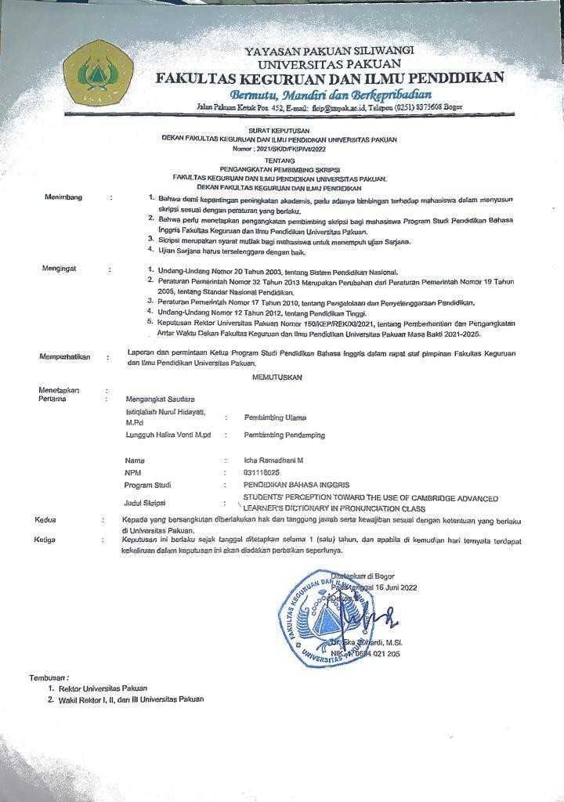
APPENDIX 5
APPENDIX 6
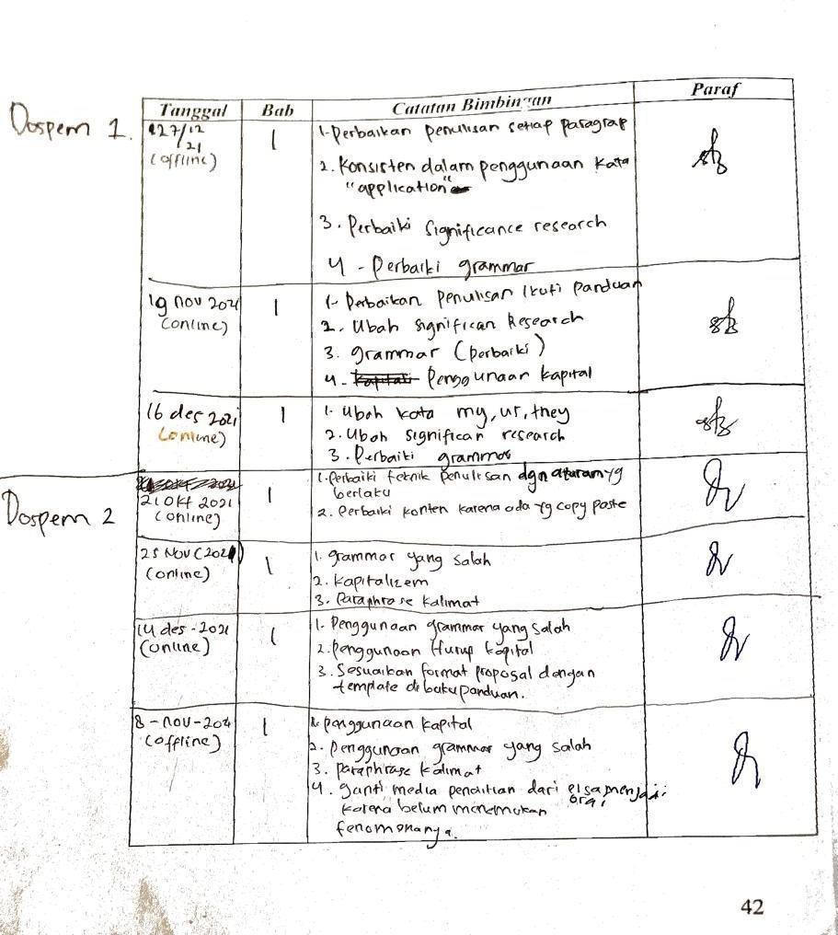

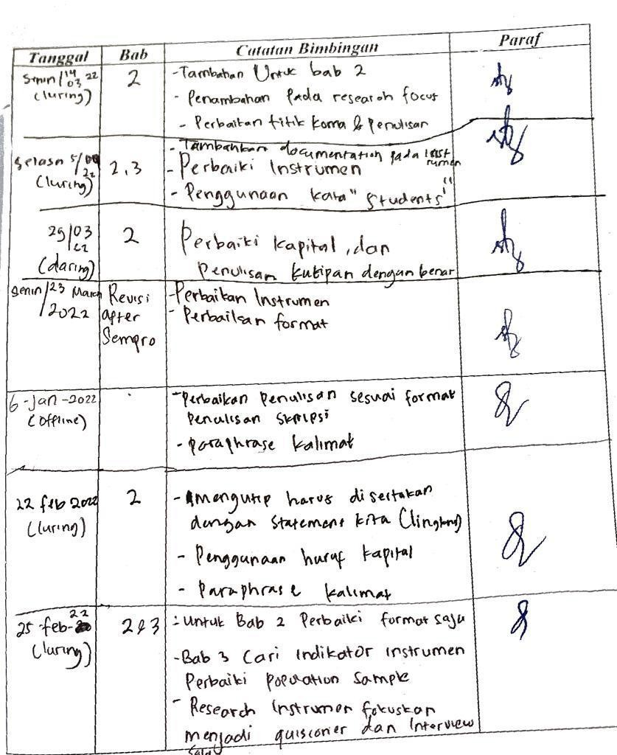

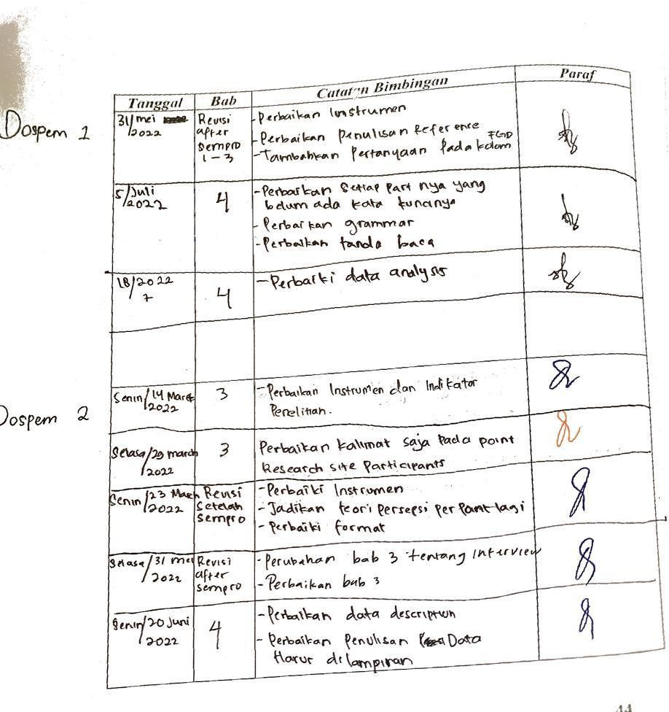

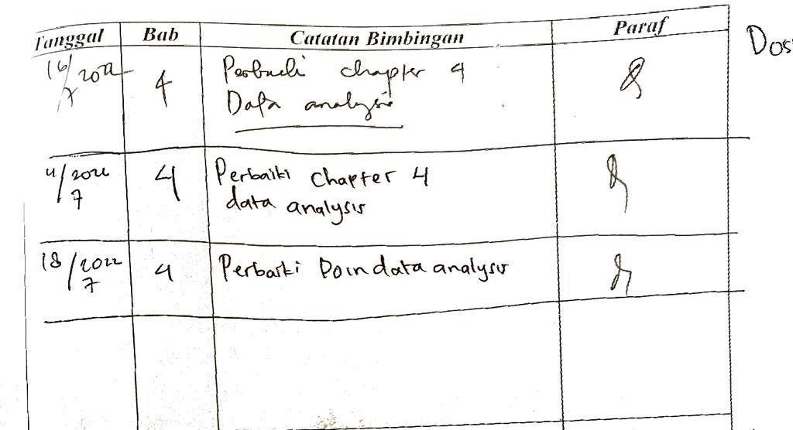

APPENDIX 7
