STUDENTS’ DIFFICULTIES IN LEARNING ACADEMIC WRITING
THROUGH GOOGLE MEET

A PAPER
Submitted to English Language Education Study Program, Faculty of Teacher Training and Educational Sciences, Pakuan University as Partial Fulfilment of the Requirement for Sarjana Pendidikan Examination.

By
Albertha Arimbi Astriwerdhani
031118022


ENGLISH LANGUAGE EDUCATION STUDY PROGRAM
FACULTY OF TEACHER TRAINING AND EDUCATIONAL SCIENCES
PAKUAN UNIVERSITY
2023
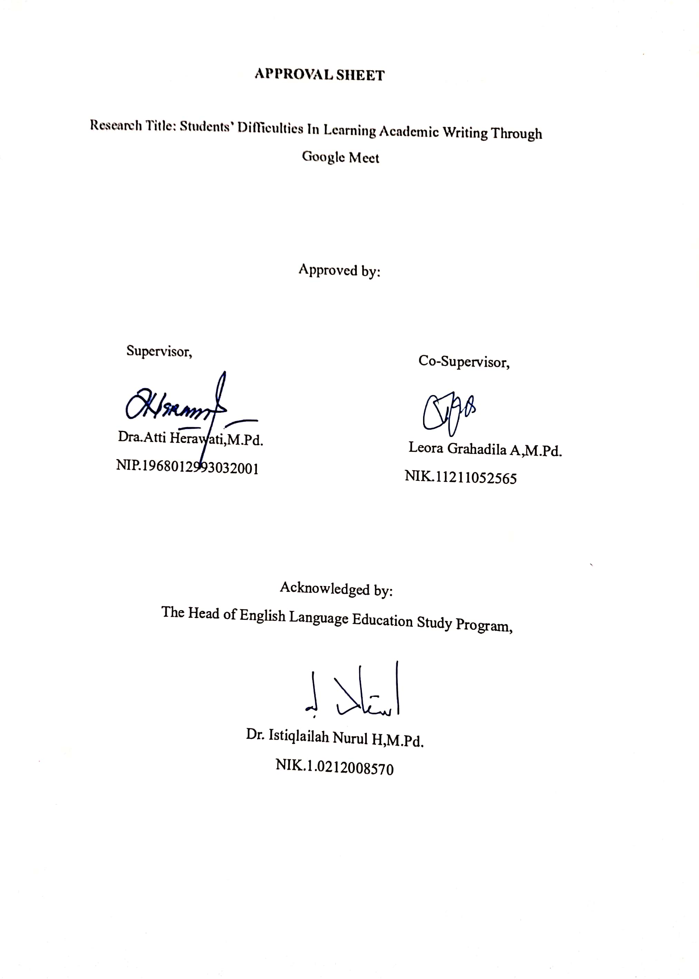
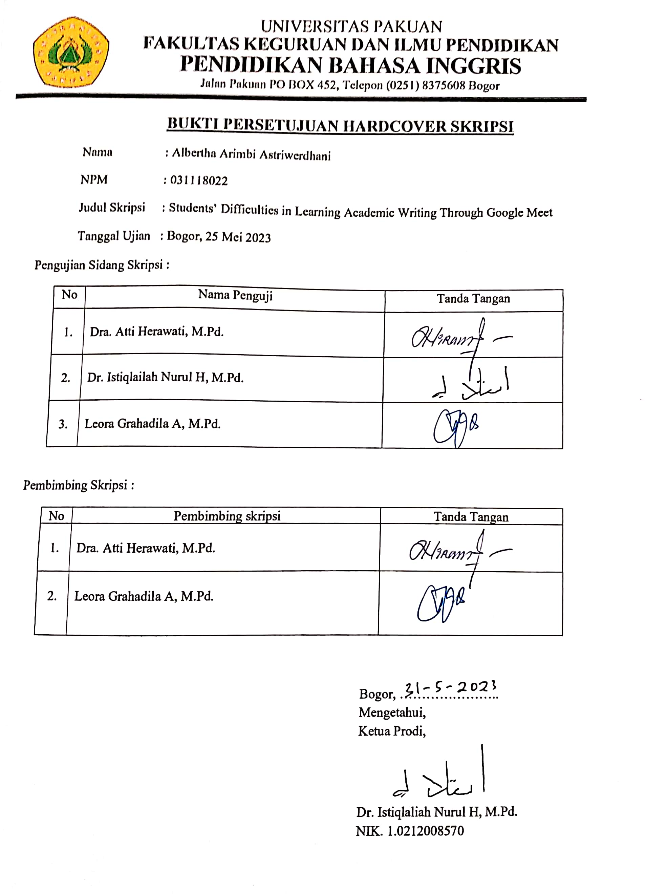

DECLARATION
I hereby declare that the paper entitled “Students’ Difficulties in Learning Academic Writing Through Google Meet” is completely my own work. I am fully aware that I have quoted some statements and ideas from many resources. All quotations are properly acknowledged in the text. Should there be a claim on the originality of this paper, I would be prepared to take any legal responsibility.

Bogor, May 2023

Albertha Arimbi Astriwerdhani
PREFACE
Alhamdulillahhirabill’alamin, all praise and gratitude are dedicated to Allah SWT who has given health, strength, and guidance to the researcher until she could finish her paper entitled Students’ Difficulties in Learning Academic Writing Through Google Meet.
This paper is written to fulfil one of the requirements for Sarjana Pendidikan Examination at English Language Education Study Program, Faculty of Teacher Training and Educational Sciences, Pakuan University.
Even though the researcher has tried to do her best in conducting the research, the researcher realizes that this paper is far from being perfect. Therefore, she accepts any suggestion and constructive criticism for the completion of this paper and her study in the future.

Bogor, May 2023

Albertha Arimbi Astriwerdani
ACKNOWLEDGEMENT
All praises and gratitude will always be dedicated to Allah SWT who has given His mercy, guidance and blessings for the researcher to finish and submit this paper. She also realizes that she could not write the paper properly without the involvement of those who have supported her in conducting the research.
The first, the researcher would like to express her appreciation to herself who can pass through complication become strong for herself to finish this paper. The researcher would also like to express her gratitude to Dra. Atti Herawati, M.Pd. as the first supervisor and Leora Grahadila Andovita, M.Pd. as the second supervisor. They have given their help, advices, suggestion, motivation, support, and contributions to the researcher in the process of write the paper.
Her gratitude also goes to Dr. Eka Suhardi,M.Si. as Dean of Faculty of Teacher Training and Educational Sciences and Mrs. Atti Herawati, M.Pd. as her academic counsellor of class A 2018, and all lectures of English Language Education Study Program Faculty of Teacher Training and Educational Sciences for giving their valuable knowledge. Thanks to the head of study program, Mrs. Dr.Istiqlalilah Nurul Hidayati, M.Pd. who have provided assistance, advice, motivation, and support.
Another grateful is dedicated to her beloved parents who have given prayers and always give encouragement to be a successful person in the future. Their continuous support and understanding when undertaking this paper are worth their weight in gold.
ABSTRACT
In the course of the COVID-19 pandemic, students of the academic year 2018 in ELESP, Pakuan University experienced online learning. This may lead to a different result of the study compared to studying offline. The purpose of this study is to find out the difficulties students face in Academic Writing lessons which are carried out online at home. This research applies descriptive method. The research findings show students have difficulties to understand the lecturer’s explanation because it is hard to get a stable internet network, to do the assignments given by the lecturer, and to have discussion with friends. In addition, some students experience semantic barriers due to misunderstanding in interpreting messages during discussions. As a result, it is difficult for them to understand learning material particularly the introduction section. In conclusion, most students have difficulties in technical difficulties during studying Academic Writing through Google Meet and it affected their motivation and how they did the assignment. Students have a difficulty in learning Academic Writing through Google Meet is when a student have a video conference with their lecturer at home during pandemic with online learning a student get bad signal and also when have a discussion with friend get a misunderstanding because a student do not understand about a lesson that have lecturer explanation. Also, student not read references from their lecturer before begin a class, and then student still confused with writing in a lesson Academic Writing. For solve this problem a student must study hard for get a knowledge in a lesson Academic Writing.
Keywords: students’ difficulties, Academic Writing, Google Meet

TABLE OF CONTENT
Approval Sheet
Declaration ……………………………………………………………i
Preface………………………………………………………………. ii
Acknowledgement……………………………………………………iii
Abstract………………………………………………………………. iv
Table of Content……………………………………………………...vi
CHAPTER I INTRODUCTION 1
- Background of the Study 2
- Reason for Choosing the Topic 2
- The aim of the Study 2
- Research Question 3
- Research Focus 3
- Operational Definition 5
- Research Significance 5
CHAPTER II THEORETICAL FRAMEWORK 6
- Learning Writing 6
- Academic Writing 7
- Google Meet 10
- Related research 12
CHAPTER III RESEARCH METHOD 13
- Research Method……………………………………………….13
- Research Site and Participant 14
- Data Collection Technique 14
- Data Analysis 15
CHAPTER IV DATA DESCRIPTION AND DATA ANALYSIS 16
- Data Description……………………………………................25
- Data Analysis………………………………………………….33
CHAPTER V CONCLUSION AND SUGGESTION 34
- Conclusion 34
- Suggestion 35
BIBLIOGRAPHY 36
APPENDICES 37
Appendix 1 40
Appendix 2 43
CHAPTER I
INTRODUCTION
- Background of the Study
In the course of the COVID- 19 pandemic, many schools shifted to implementing online learning, students must learn at home. Teachers teach students through video conferences for example using Zoom. In addition, students must search for a lesson on the internet to get knowledge such as videos from YouTube to support online learning. The teacher also uses WhatsApp and Google Classroom. Teachers can take advantage of the Google Classroom by checking students’ presence, provides assignments and learning materials for teachers, namely as a learning application, Google Classroom allows for students learning at home during pandemic.
Students of the academic year 2018 in ELESP, Pakuan University also experienced online learning shifting the way students usually study presents some new experiences. These may lead to a different result of the study compared to studying offline. Students experiences difficulties during online class felt unsatisfied with their study because when a student did not understand a lesson they cannot ask them teachers at that time, they must search references from internet for solve a problem in difficulties in learning Academic Writing.
When students learn Academic Writing at home during pandemic, students get difficulties do an assignment from their lecturer because students get a bad connection from the internet and also students do an online learning must do a video conference with their lecturer use an application Zoom. Student usually learn in E-Learning, then a lecturer gives a lesson with there is a video about learning materials for student get knowledge in lesson Academic Writing.
- Reason for Choosing the Topic
Along with the change in the learning system due to the COVID-19 pandemic, teachers design adaptive strategies which students found quite unfamiliar. These sudden changes made students experience a new uncomfortable learning atmosphere. Here, a study of what difficulties students encountered during online classes will be conducted when students have an online class using video conferences for example using Zoom or using Google Meet, their teachers explain a lesson and one of them did not understand a lesson they ask their teachers for giving an explanation until a student understands about a lesson. When students did not know how to use an application they must watch videos on YouTube about using application video conferences for example zoom or Google Meet.
For this reason for choosing the topic a students difficulties do a research proposal in lesson Academic Writing also a researcher want to know about the difficulties in making proposal and also the extent to which students have difficulties in preparing proposals.
- The Aim of the Study
This study aims to identify students’ difficulties during their learning in an online class.
- Research Question
The question of this study is: “what are students’ difficulties in learning during the online course?”
- Research Focus
The focus of this research finding students’ difficulties in Academic Writing class, when students gets difficulties in learning Academic writing class they feel confused to finish an assignment or when they final examination must submit to their lecturer before time is over and also they must study hard for get a better result final examination. Student must learn alone at home because they must focus for learning Academic Writing and also must focus on laptop when they lecturer gives a lesson on video conference, when they did not understand must ask to their lecturer for get new knowledge in lesson Academic Writing class.
F. Operational Definition
1. Students difficulties
Students’ difficulties in Academic Writing is related to explanation given by a lecturer, and internet connection with online learning through Google Meet at home have a bad signal also a student not understand to use features on Google Meet when a share screen or turn on a microphone. Also, a student not reading references from their lecturer should a student search on the internet about a lesson for get a knowledge in Academic Writing. (Ali, 2015)
2. Online class
Online classes for is this study examines how student enrolled in two web based sections writing class compared to students enrolled in conventional version of class. Although no significant difference in a student performance was found between the two learning conditions also a student between knowledge then attitude and learning style in a lesson Academic Writing environment. Our study of effective teaching and difficulty of making comparison between online and the classroom environment. When a student learns from home during a pandemic with online learning use a video conference through Google Meet. the education process at schools in the online form of distance learning that was used likes Zoom and also Google Meet. (David, 2020)
3. Academic Writing
Academic Writing is a form of evaluation that asks you to demonstrate knowledge and show proficiency with certain disciplinary skills of thinking, interpreting, and presenting. As a college student give importance of writing as a communication skill also student must understand about a lesson in Academic Writing. Also, a student can add insight and knowledge in Academic Writing lessons students can access material in e-learning that has been provided by their lecturers. (Irvin, 2010)

- Research Significance
The result of this study is expected to benefit lecturers as it provides them information about the difficulties appeared during online class. For students, it is expected that the result of this study can be a self-evaluation for the betterment of their study. The results of research conducted by researchers are helping students with difficulties in learning Academic Writing lessons using Google Meet.
CHAPTER II
THEORETICAL FRAMEWORK
- Learning Writing
In this research learning writing the findings indicate that these two courses represented distinct communities where different issues were addressed, different lines of reasoning used, different writer and audience roles assumed, and different social purposes served by writing. These findings show the function that writing can serve in introducing students not only to the intellectual activities of a discipline, but also to the social roles and purposes of various disciplinary communities. The findings also show some of the problems that arose in specific classroom contexts when professors gave students mixed messages as to the audience for writing and when no issue was perceived for writing. (Anne, 1994)
According to this research about learning writing is a student at classroom contexts when professors gave students mixed messages as to the audience for writing and when no issue was perceived for writing. Also student learning writing at home during pandemic, a lecturer give lesson to student with a video conference use application Zoom or use Google Meet.
- Academic Writing
In this research example of Academic Writing is proposal activity for plan who write into work plan. Proposal activity make before held for get a sponsors in events and permits, before an event is taking place for instance school anniversary we have to draw up a proposal for the activity. Also the definition of the Academic Writing from the research article and the most original paper also represents ideas, concepts, findings theories form other resources. Definitely situation a way of language is use a previous next and for purpose to outline ways in which appropriate resources may help students to develop in Academic Writing. About the definition of Academic Writing other resources specifically reporting in situation a way of language used in a previous next and also purposes of this chapter to outline ways may help students to develop specific academic domains. For activity of Academic Writing is about use reformulation as a strategy for the teaching Academic Writing it has aim for our understanding the workings of such a strategy is described has been develop and used with non-native writers of English for conclusion is emphasized that although the result is consistent generally positive interpretation of a strategy’s effects they should as helping student. Also students during learning process can get knowledge in Academic Writing. (Christiane, 2012)
According to this research should as helping student for understand about lesson in Academic Writing class also for learning in Academic Writing class student must do an assignment from their lecturer, when a student learns in Academic Writing they get difficulties because they did not understand about a lesson they must study hard until they understand about a lesson, a student learns from home during this pandemic.
- Google Meet
History Google Meet is a service offered by the internet titan so that its users can make video calls and connect with many people regardless of distance and time zone This app was Launched by Google company in February 2017 However, for devices with iOS operating system, its official launch for other platforms was in March 2017, to date only a total of 30 participants can participate per meeting. is a video conferencing application that can be accessed by everyone, both individuals and institutions based on Google.
Student usually learn use application Google Meet with their lecturer with video conference can also be used as a phone call or audio by not turning on the camera. The video calling system via Google Meet is based on an invitation or code to join a meeting via a link. Also, in Google Meet offers conveniences such as no need to install applications on a computer or laptop. All users, both meeting participants and organizers can use the Google Meet network-based link to start the meeting right away (Saeed,2020)
According for this research for a benefit google meet Easy access for free version users and also flexible version for paid users has a 60-minute access time limit for free users Connect and integrate organically with a Google account or Google based email (Gmail) Increase productivity potential and multi-party engagement opportunities as chat rooms Participants and users can share documents, spreadsheets, presentations and various screen tools for real-time feedback Integrated with Google Contacts and Google Calendar so it's easy to remember meeting schedules and participants. For students use google meet must easier to do an assignment during this pandemic at home.
The increase number of Covid-19 outbreak has profoundly changed our education system. This condition has led the teachers to alter the face-to-face learning into online learning. Online learning emphasizes on the internet-based courses synchronously and asynchronously. Besides its technical problems, conducting online learning was said to be monotonous since the teachers preferred doing online tasking to providing effective learning experience. Further, this condition led to low students’ motivation in learning English. In other words, the students might be in boredom to participate and engage in the teaching- learning process owing to the monotonous learning. Most students were said to be late or even reluctant to complete the assignments. Therefore, the researcher conducted the Classroom Action Research dealing with the use of Google meet to improve the students’ motivation in learning English during the online learning (Wahid, 2021)
According to this research students learning Academic Writing through Google Meet can understand a lesson and also students learn can be more affective use Google Meet to improve the students’ motivation in learning English during the online learning.
During this pandemic various business and government institutions and religious institutions meeting activities must use the online platform, several meeting platform options such as Skype, Facebook, Zoom, google meet, etc. In addition to these institutions all elementary and secondary school also use online media to carry out the teaching and learning process it is also the case with universities throughout Indonesia. The ministry of education and culture requires all higher education institutions to implement online lecture systems during the COVID-19 pandemic (Purwanto, 2020)
According to this research during this pandemic government institutions meeting activities must use the online platform such as Skype, Facebook, Zoom, Google Meet, etc. Secondary school also use online media to carry out the teaching and learning process also the case with universities throughout Indonesia. Culture requires all higher education institutions to implement online lecture systems during the COVID-19 pandemic.
- Related Research
This qualitative data speaks to some of the most profound and transcending human experiences. As researchers must write, also teach, or engage to give voice to the voiceless, and often seek to foster influence and understanding where none has been. Yet, despite the most human of subject matter, writing of qualitative research often fails. It can be conventional, formulaic, and, sometimes, even stilted. Also write poetry, crime stories, mysteries, romances, literary works, or science fiction. No two categories carry the same voice. Academics also have many voices: the research paper, the grant application, the tweet, the journal review, the textbook, the dissertation, and the editorial. These categories or genres draw readers in via repetitive familiarity (Paré, 2014). Genre shapes writing by demanding specific conventions.
Clark, Alexander M. 2018. "Five Steps to Writing More Engaging Qualitative Research." International journal of qualitative methods 2. In this qualitative research about Academic Writing also have research paper and the journal review, the textbook Each places different constraints on the writer and has different goals, forms, and structure. As approach in writing, consider more deliberatively which genre are writing in and what defines successful writing in that genre not only in terms of its characteristics and appearance but also in terms of its effects on the reader.
This descriptive qualitative research determined and analyzed the difficulties of senior high school students in writing academic essays and the overall quality of the academic essay of the students. Further, it compared the quality of the academic essays from public and private schools.
Writing has been given great emphasis in the Philippine educational systems since the teaching and learning of English as a Second language (ESL) support the aim of enchasing the English competence of Filipino learners. (Christzer et al., 2018). In this research for choose this topic because when students difficulties in learning academic writing because students learn from home, they cannot go to campus this pandemic. Students must understand about a lesson that has given from their lecturer. Students face difficulties in writing composition, especially academic writing which affects negatively their exam results.
This study has been conducted in the Department of English at college of Education for women, University of Baghdad in order to identify first year EFL students’ incompetence in writing. (Nasser, 2018) In this research students face difficulties in learning academic writing because students must understand about digital for learning academic writing, for example student have a video conference with their lecturer in their home during this pandemic. This study seeks to explore the effect of fear emotion on students’ and teachers’ technology adoption during COVID-19 pandemic the study has made use of Google Meet as an educational social platform in private higher education institutes, universities and colleges have dictated much of their effort to build up a group of virtual teaching environment supported by necessary resources and platforms. In fact, they are striving to achieve certain successful results. However, the spread of COVID-19 has left these institutions in a predicament. It has led to bad consequences of emotions, such as fears, worries and feeling of apprehension among students all over the world. Fear alone negatively affects the psychological status of students and lead to stigma in some situations. The pandemic nature of COVID-19 has even worsened the situation leading to psychosocial challenges, such as loss and discrimination (Saeed, 2020)
CHAPTER III
RESEARCH METHOD
- Research Method and Design
In this research method and design about a descriptive research design can use a wide variety of research methods to investigate one or more variables. Unlike in experimental research, the researcher does not control or manipulate any of the variables, but only observes and measures them. Descriptive research is an appropriate choice when the research aim is to identify characteristics, frequencies, trends, and categories. It is useful when not much is known yet about the topic or problem. Before a student can research why something happens, need to understand how, when, and where it happens.
Descriptive research is usually defined as a type of quantitative research though qualitative research can also be used for descriptive purposes. The research design should be carefully developed to ensure that the results are valid and reliable. Observations allow need to gather data on behaviours and phenomena without having to rely on the honesty and accuracy of respondents. This method is often used by psychological, social, and market researchers to understand how people act in real-life situations. Observation of physical entities and phenomena is also an important part of research in the natural sciences. Before can develop testable hypotheses, models, or theories, it is necessary to observe and systematically describe the subject under investigation. To clarify the process of the research, the researcher drew the research design as follows.
Students’ Difficulties in Learning Academic Writing Through Google Meet

Starting the Research Question:
What are students’ difficulties in learning during the online course?

Determining Research Focus:
Students’ difficulties in Academic Writing class also must focus in learning for get knowledge a lesson Academic Writing class.

Determining Research Site and Participant:
In research site was be held at campus and for participant students who passed the academic writing lesson in 2018.

Drawing Conclusion and Suggestion
Conducting the Research
Observation  Observation to collect data from respondents and processed into information for research materials by researchers. | Questionnaire  After obtaining data from respondents and used as research material using the Google form, the researcher made a questionnaire.
Describing the collect data and validating

The research design consisted of six steps. The first step was deciding the research title based on the phenomenon or curiosity. Therefore, research question was stated to determine the aim of research, and the limitation determine to the research focus. Then, the researcher site and participants. After that, the research instruments were developed to collect the data in the form of observation, and questionnaire. Observation was to collect data from respondents and processed into information and questionnaire after obtaining data from respondents and use research material from the researcher. In addition, the researcher described and validated the data. Finally, the researcher made conclusion and suggestion.
- Research Site and Participant
In research site was be held at campus and for a participant of students who have passed the academic writing lesson in 2018 are classmates because the researcher researches student’s difficulties in Academic Writing.
- Data Collection Technique
An open-ended questionnaire is a questionnaire that is usually composed of a series of questions that allow respondents to provide answers freely based on their complete knowledge, feelings, and understanding. For students can provide opinions about the questionnaire that has been made by the researcher. Researchers using the audit trail method is a step in examining data that has just been obtained and is still raw, then analyzed and the conclusions corrected by other parties. The other party is usually a supervisor who helps a researcher in compiling the research.
- Data Analysis
When a researcher gives a questionnaire to a respondent and getting answers from respondents, researchers processed data from google form. For a respondent at classmates also when a researcher get data from respondent. A researcher can get more information from a respondent through google form application after the researcher obtains the results of the questionnaire, can obtain data from the respondents to be processed into information. Researcher can find out the extent of students' difficulties in carrying out the learning process in Academic Writing online during a pandemic.
CHAPTER IV
DATA DESCRIPTION AND DATA ANALYSIS
- Data Description
This research was carried out on 27th December 2022 until 24th January 2023 at Pakuan University. The respondents were 60 students from batch 2018 who had passed Academic Writing class. The research data was obtained from closed questionnaires that were given to students through Google form. There are 10 questions with four choices. The following are the result of data description.
Question #1: What do you think about Academic Writing lectures held through Google Meet?
The first question aims at finding general information or opinion about Academic Writing course held through Google Meet. This question provides four choices. Two students (6.3%) choose the second choice that is the lecturers explain Academic Writing lesson through Google Meet is very easy to understand. 21 students (65.6%) choose Academic Writing through Google Meet is easy to understand. Nine students (28.1%) choose that Academic Writing through Google Meet is difficult to understand.

Table 4.1. Number of respondents’ answer toward Question
Alternatives | Number of respondents
- The lecturer’s explanation of Academic Writing through Google Meet is very easy to understand | 2 (6.3%)
- The lecturer’s explanation of Academic Writing through Google Meet is easy to understand | 21 (65.6%)
- The lecturer’s explanation of Academic Writing through Google Meet hard to understand | 9 (28.1%)
- The lecturer’s explanation of Academic Writing through Google Meet is very hard to understand | 0

Question #2: How is your level of motivation to learn about the Academic Writing course online through Google Meet?
The second question of the questionnaire is asking the respondents to rate their motivation to learn Academic Writing. The answers are in the following table.
Table 4.2. Number of respondents’ answer toward Question #2
Alternatives | Number of respondents
- High motivation | 3 (9.4%)
- Moderate motivation | 26 (81.3%)
- Low motivation | 3 (9.4%)
- Have no motivation | 0

This question provides four choices and the students choose level of learning motivation. There are three students who had high level motivation in learning Academic Writing through Google Meet. 26 students had moderate motivation to learn Academic Writing through Google Meet. Also, three students have a low motivation.
It means students’ motivation in taking Academic Writing through Google Meet have a sufficient level in the learning process. The number of students who chose moderate level in motivation is 26.
Question #3: What are your difficulties in studying Academic Writing course which is held through Google Meet?
The third question is intended to know what difficulties students have to study Academic Writing through Google Meet. The answers are shown in the following table.
Table 4.3. Number of respondents’ answer toward Question
Alternatives | Number of respondents
- Difficult to understand the lecturer’s explanation | 1 (3.1%)
- Hard to get a stable internet network | 20 (62.5%)
- Difficult to do the assignment given by lecturer | 1 (3.1%)
- Difficult to have discussions with friends | 10 (31.3%)

One student answer that it was difficult to understand the lecturer’s explanation. 20 students answer that the internet connection at their places is not stable so it disturbs them during the class. One student gets difficulty to do the assignments given by the lecturer. 10 students get difficulty to have discussion with friends.
Question #4: What are your difficulties in understanding the lecturer's explanation when Academic Writing lectures are conducted through Google Meet?
One student answer that it was difficult to understand the lecturer’s explanation. 20 students answer that the internet connection at their places is not stable so it disturbs them during the class. One student gets difficulty to do the assignments given by the lecturer. 10 students get difficulty to have discussion with friends.
The fourth question aimed at finding information about students’ difficulties in understanding lecturer’s explanation in Academic Writing through Google Meet. The answers are shown in table 4.4.
Table 4.4. Number of respondents’ answer toward Question #4
Alternatives | Number of respondents
- it is difficult to understand the lecturer's explanation because the audio is not clear | 5 (15.6%)
- difficult to understand the lecturer's explanation because the internet network is unstable | 16 (50%)
- it is difficult to understand the lecturer's explanation because they have not read the lecture material | 9 (28.1%)
- it is difficult to understand the lecturer's explanation because they do not really listen | 2 (6.3%)

As many as 16 respondents admit that it is difficult to understand lecturer’s explanation because the internet connection is not stable. Nine respondents get difficult to understand the lecturer’s explanation because they have not read the lecture material. Also, it is difficult to understand the lecturer’s explanation because the audio is not clear for five students. They get difficulty because the network is unstable. Two students did not really listen.
Question #5: What are your difficulties when discussing topics in Academic Writing with lecturers and/or classmates online via Google Meet?
Question number five is about difficulties when discussing topic in Academic Writing with lectures also with a classmate through Google Meet because technical barriers with the internet network is less given the opportunity for communication because it often occurs in one direction. During discussion in the class, 15 respondents (46.9%) admit that semantic banners occur due to misunderstanding in interpreting messages during discussion.
Table 4.5. Number of respondents’ answer toward Question #5
Alternatives | Number of respondents
- technical barriers because of the internet network | 12 (37.5%)
- semantic barriers that occur due to misunderstandings in interpreting messages during discussions | 15 (46.9%)
- less given the opportunity because communication in the classroom often occurs in one direction | 4 (12.5%)
- no trouble at all | 1 (3.1%)

Question #6: What material do you think is difficult to understand from Academic Writing course which is held through Google Meet?
The sixth question aims at finding respondents’ answer dealing with Academic Writing learning material. The following table shows the answers.
Table 4.6. Number of respondents’ answer toward Question #6
Alternatives | Number of respondents
- the introduction section | 13 (40.6%)
- the theoretical framework section | 12 (37.5%)
- the research finding section | 5 (15.6%)
- the conclusion section | 2 (6.3%)

Students’ difficulties in understanding Academic Writing material through Google Meet is writing the introduction section (13 students), also get difficulties in writing the theoretical framework section (12 students), in writing the research finding section (five students), in writing the conclusion section (two students).
Question #7: Why do you find the material difficult?
The seventh question intends to find information about the reason why they think that certain learning material in Academic Writing is difficult. For question number seven, the student is a confused about how to write it and also not reading references before the class.
Table 4.7. Number of respondents’ answer toward Question #7
Alternatives | Number of respondents
- confused about how to write it | 5 (15.6%)
- lacking a formal vocabulary | 10 (31.3%)
- not reading references | 11 (34.4%)
- I'm not used to writing essays | 6 (18.8%)

Student get difficulty in understanding the material through Google Meet, because they are still confused about how to write it (five students), get lacking a formal vocabulary (10 students), not reading refences (11 students), not used to write an essay (six students).
Question # 8: What are your difficulties in using the features on Google Meet while taking Academic Writing lectures?
This question reveals respondents’ answer about their difficulties making use the features on Google Meet.
Table 4.8. Number of respondents’ answer toward Question #8
Alternatives | Number of respondents
- Write in chat box | 3 (9.7%)
- Do share screen | 23(74.2%)
- Turn on camera | 4 (12.9%)
- Turn on a microphone | 1 (3.2%)

Students’ difficulties in using features on Google Meet when learning Academic Writing are write in chat box (three students), doing share screen (23), turning on the camera (four students), and also turning on the microphone (one student).
Question #9: What academic writing difficulties do you often experience?
The ninth question aims at finding information about difficulties encountered by the students in learning Academic Writing through Google Meet. Students’ experiences are they often get difficulties in using the correct grammar.
Table 4.9. Number of respondents’ answer toward Question #9
Alternatives | Number of respondents
- determine the thesis statement and develop it into a coherent paragraph | 11 (35.5%)
- paraphrasing, synthesizing, and elaborating from various sources | 10 (32.3%)
- use the correct grammar rules | 3 (9.7%)
- all answer a, b, and c | 7 (22.6%)

From the table it can be seen the students experience difficulties in Academic Writing is paraphrasing and also use the correct grammar rules. There are many students who have difficulty in writing grammar correctly and at least students have difficulty writing paraphrasing. Students’ difficulties Academic Writing is determining the thesis statement and developing it into a coherent paragraph (11 students), paraphrasing (10 students), use the correct grammar rules (three students), and all answers (seven students).
Question #10: What difficulties did you face when working on Academic Writing assignments?
The tenth question intends to know information about difficulties faced by the respondents during working on Academic Writing assignments. The students face difficulties when working on Academic Writing an assignment is in writing background of the study, working on the theory, writing reason for choosing the topic, and doing writing related research.
Table 4.10. Number of respondents’ answer toward Question #10
Alternatives | Number of respondents
- writing background of the study | 14 (43.8%)
- writing reason for choosing the topic | 4 (12.5%)
- working on the theory part that supports the thesis title | 13 (40.6%)
- writing related research | 1 (3.1%)

The students have difficulty writing the background of the study (14 students), reason for choosing the topic (four students), working on the theory part that supports the thesis title (13 students), related research (one student).
- Data Analysis
Based on the students’ opinion learning Academic Writing through Google Meet is easy to understand because they must read the book or some refences from the internet before the class to make them understand about the lesson in Academic Writing class. They must study hard from home during this pandemic.
Student motivation level to learn Academic Writing through Google Meet is high. The students were excited for learn Academic Writing because the students want to understand the lesson. The students had moderate motivation because they had to fulfil their obligations as students in Academic Writing lessons. Definite situation a way of language is use for a purpose to outline ways in which appropriate resources may help students to develop ideas in Academic Writing. The students have motivation to learn Academic Writing course online through Google Meet.
The students have difficulty to understand the lecturer’s explanation some student gets hard to get a stable internet network also get difficult to do the assignments given by the lecturer and for the least is get difficult to have discussion with friends. When a student does an assignment at home sometimes hard to get a stable internet network, then a student gets difficult to do an assignment given by the lecturer because a student has a difficult for discussion with friends.
The highest number is internet network constraints and the least number is the difficulty for students to understand the lecturer's explanations and assignments given by lecturers. Students’ difficulties in learning Academic Writing through Google Meet happened when they did an assignment at home. It was hard for them to get a stable internet network, also a lecturer gives an explanation student difficulty to understand in Academic Writing lesson, to do an assignment in Academic Writing lesson through Google Meet.
The students get difficulties in understand the lecturer’s explanation in Academic Writing through Google Meet it is difficult to understand the lecturer’s explanation because the audio is not clear and also some students have a assignment sometimes the internet network is unstable. Before a lecturer already begin a class during online student have not read the lecturer material. The students had difficulty understanding the lecturer's explanation when Academic Writing lectures are conducted through Google Meet it is difficult to understand the lecturer's explanation because the audio is not clear around five students. When a lecturer gives an explanation a student difficult for understand a lesson through Google Meet because have a bad signal around sixteen students. when lectures give an explanation in lesson Academic Writing trough Google Meet a student gets a difficult to understand the lecturer explanation because the audio is not clear also the internet network. It means that when a lecturer give explanation in front of the class when learning offline or online through Google Meet.
The students usually learn use application Google Meet with their lecturer with video conference can also be used as a phone call or audio by not turning on the camera. The video calling system via Google Meet is based on an invitation or code to join a meeting via a link. Also, in Google Meet offers conveniences such as no need to install applications on a computer or laptop.
Discussing Academic Writing topics with classmates via Google Meet is less given the opportunity, because communication in the Google Meet often occurs in one direction. Besides, the students must focus when the lecturer gives explanation. Some students get technical barriers because of the internet network and also semantic barriers that occur due to misunderstanding in interpreting messages during discussions.
The highest number are semantic barriers that occur due to misunderstandings in interpreting messages during discussions and the least are no difficulties at all. For the data analysis number five student difficulties topics in Academic Writing with lectures because technical barriers because of the internet network also with a classmate online via Google Meet les given the opportunity because communication in the classroom often occurs in one direction.
It can be seen fifth statement student difficulties when discussing topics in Academic Writing with lecturers or classmates online via Google Meet when student do an assignment at home during this pandemic with a problem technical barrier because of the internet network around twelve students. Then student semantic barriers due to misunderstanding when discussing around fifteen students. There are many student constraints on the internet network during the learning process and only one student does not have problems during learning.
During this pandemic government institutions meeting activities must use the online platform such as Skype, Facebook, Zoom, Google Meet, etc. Secondary school also use online media to carry out the teaching and learning process also the case with universities throughout Indonesia. Culture requires all higher education institutions to implement online lecture systems during the COVID-19 pandemic.
Academic Writing material is difficult to understand from the Academic Writing course Google Meet some student get difficulties write the introduction section also some student get in write the conclusion section, a student must understand about a material in Academic Writing through Google Meet. They must learn again in lesson Academic Writing through Google Meet for make a student really understand in this lesson. The material is difficult to understand from the Academic Writing course which is held through Google Meet in write the introduction section and also write the wrote the theoretical framework section.
Students’ difficulties in learning Academic Writing material held through Google Meet is when they write the introduction section, and the theoretical framework section because they do not really understand the lessons that will be studied in Academic Writing. They should pay more attention when the lecturer explains the material. The material that was difficult for students to work on was writing the research finding section and the conclusion.
Also, the definition of the Academic Writing from the research article and the most original paper also represents ideas, concepts, findings theories form other resources. Definitely situation a way of language is use a previous next and for purpose to outline ways in which appropriate resources may help students to develop in Academic Writing. About the definition of Academic Writing other resources specifically reporting in situation a way of language used in a previous next and also purposes of this chapter to outline ways may help students to develop specific academic domains.
The students are still confused about how to write it and also lacking formal vocabulary because a student not reading a refences before a lecturer explanation a lesson. The student is a confused about how to write it and also not reading references before a class will entrance with a lecturer. The highest number is when the lecturer will explain the lesson the students have not read the references and the least students still do not understand how to write in Academic Writing lessons.
Students' difficulties in Academic Writing lessons because students are confused about how to write and also use formal vocabulary. Also many students do not read references. the number of students lacks many references and also the few students who are confused about their writing. Also student learning writing at home during pandemic, a lecturer give lesson to student with a video conference use application Zoom or use Google Meet.
The students get difficulties to use features on Google Meet while taking Academic Writing such as writing in chat box and doing share screen. It means the students must learn again how to use features on Google Meet application. Besides the technical problems, conducting online learning was said to be monotonous since the teachers preferred doing online task to provide effective learning experience. Further, this condition led to low students’ motivation in learning English.
Students’ experience to determine the thesis statement and develop it into a coherent paragraph and also use the correct grammar rules. The students must learn paraphrasing, synthesizing, and elaborating from various sources. The students often experience difficulties when they should use the correct grammar rules and paraphrasing. The students have difficulty in determining the thesis statement and developing it into coherent paragraphs and the least students selecting all the answers on the research questionnaire on the Google form given by a researcher to respondents totalling thirty-two students who have passed the Academic Writing lesson.
The students face difficulties when working on Academic Writing assignments such as writing background of the study and also do reason for choosing the topic. They also have difficulties working on the theory part that supports the thesis title and the related research section. In this research example of Academic Writing is a research proposal.
The findings are in accordance to what Purwanto (2020) said that during this pandemic student activities must use the online platform such as Google Meet, student in lesson Academic Writing through Google Meet easy to understand with online learning during this pandemic. Some student gets difficult when a lecturer explains in Academic Writing through Google Meet because a student gets a bad signal at their home.
The findings are in accordance to what Christiane (2012) said that also student during learning process can get knowledge in Academic Writing, student have a high motivation for learn in Academic Writing use video conference for example Google Meet with online learning during this pandemic at their home.
The findings are in accordance to what Anne (1994) said that some problems in classroom during online learning, student get difficult with a lecturer explanation because a student hard to get a stable internet network also difficult to do the assignments given by the lecturer when a student get difficult to have discussions with friends with online learning at their home during this pandemic.
The findings are in accordance to what Saeed (2020) said that student usually learn use application Google Meet with their lecturer with video conference can also be used as phone call or audio by not turning on the camera, student get difficult to understand with lecturer explanation because the audio is not clear get a problem internet network.
The findings are in accordance to what Wahid (2021) said that a lecturer must face to face with student in online learning besides a technical problem, when student have a topic in learning Academic Writing through Google Meet there is a technical berry because of the internet network.
The findings are in accordance to what Anne (1994) said that these findings show the function that writing can serve an introduction student not only the intellectual activities, student get difficulties in a lesson Academic Writing material in the conclusion section, in the introduction section, in the theoretical framework section, and also the research finding section.
The findings are in accordance to what Wahid (2021) said that in the teaching learning process most students were said to be late for understand a material in a lesson Academic Writing, student still get confused about how to write and also student not understand in a lacking a formal vocabulary. Also, student not reading references before a class online learning will begin with their lecturer through Google Meet.
The findings are in accordance to what Saeed (2020) said that the video calling system via Google Meet based on an invitation or code to join a meeting via a link, student difficulties use features in Google Meet such as write in chat box, do share screen. Also, when a lecturer explains a lesson in Google Meet some student get difficult to turn on camera, and also turn on microphone.
The findings are in accordance to what Wahid (2021) said that beside its technical problems conducting online learning since a lecturer preferred doing online tasking to providing effective learning experience, student difficulties in often experience a lesson Academic Writing through Google Meet a paraphrasing, synthesizing, and elaborating from various sources.
The findings are in accordance to what Christiane (2012) said that for activity of Academic Writing it has aim for understanding the workings they should helping student, they difficult on assignment in a lesson Academic writing through Google Meet on working the theory part that supports the thesis title.

CHAPTER V
CONCLUSION AND SUGGESTION
- Conclusion
This research was carried out on 27 December 2022 until 24 January 2023 and conducted at Pakuan University. The respondents were students from class of 2018 as many as thirty-two students who have passed in Academic Writing lessons. Researcher gave a questioner to thirty-two students who filled out the questionnaire from the batch that had passed the Academic Writing lesson. The research data was obtained from closed questionnaires that were distributed to students through Google form. There are ten questions that have been made by the researcher and there are also multiple-choice answers.
Students’ difficulties in a lesson Academic Writing through Google Meet also when a student have an assignment students get obstacles in doing assignments from their lecturers for example a student get a bad signal at their home with online learning during pandemic namely the signal around their house is unstable.
Also student get difficulties when a lecturer explanation because a student not reading references before a lecturer will begin a lesson. When a lecturer gives a video conference with a student get difficulties use features on Google Meet in share screen. After that a student have an assignment from their lecturer at their home get stable internet network and also get difficulties in semantic barriers that occur due to misunderstanding in interpreting messages during discussion.
- Suggestion
Based on the conclusion above, there are some suggestions for student difficulties in lesson Academic Writing through Google Meet from a researcher is student must focus when a lecturer give an explanation for student understand in a lesson also must read a refences from their lecturer to get knowledge in a lesson Academic Writing.
For further researchers’ suggestion can use interview for process data and also find out student difficulties in Academic Writing through Google Meet. Then Also should be an approach to respondents because to better know the extent to which students experience difficulties during Academic Writing learning through Google Meet which was carried out online at home during the pandemic.

BIBLIOGRAPHY
Amirul, M., Raden,M.A.,& Muhammad.F. (2015). Voices from Within: Student Teachers’ Experiences in English Academic Writing Socialization at One Indonesian Teacher Training Program. Journal of The Qualitative Report 9(20), 1-16. http://bitly.ws/F9GI
Ara, S. (2021). Student Readiness to e-learning in Clinical Medicine. COVID Experience of Gynaecology Clerkship Students of Shifa College of Medicine. Journal of Education (2). http://bitly.ws/F9JN
Bethan, A., & Anthony K. (2022). Change in technology-enabled omnichannel customer experiences in-store. Journal of Retailing (65). http://bitly.ws/F9Nr
Edi, P., & Hendry. T. (2020). The Factors Affecting Intention to Use Google Meet Amid Online Meeting Platforms Competition in Indonesia. Journal of Use Google Meet (06). http://bitly.ws/F9PX
Fred, D., & Forest, D. (2020). Strategic Management Concepts and Cases. Journal of A competitive Advantage Approach (16). http://bitly.ws/F9QZ
Haryanto, A. (2018). Research Methods in TEFL Studies: Descriptive Research, Case Study, Error Analysis, and R & D. Journal of Language Teaching and Research (9). http://bitly.ws/F9So
Irvin. (2010). What is Academic Writing. http://bitly.ws/GkNm.
Linda, N., & Zelal, A. (2017). Showcasing the diversity of service research: Theories, methods, and success of service articles. Journal of Service Management (1). http://bitly.ws/F9UA
Mary, D., & Peter, O. (2011). Writing in the Disciplines. Journal of Academic Writing (1), 1-13. http://bitly.ws/F9Vc
Pare, G. (2002). Enhancing the Rigor of Qualitative Research: Application of a Case Methodology to Build Theories of IT Implementation. Journal of The Qualitative Report (4). http://bitly.ws/F9VX
Said, M., & Wahid. A. (2021). Challenges in Emergency Remote Teaching Among Malaysian Public Elementary School Teachers. Journal of Learning and Teaching (16). http://bitly.ws/F9Wz
Tinto., Vincent., & Anne. (1994). Freshman Interest Groups and the First-Year Experience: Constructing Student Communities in a Large University. Journal of The First-Year Experience & Students in Transition (1). http://bitly.ws/wgTF

APPENDICES
Appendix 1
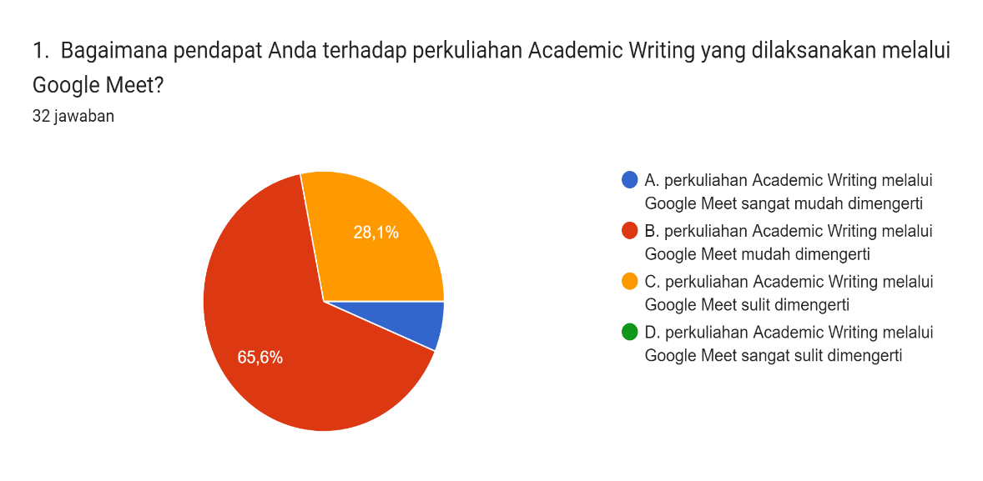
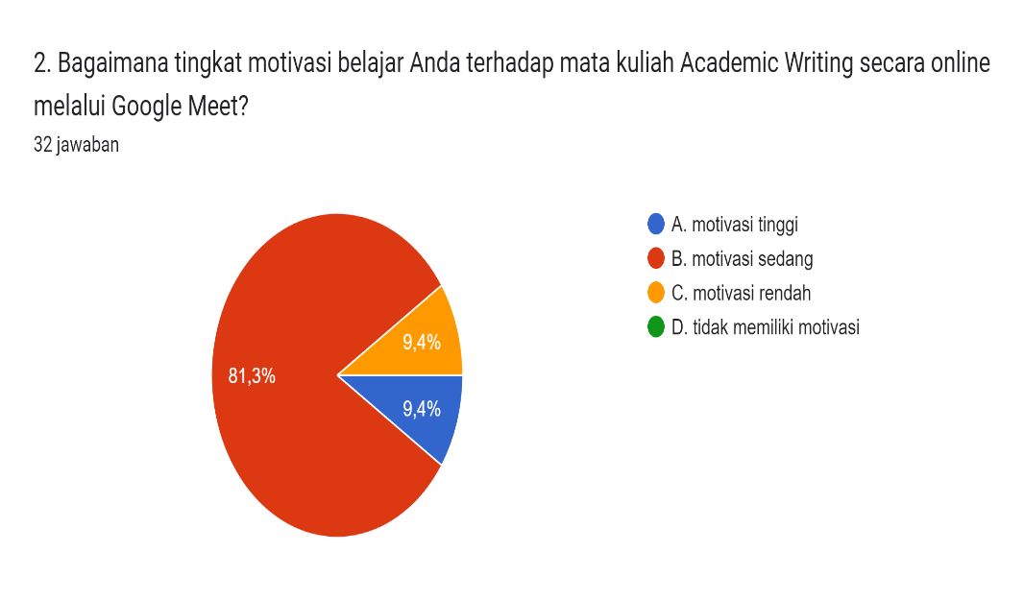
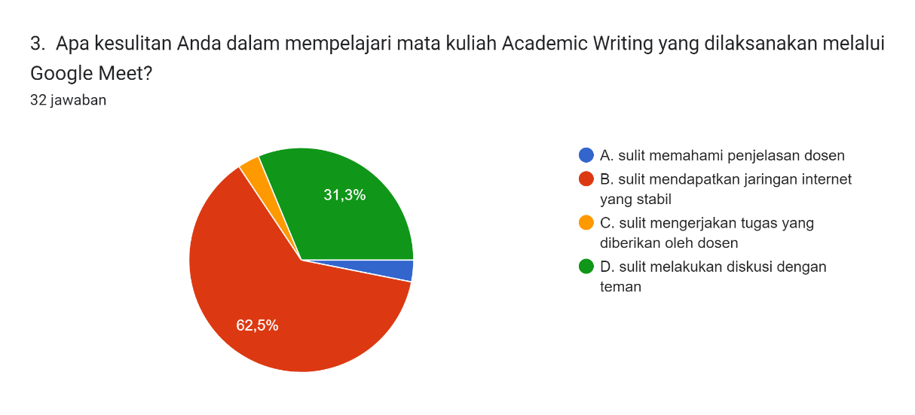

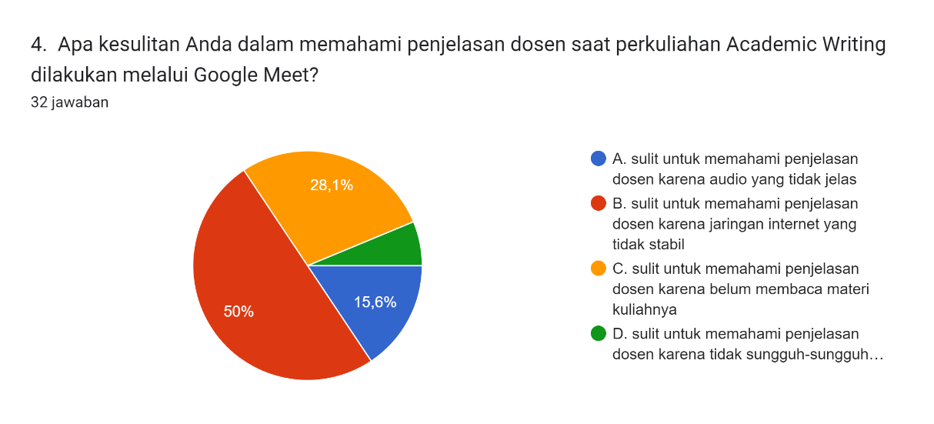
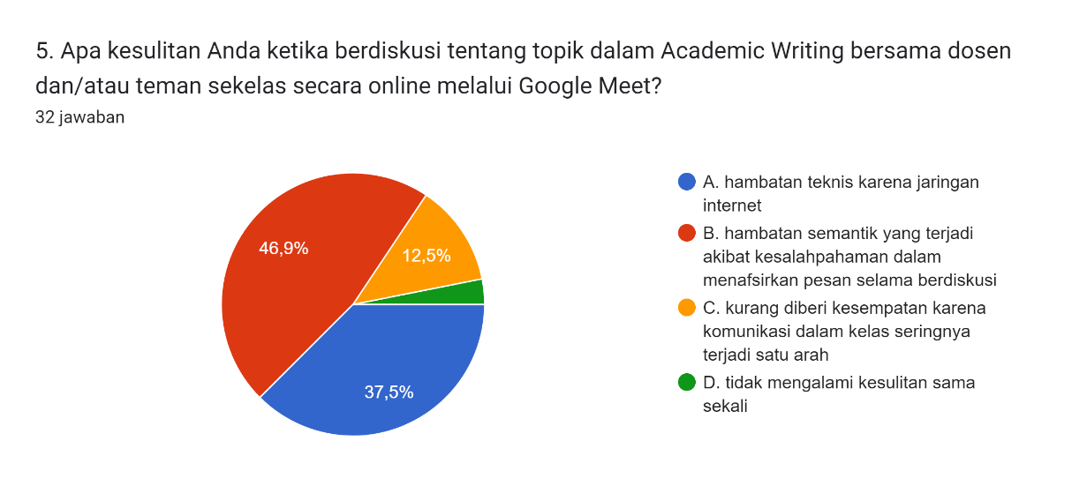
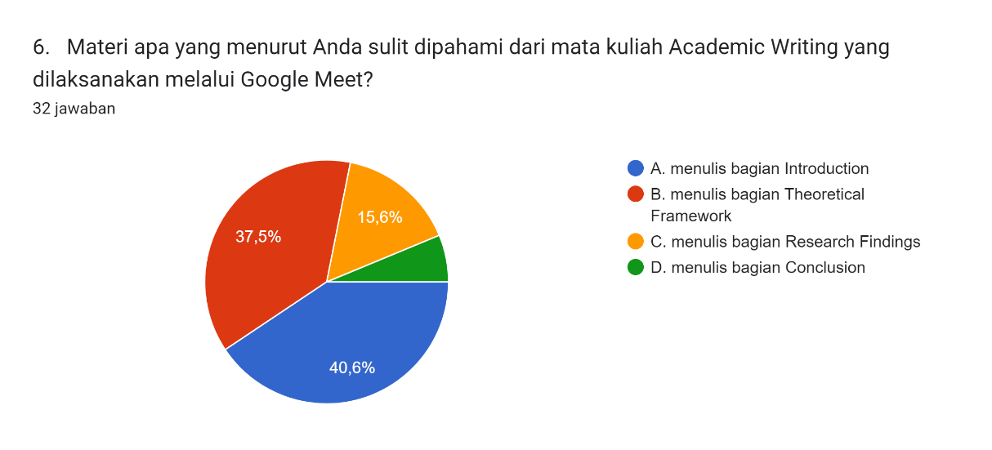
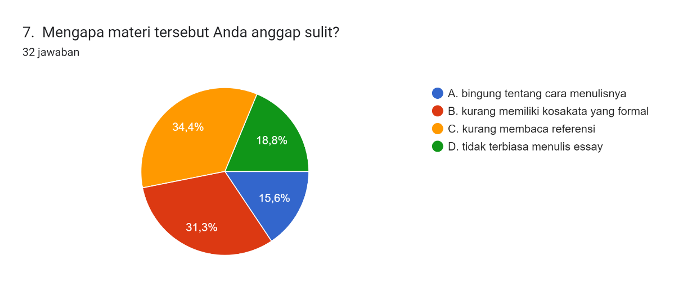
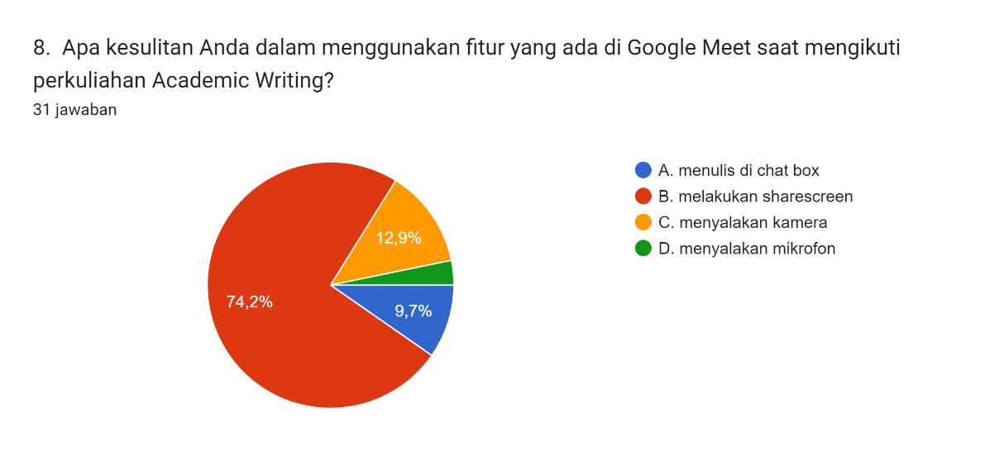

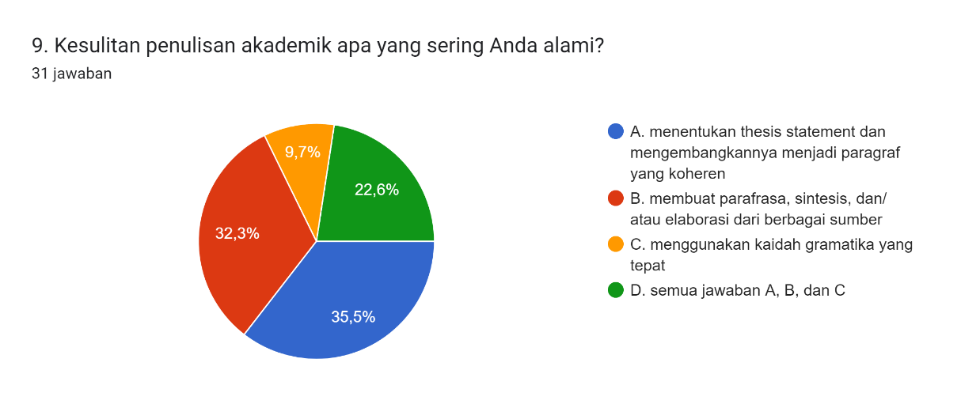
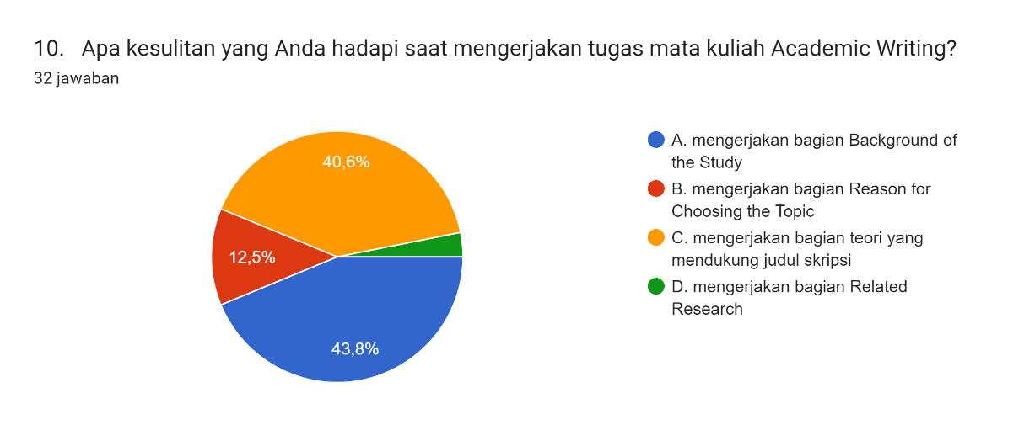

Appendix 2
Albertha Arimbi Astriwerdhani, a student of the English Language Education study program, FKIP, Pakuan University, am currently working on my thesis entitled "Students' Difficulties in Learning Academic Writing through Google Meet". To obtain data for this research, I ask for your willingness to fill out this questionnaire. Thank you for your willingness.
- What do you think about Academic Writing lectures held through Google Meet?
  - The lecturer’s explanation of Academic Writing through Google Meet is very easy to understand
  - The lecturer’s explanation of Academic Writing through Google Meet is easy to understand
  - The lecturer’s explanation of Academic Writing through Google Meet hard to understand
  - The lecturer’s explanation of Academic Writing through Google Meet is very hard to understand
- How is your level of motivation to learn about the Academic Writing course online through Google Meet?
- High motivation
- Moderate motivation
- Low motivation
- Have no motivation
- What are your difficulties in studying Academic Writing course which is held through Google Meet?
- difficult to understand the lecturer's explanation
- hard to get a stable internet network
- difficult to do the assignments given by the lecturer
- difficult to have discussions with friends
- What are your difficulties in understanding the lecturer's explanation when Academic Writing lectures are conducted through Google Meet?
- it is difficult to understand the lecturer's explanation because the audio is not clear
- difficult to understand the lecturer's explanation because the internet network is unstable
- it is difficult to understand the lecturer's explanation because they have not read the lecture material
- it is difficult to understand the lecturer's explanation because they do not really listen
- What are your difficulties when discussing topics in Academic Writing with lecturers and/or classmates online via Google Meet?
- technical barriers because of the internet network
- semantic barriers that occur due to misunderstandings in interpreting messages during discussions
- less given the opportunity because communication in the classroom often occurs in one direction
- not trouble at all
- What material do you think is difficult to understand from Academic Writing course which is held through Google Meet?
- the introduction section
- the theoretical framework section
- the research finding section
- the conclusion section
- Why do you find the material difficult?
- confused about how to write it
- lacking a formal vocabulary
- not reading references
- I'm not used to writing essays
- What are your difficulties in using the features on Google Meet while taking Academic Writing lectures?
- Write in chat box
- Do share screen
- Turn on camera
- Turn on a microphone
- What academic writing difficulties do you often experience?
- determine the thesis statement and develop it into a coherent paragraph
- paraphrasing, synthesizing, and elaborating from various sources
- use the correct grammar rules
- all answer a, b, and c
- What difficulties did you face when working on Academic Writing assignments?
- writing background of the study
- writing reason for choosing the topic
- working on the theory part that supports the thesis title
- writing related research

